Lesson 8 – Adjectives Part 1

(Lección 8 – Adjetivos parte 1)

|  |  |  |
| --- | --- | --- |
| **English** | **español** | **Foto** |
| big or large | grande | Elephant,cartoon,baby elephant,funny,big eyes - free image from needpix.com |
| small or little | pequeño(a) | SnappyGoat.com - Free Public Domain Images - SnappyGoat.com-  mouse-rodent-animal-small-pet-311206.svg |
| good | bueno(a) | 300 Free Thumbs Up Illustrations and Graphic - Pixabay - Pixabay |
| bad | malo(a) | Samuel Smiley Smiliy Thumbs - Free image on Pixabay |
| long | largo(a) | Cartoon Wiener Dog Dachshund - Vector Image |
| tall | alto(a) | Giraffe,neck,cartoon,wildlife,safari - free image from needpix.com |
| short | corto(a) o bajo(a) | Tall Person Short Cartoon drawing free image |
| young | joven | Baby Boy Blue - Free vector graphic on Pixabay |
| old | viejo | Cartoon old man with a cane free image |

Write the adjective with the picture.

(Escribe el adjetivo con la imagen.)

|  |  |  |
| --- | --- | --- |
| **Number**  (número) | **Picture (imagen)** | **Answer (Responder)** |
| 1 | Tall tree and children free image |  |
| 2 | Bear is Giving Thumbs Up clipart. Free download transparent .PNG | Creazilla |  |
| 3 | Old man as a cartoon character free image |  |
| 4 | Long Neck Dinosaur Cartoon Clip Art free image |  |
| 5 | Cartoon girl with long red hair free image |  |
| 6 |  |  |
| 7 | Over 90 Free Rat Vectors - Pixabay - Pixabay |  |
| 8 | Tall And Short People drawing free image |  |
| 9 | 900+ Free Baby & Cute Vectors - Pixabay |  |

Answers on next page (respuestas en la página siguiente)

1. Tall
2. Good
3. Old
4. Big or Large
5. Long
6. Bad
7. Small or Little
8. Short
9. Young

Pick the right adjective

(Elige el adjetivo correcto)

|  |  |
| --- | --- |
| 1. Thumbs up business man clipart. Free download transparent .PNG | CreazillaMarco feels ____. 2. Good 3. Bad 4. Short | 1. The grandfather is ___________. 2. Grandparent,family,child,grandfather,grandchild - free image from ...Young 3. Old 4. Long |
| 1. The baby is _____________. 2. Clip Art Baby Jesus Coloring Page free imageOld 3. Bad 4. Small | 1. His father is _____________. 2. I am taller than you free imageGood 3. Short 4. Tall |
| 1. Rocky is ____________. 2. Muscle Man Bison Muscular - Free image on PixabayBig 3. Good 4. Young | 1. The mother feels _________ 2. Mother and Baby are Both Crying clipart. Free download transparent .PNG |  CreazillaGood 3. Young 4. Bad |

Answers on next page (respuestas en la página siguiente)

1. Good
2. Old
3. Small
4. Tall
5. Big
6. Bad

Draw the adjective.  
(Dibuja el adjetivo.)

Good Young Short or Little

Bad Tall Big or Large

To try at home (Para probar en casa)

1. Use an adjective to tell about each person in your family. (Use un adjetivo para hablar sobre cada persona de su familia.)
2. Make a sentence for each adjective.

(Haz una oración para cada adjetive.)

1. More difficult – Use the emotions and personal pronouns vocabulary to make a sentence with an adjective from this lesson. For instance, “My tall mother feels hungry. Use a translator to figure out the English word if you don’t know it.

(Más difícil - Usa el vocabulario de emociones y pronombres personales

para formar una oración con un adjetivo de esta lección. Por ejemplo, “Mi madre alta tiene hambre. Utilice un traductor para averiguar la palabra en inglés si no la conoce.)

**Please consider donating to Acts 2:42 Ministries (**<https://www.paypal.com/fundraiser/charity/213230>**) to support the free English lessons. Thank you!**

Considere hacer una donación a Acts 2:42 Ministries (<https://www.paypal.com/fundraiser/charity/213230>) para apoyar las lecciones de inglés gratuitas. ¡Gracias!

How do I get to heaven?

¿Cómo llego al cielo?

كيف أصل إلى الجنة؟

[چگونه به بهشت ​​برسم؟](#فارسی" \o "فارسی)

میں جنت میں کیسے جاؤں؟

[Cennete nasıl gidebilirim?](#Türk" \o "Türk)

[मैं स्वर्ग कैसे पहुँचूँ?](#हिंदी" \o "हिंदी)

我怎样才能上天堂？

English:

<https://peacewithgod.net/>

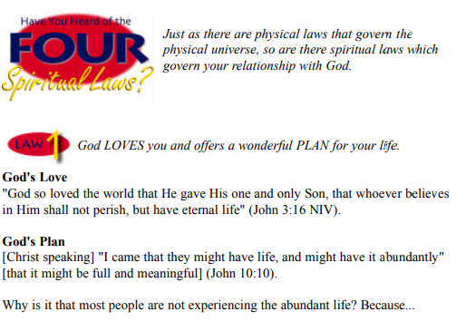

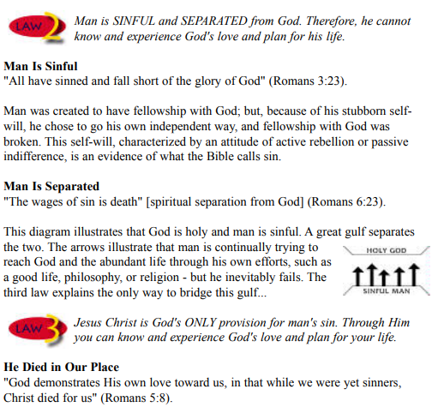

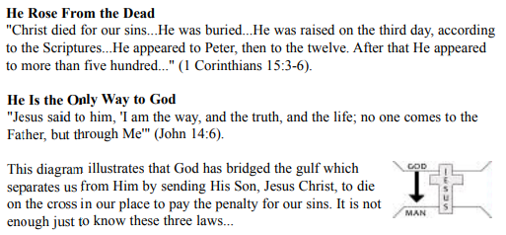

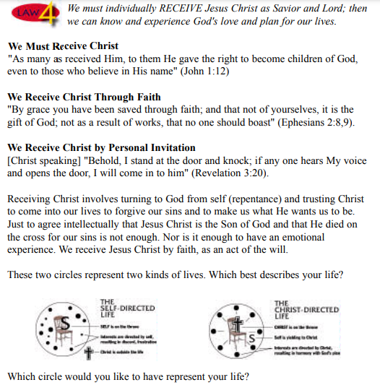

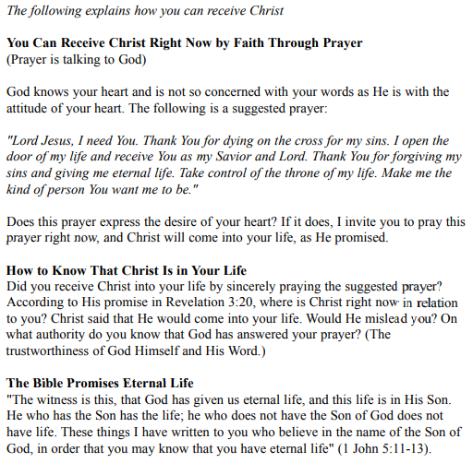

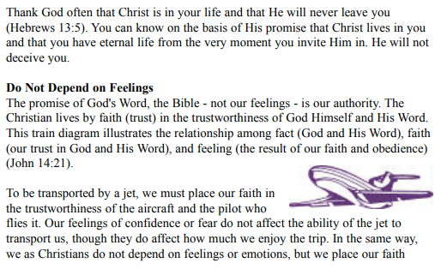

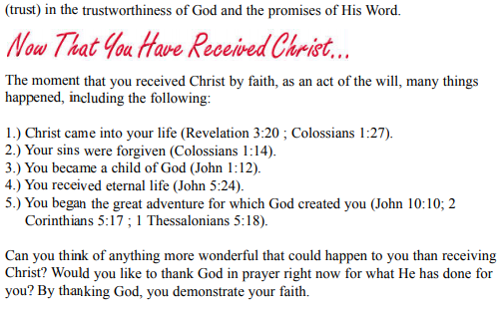

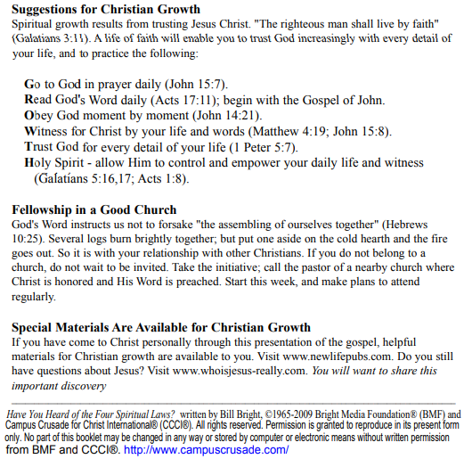

If you accepted Christ Acts 2:42 Ministries would love to know. Or if you have anything to share about these worksheets please let us know. [nathand@242ministries.org](mailto:nathand@242ministries.org)

español:

<https://www.youtube.com/watch?v=NRUqXwqTA8w>



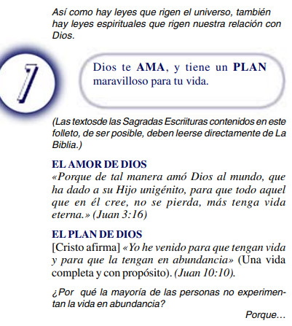

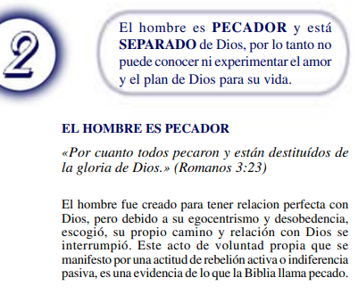

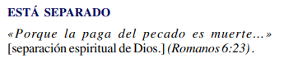

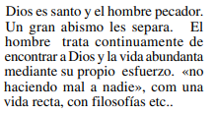

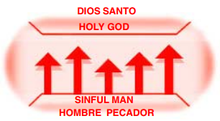



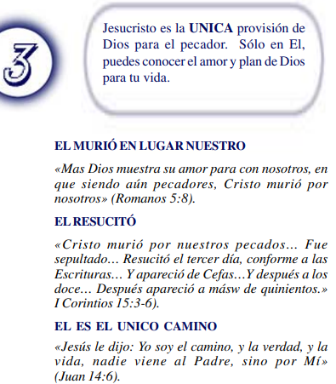

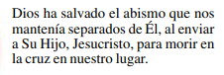

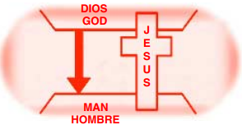



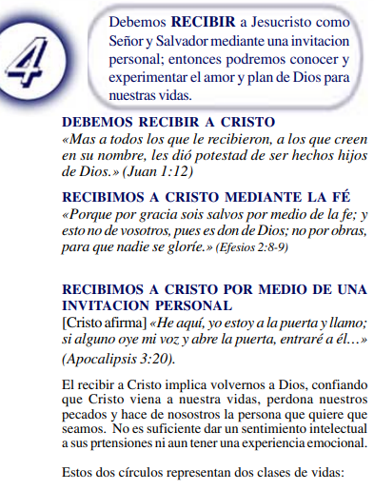

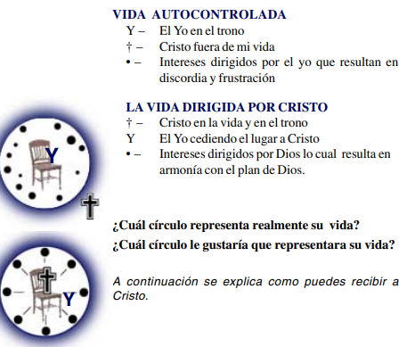

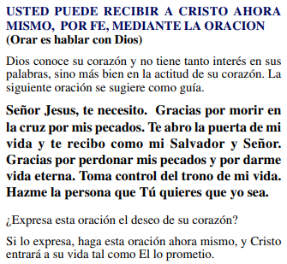

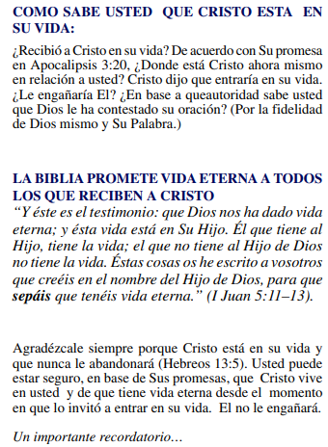

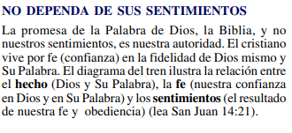

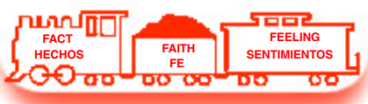

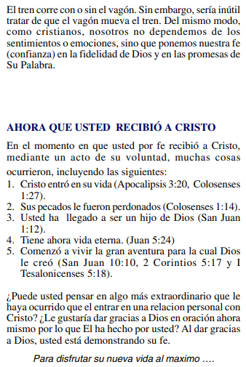

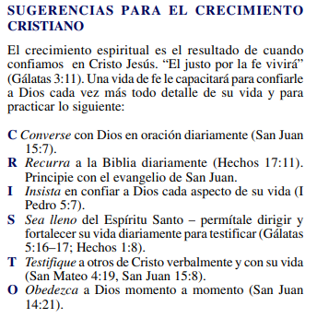

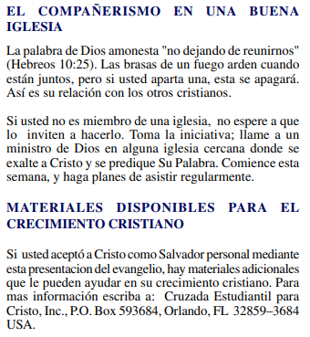

(Si aceptaste a Cristo Hechos 2:42 a Ministerios le encantaría saberlo. O si tiene algo que compartir sobre estas hojas de trabajo, háganoslo saber.)

[nathand@242ministries.org](mailto:nathand@242ministries.org)

عربى:

<https://www.youtube.com/watch?v=ePa_MElCi68>

<https://www.youtube.com/watch?v=o0GFYMPArW0>







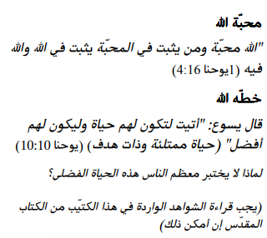

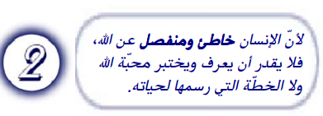

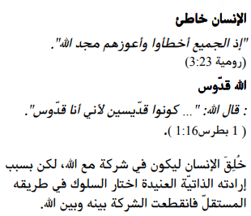

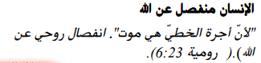

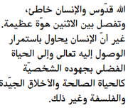

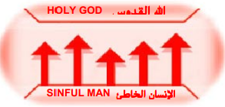



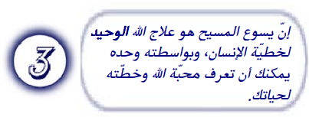

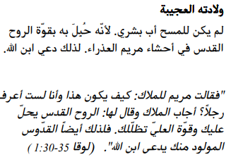

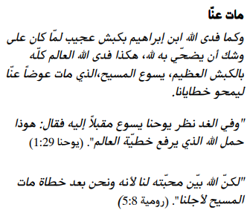

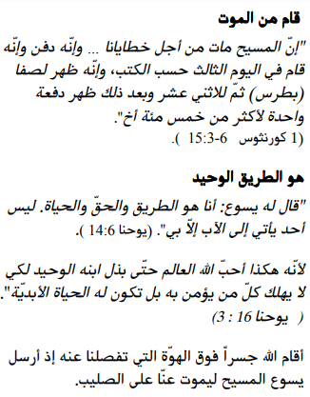

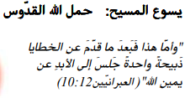

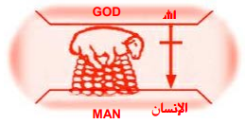





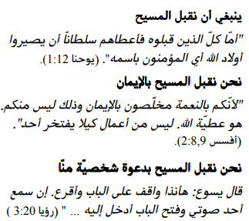

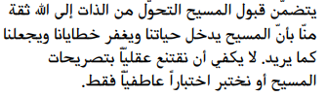



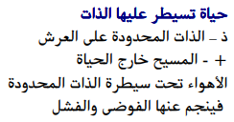

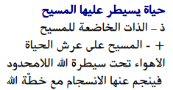

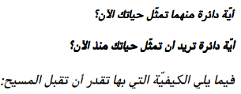

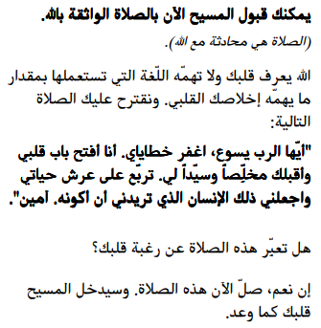

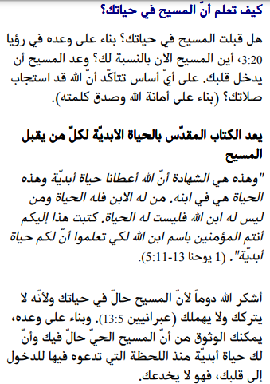

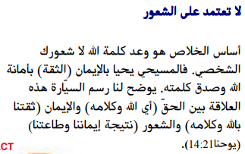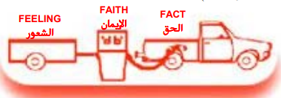

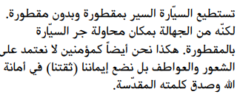

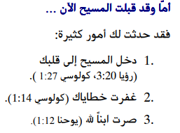

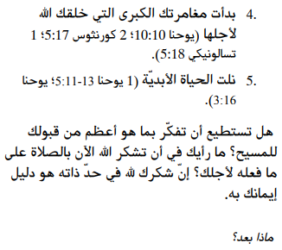

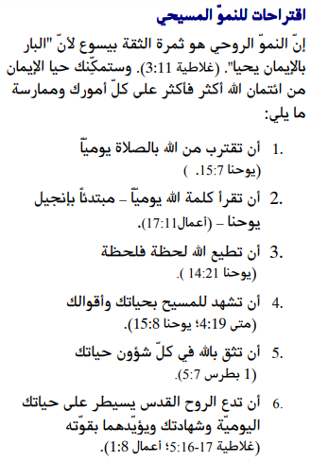

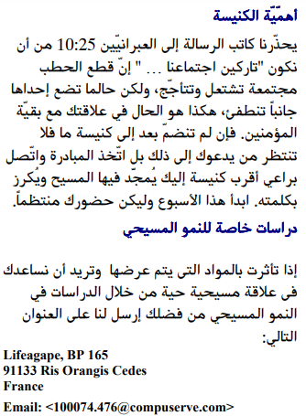

إذا قبلت المسيح فإن الخدمات تحب أن تعرف. أو إذا كان لديك أي شيء تريد مشاركته حول أوراق العمل هذه ، فيرجى إخبارنا بذلك.

[nathand@242ministries.org](mailto:nathand@242ministries.org)

فارسی:<https://www.youtube.com/watch?v=eWLsQ0DTsq0&t=12s>



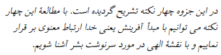



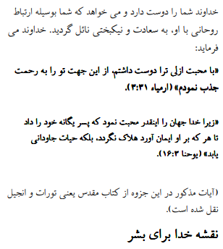

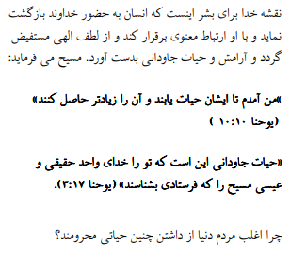



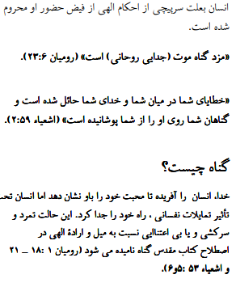

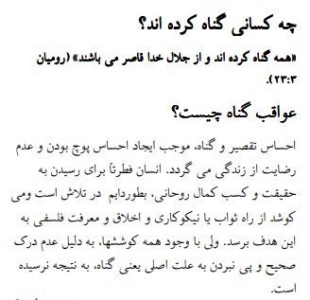

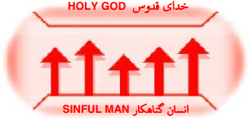





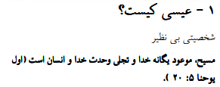

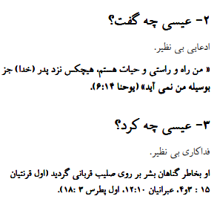

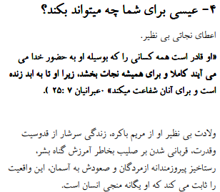

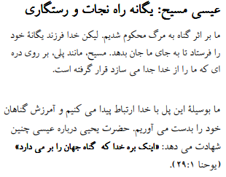

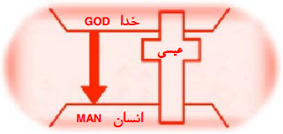





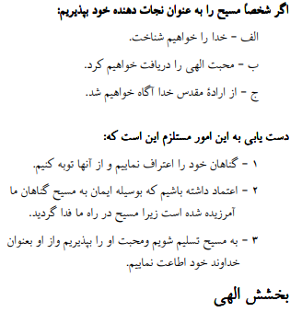

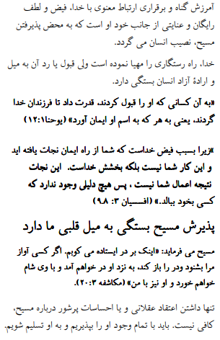

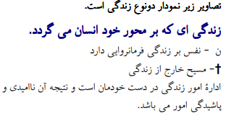



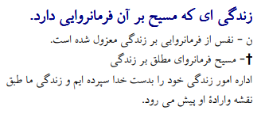



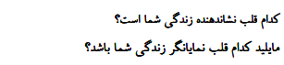

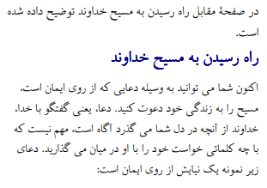

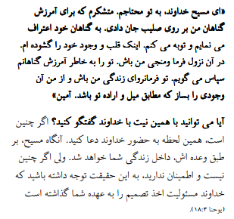

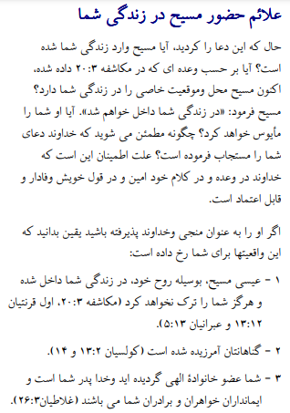

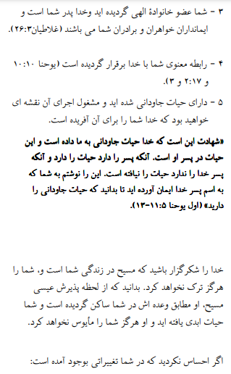

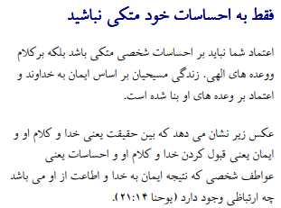

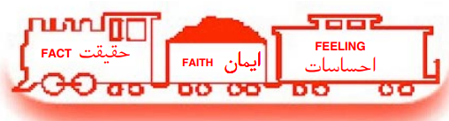

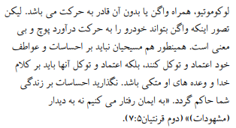

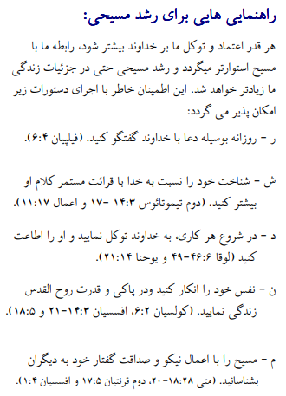

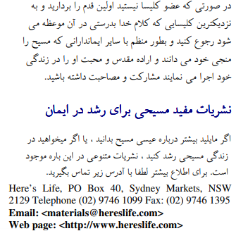

اگر مسیح را پذیرفتید اعمال رسولان 2:42 وزارتخانه ها دوست دارند بدانند. یا اگر چیزی برای به اشتراک گذاشتن در مورد این کاربرگ ها دارید ، لطفاً به ما اطلاع دهید

[nathand@242ministries.org](mailto:nathand@242ministries.org)

اردو:

<https://www.youtube.com/watch?v=6-GclzuUbxY>

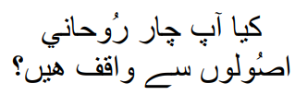

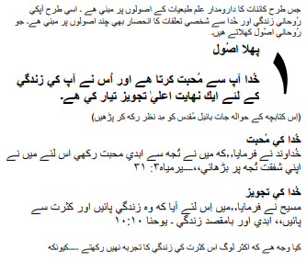

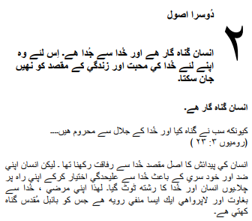

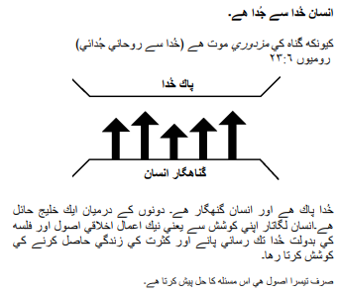

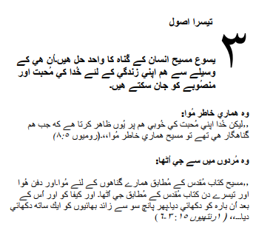

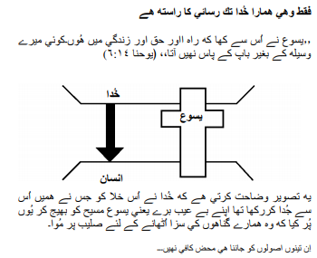

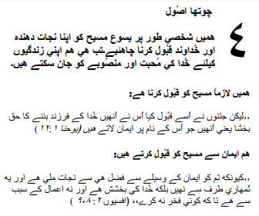

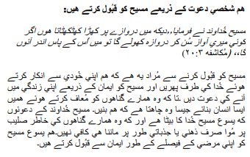

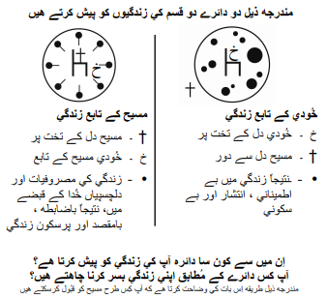

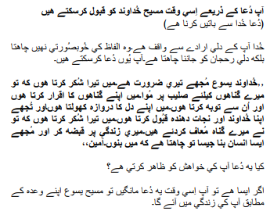

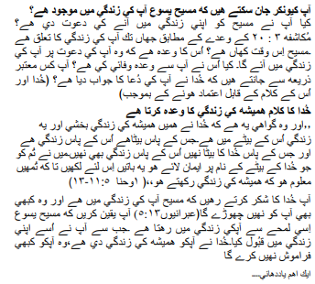

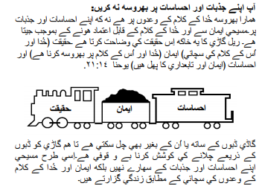

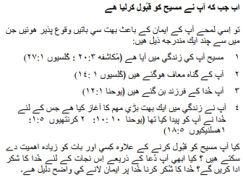

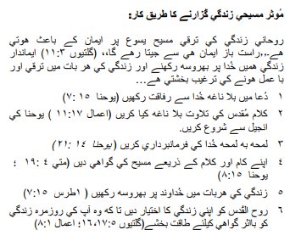

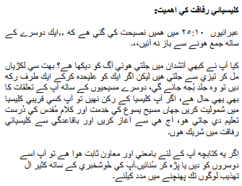

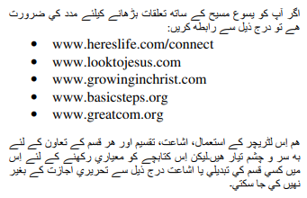

اگر آپ نے مسیح کے اعمال کو قبول کیا تو 2:42 وزارتیں جاننا پسند کریں گی۔ یا اگر آپ کے پاس ان ورک شیٹس کے بارے میں کچھ شیئر کرنا ہے تو براہ کرم ہمیں بتائیں۔

[nathand@242ministries.org](mailto:nathand@242ministries.org)

Türk:

<https://www.youtube.com/watch?v=6YwHd_PwOOQ>







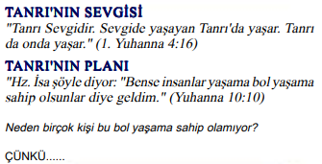



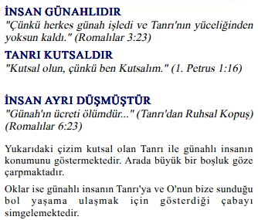

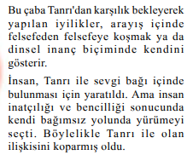

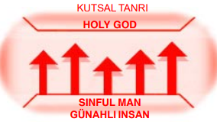





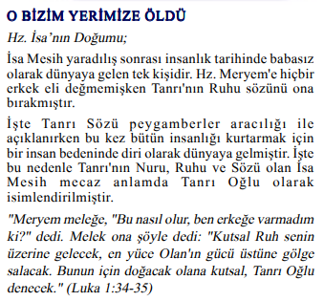



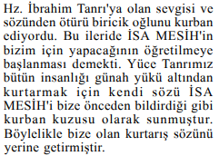

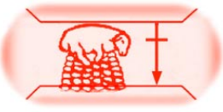

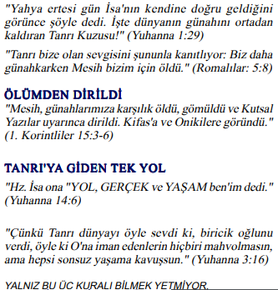

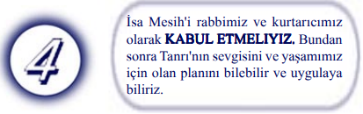

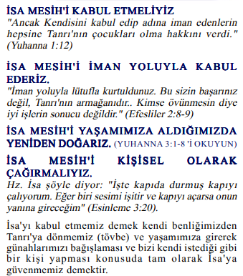

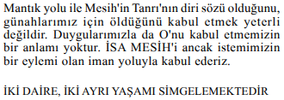

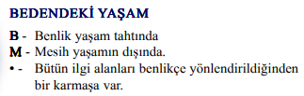

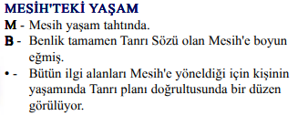

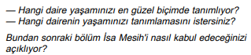

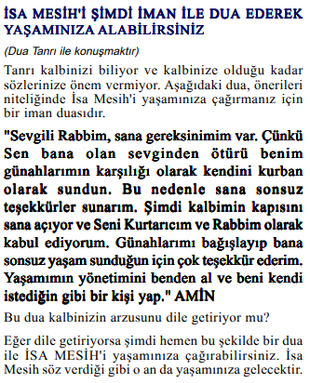

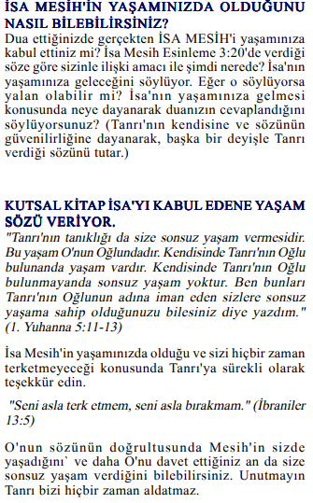

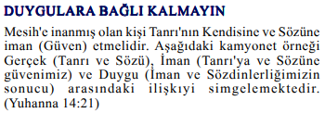



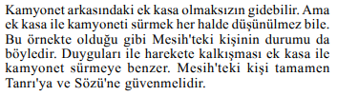

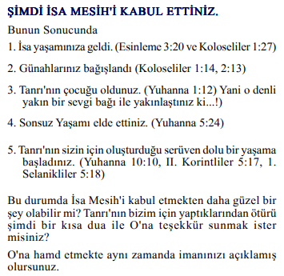

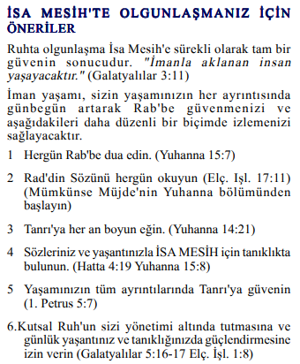

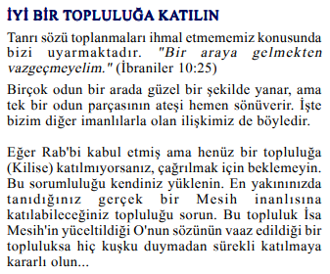

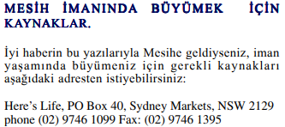

Mesih'in Elçilerinin İşleri 2:42'yi kabul ettiyseniz, Bakanlıklar bilmek ister. Veya bu çalışma sayfaları hakkında paylaşmak istediğiniz bir şey varsa lütfen bize bildirin.

[nathand@242ministries.org](mailto:nathand@242ministries.org)

हिंदी:

<https://www.youtube.com/watch?v=NR7AieVQI2A>

<https://www.youtube.com/watch?v=nmHla8doL5o>

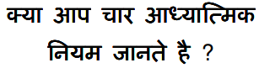

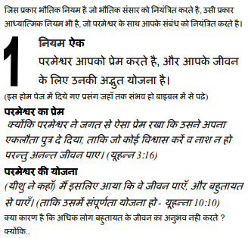

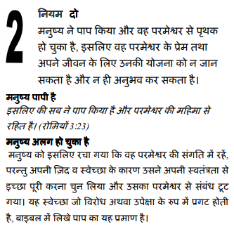

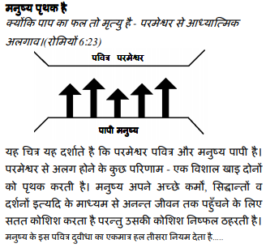

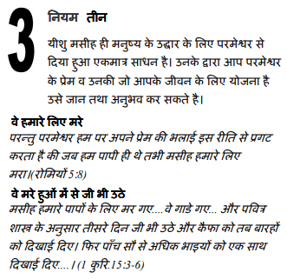

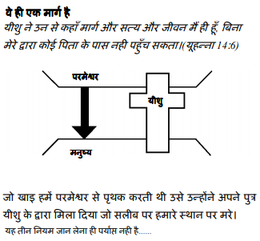

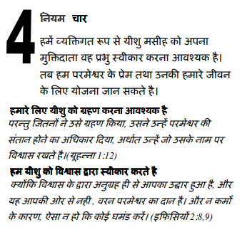

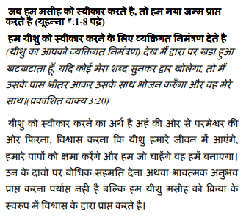

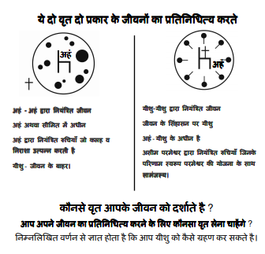

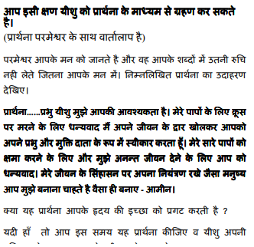

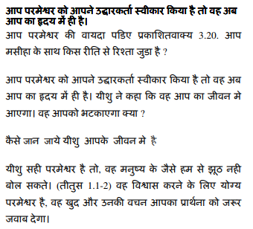

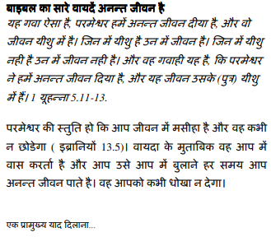

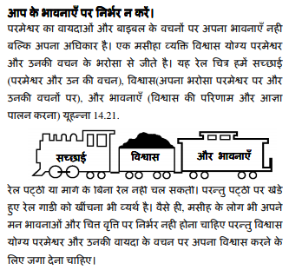

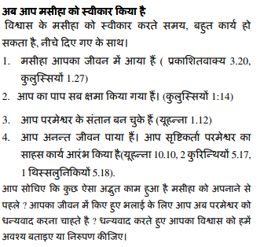

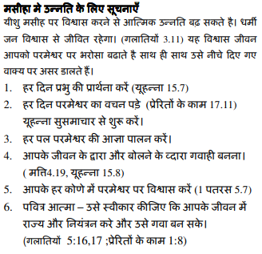

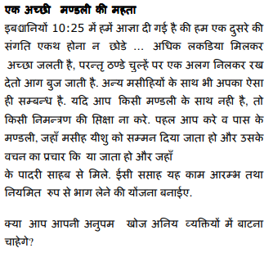

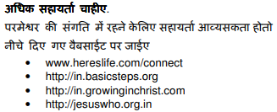

यदि आप मसीह के कामों को स्वीकार करते हैं प्रेरितों 2:42 मंत्रालयों को जानना अच्छा लगेगा। या यदि आपके पास इन कार्यपत्रकों के बारे में साझा करने के लिए कुछ है तो कृपया हमें बताएं।

[nathand@242ministries.org](mailto:nathand@242ministries.org)

中国人:

<https://www.youtube.com/watch?v=ebaT4PvcUEc>









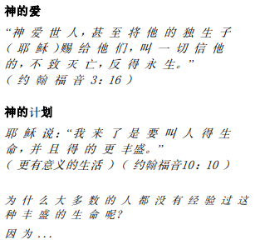



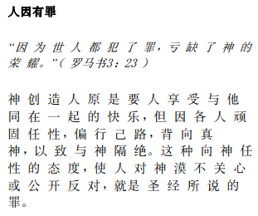

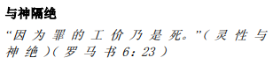

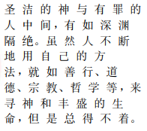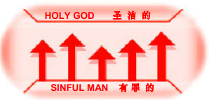





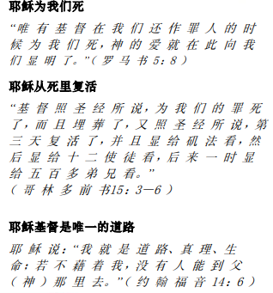

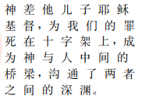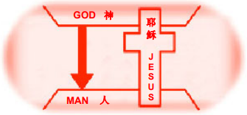





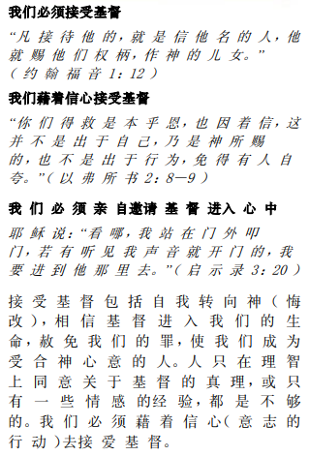

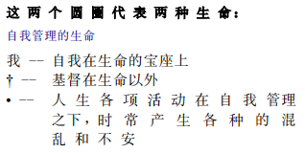

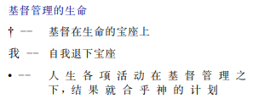

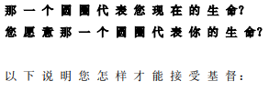

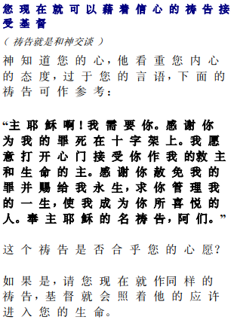

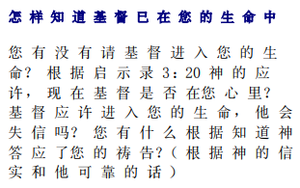

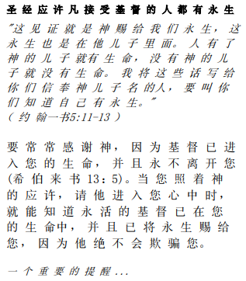

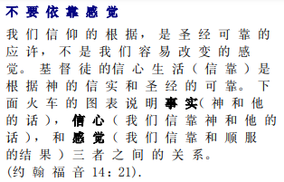

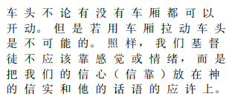

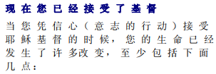

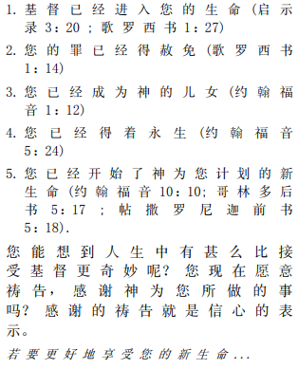

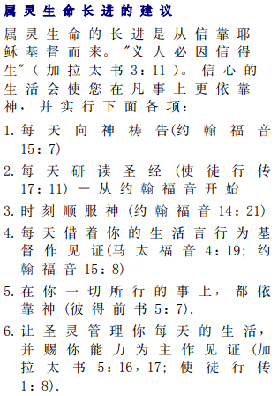

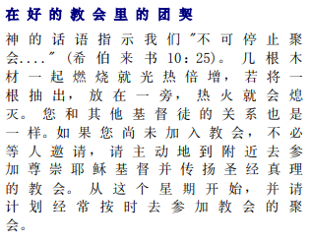



如果你接受基督使徒行传 2:42 事工很想知道。或者，如果您对这些工作表有任何要分享的内容，请告诉我们。

[nathand@242ministries.org](mailto:nathand@242ministries.org)