Lesson 1 – Personal pronouns

(Lección 1- pronombres personales)

|  |  |  |
| --- | --- | --- |
| **English** | **español** | **Foto** |
| I | Yo | Boy Young Stand - Free vector graphic on Pixabay |
| You (Singular) | Tú | Royalty-Free photo: Man wearing polo shirt while woman wearing ... |
| He/She | Él/Ella/Usted | Royalty-free self-portrait photos free download | Pxfuel |
| We | Nosotros | We pronoun | Public domain vectors |
| You (plural) | Vosotros | Pronoun you | Public domain vectors |
| They | Ellos/Ellas/Ustedes | C:\Users\natha\Desktop\pronoun-they.jpg |

Label the personal pronoun

(Etiqueta el pronombre personal)

|  |  |  |
| --- | --- | --- |
| **Number**  (número) | **Picture (imagen)** | **Answer (Responder)** |
| 1 | Pronoun-you-singular-no-text | Free SVG |  |
| 2 |  |  |
| 3 | C:\Users\natha\Desktop\download.png |  |
| 4 | Diverse Group Discussion | Free SVG |  |
| 5 | You Finger Pointing - Free image on Pixabay |  |

Answers on next page (respuestas en la página siguiente)

1. He
2. They
3. I
4. We
5. You

Pick the right pronoun

(Elige el pronombre correcto )

|  |  |
| --- | --- |
| 1. Marco is watching TV. 2. Royalty-free watching tv photos free download | PxfuelHe 3. She 4. I | 1. Maria likes to swim. 2. swim, waters, swimmer, wet, pool, swimming, one person, water ...She 3. They 4. He |
| 1. The man and woman eat food. 2. Couple Eating Rice | Free SVGHe 3. We 4. They | 1. My sister and I dance. 2. C:\Users\natha\Desktop\download.jpgShe 3. We 4. You |
| 1. Karen rides her bike. 2. Free photo Woman Riding Bicycle Helmet Cycle Sport Rider - Max PixelShe 3. He 4. I | 1. Girl running vector drawing | Public domain vectorsSophia runs fast. 2. He 3. She 4. We |

Answers on next page (respuestas en la página siguiente)

1. He
2. She
3. They
4. We
5. She
6. She

Fill in the blank with the correct personal pronoun – More Difficult

(Complete el espacio en blanco con el pronombre personal correcto -   
Más difícil)

1. How old are _____________________ Emily?
2. Bob and Bart are friends. ________________________ are 5.
3. My name is John. ________________ am a boy.
4. Kim is a girl. ___________________ likes cats.
5. Tyler and I are friends. __________________ like dogs.
6. Jim is a boy. ___________ likes food.

Answers on next page (respuestas en la página siguiente)

1. you
2. They
3. I
4. She
5. We
6. He

To try at home (Para probar en casa)

1. Easier - Practice naming people in your family with personal pronouns. (Más fácil - Practique nombrar a diferentes personas de su familia con pronombres personales.)
2. More difficult - Think of a situation for each of the personal pronouns and try to make a sentence. For instance, use I in the sentence “I am cleaning.” Use a translator to figure out the English word if you don’t know it.

(Más difícil - Piense en una situación para cada uno de los pronombres personales y trate de formar una oración. Por ejemplo, use I en la oración "Estoy limpiando". Utilice un traductor para averiguar la palabra en inglés si no la conoce.)

**Please consider donating to Acts 2:42 Ministries (**[**https://www.paypal.com/fundraiser/charity/213230**](https://www.paypal.com/fundraiser/charity/213230)**) to support the free English lessons. Thank you!**

Considere hacer una donación a Acts 2:42 Ministries (<https://www.paypal.com/fundraiser/charity/213230>) para apoyar las lecciones de inglés gratuitas. ¡Gracias!

How do I get to heaven?

¿Cómo llego al cielo?

كيف أصل إلى الجنة؟

[چگونه به بهشت ​​برسم؟](#فارسی" \o "فارسی)

میں جنت میں کیسے جاؤں؟

[Cennete nasıl gidebilirim?](#Türk" \o "Türk)

[मैं स्वर्ग कैसे पहुँचूँ?](#हिंदी" \o "हिंदी)

我怎样才能上天堂？

English:

<https://peacewithgod.net/>

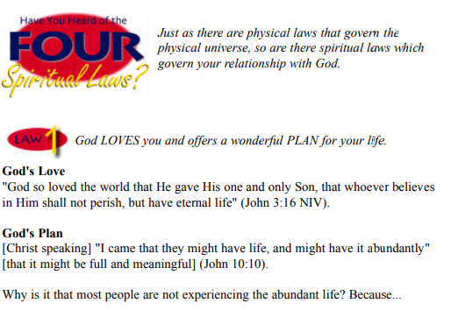

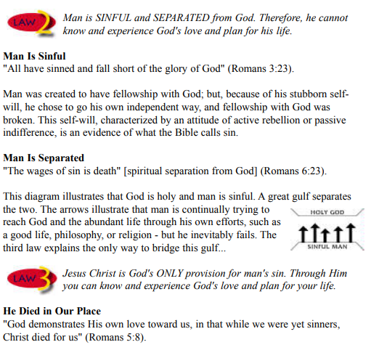

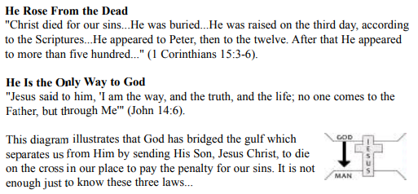

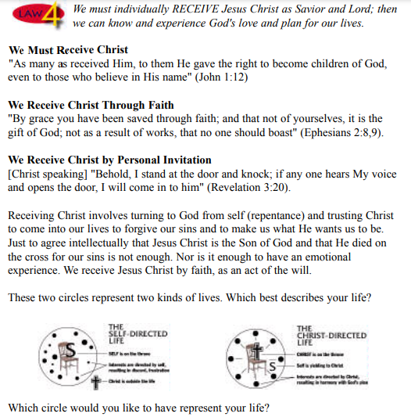

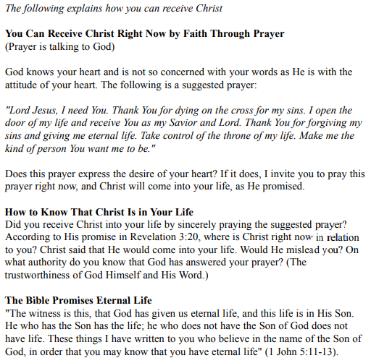

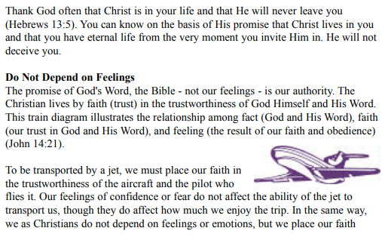

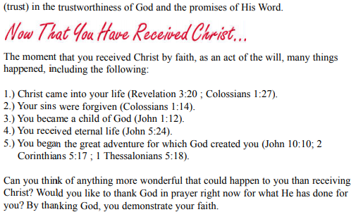

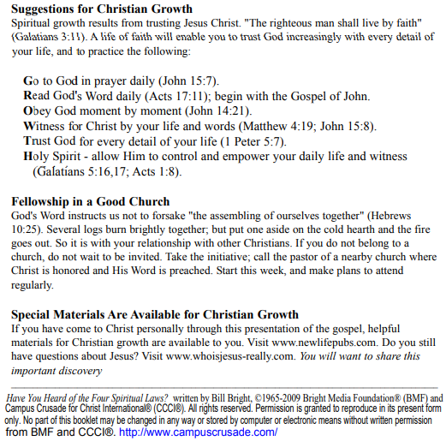

If you accepted Christ Acts 2:42 Ministries would love to know. Or if you have anything to share about these worksheets please let us know. [nathand@242ministries.org](mailto:nathand@242ministries.org)

español:

<https://www.youtube.com/watch?v=NRUqXwqTA8w>



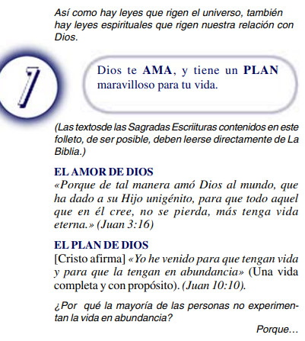

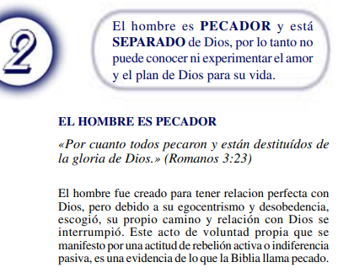

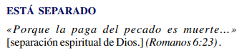

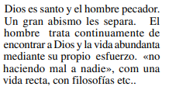

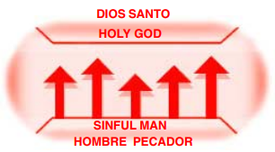



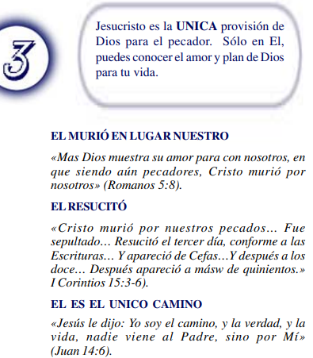

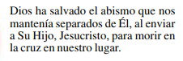

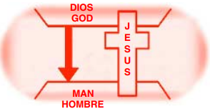



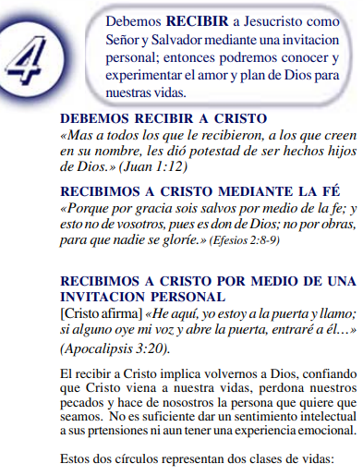

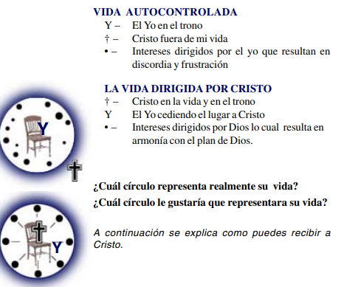

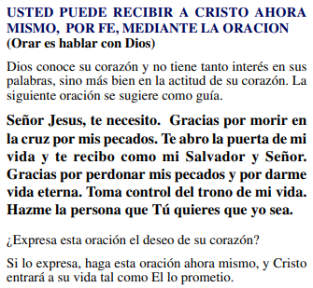

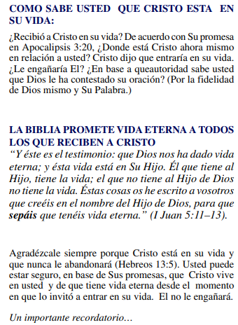

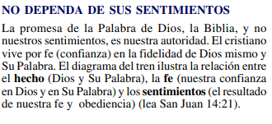

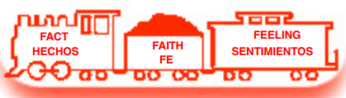

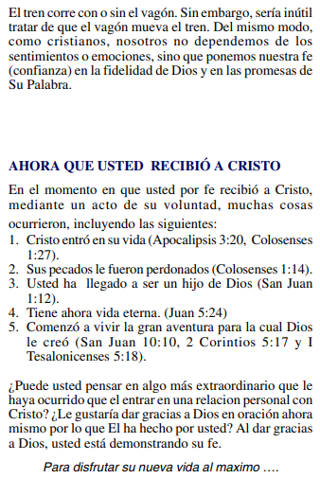

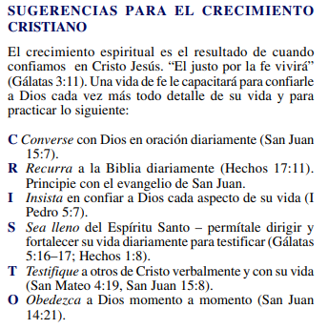

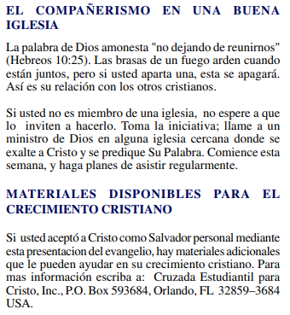

(Si aceptaste a Cristo Hechos 2:42 a Ministerios le encantaría saberlo. O si tiene algo que compartir sobre estas hojas de trabajo, háganoslo saber.)

[nathand@242ministries.org](mailto:nathand@242ministries.org)

عربى:

<https://www.youtube.com/watch?v=ePa_MElCi68>

<https://www.youtube.com/watch?v=o0GFYMPArW0>







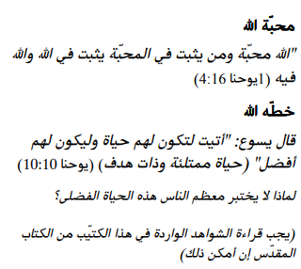

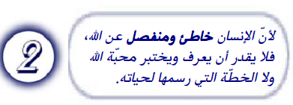

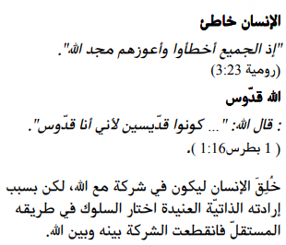

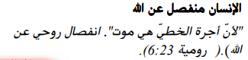

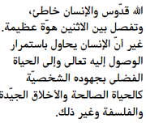

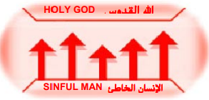



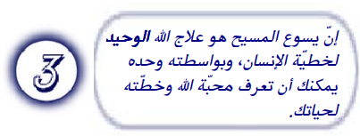

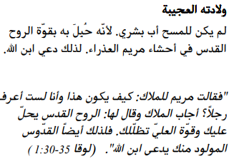

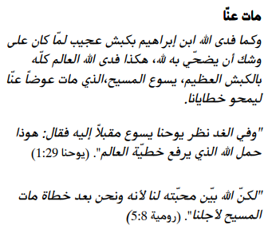

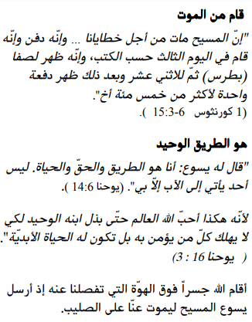

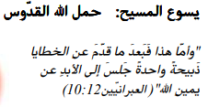

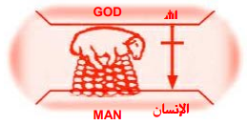





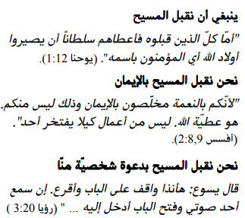

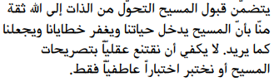



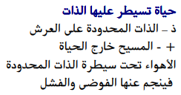

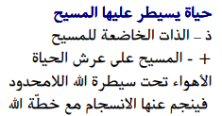

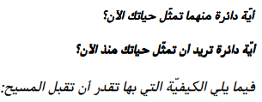

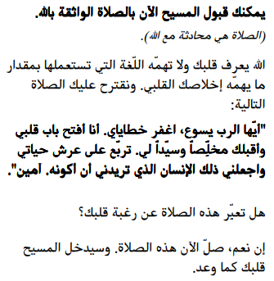

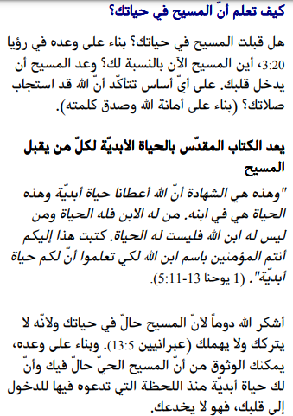

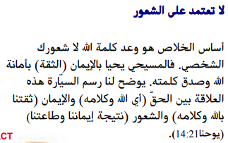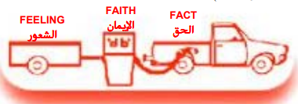

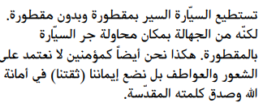

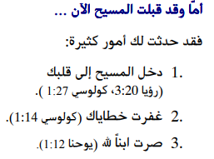

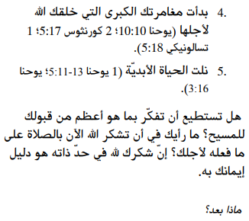

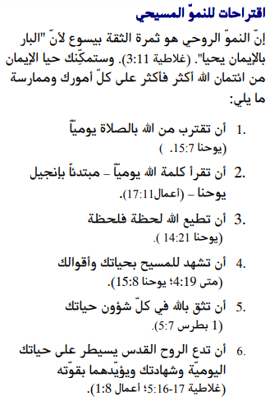

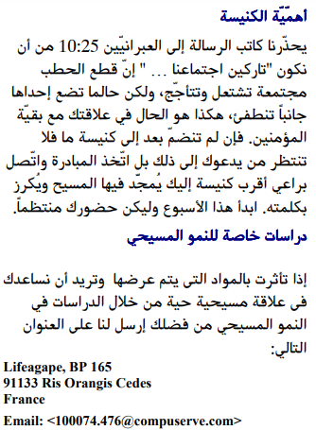

إذا قبلت المسيح فإن الخدمات تحب أن تعرف. أو إذا كان لديك أي شيء تريد مشاركته حول أوراق العمل هذه ، فيرجى إخبارنا بذلك.

[nathand@242ministries.org](mailto:nathand@242ministries.org)

فارسی:<https://www.youtube.com/watch?v=eWLsQ0DTsq0&t=12s>



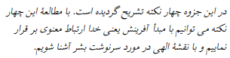



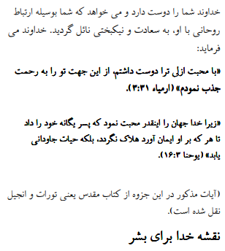

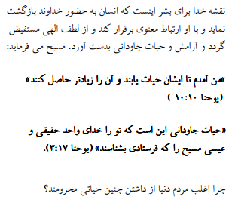



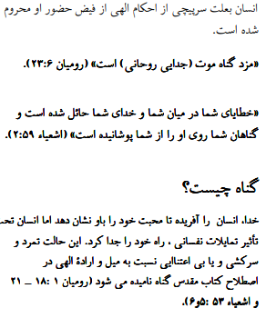

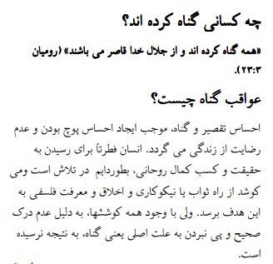

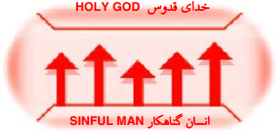





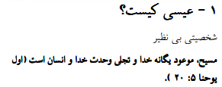

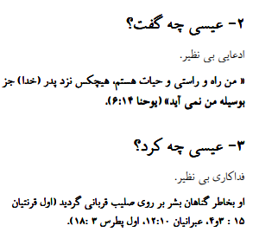

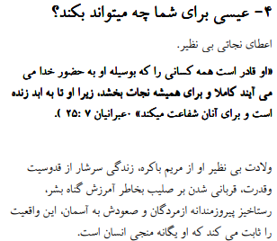

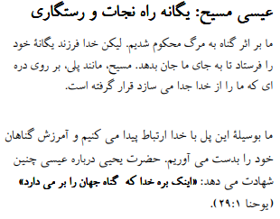

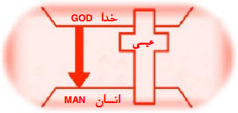





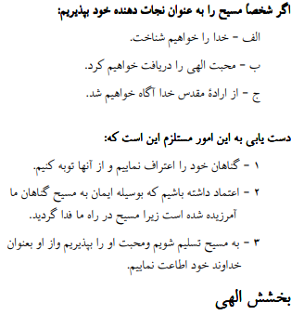

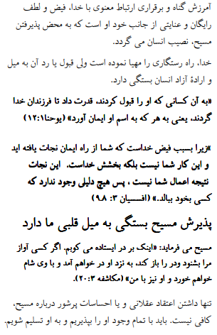

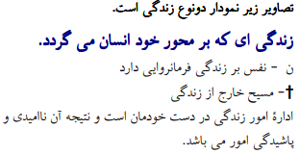



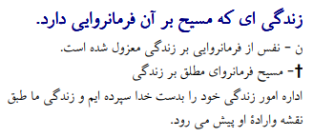





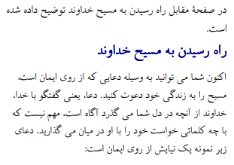

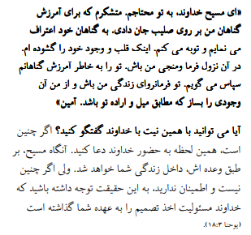

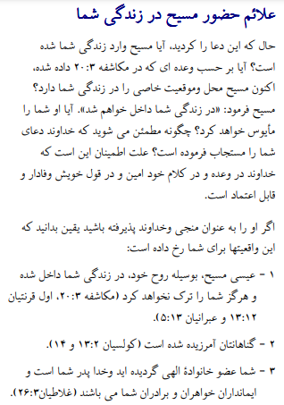

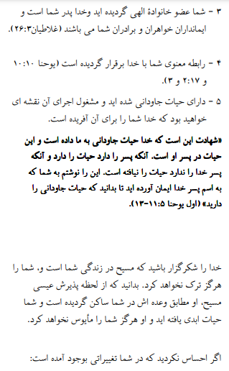

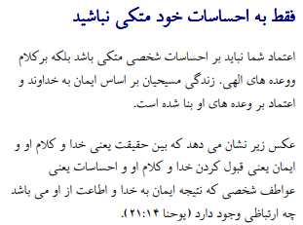

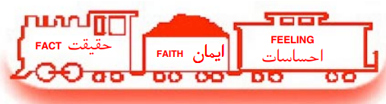

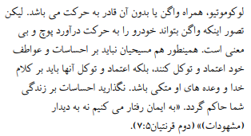

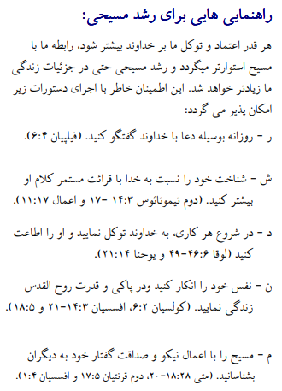

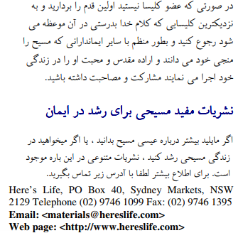

اگر مسیح را پذیرفتید اعمال رسولان 2:42 وزارتخانه ها دوست دارند بدانند. یا اگر چیزی برای به اشتراک گذاشتن در مورد این کاربرگ ها دارید ، لطفاً به ما اطلاع دهید

[nathand@242ministries.org](mailto:nathand@242ministries.org)

اردو:

<https://www.youtube.com/watch?v=6-GclzuUbxY>

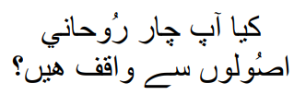

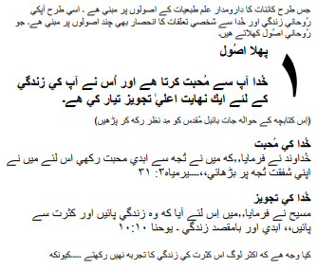

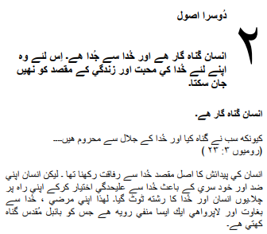

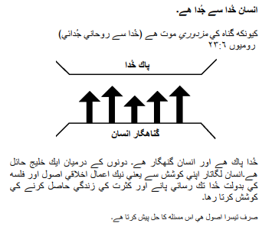

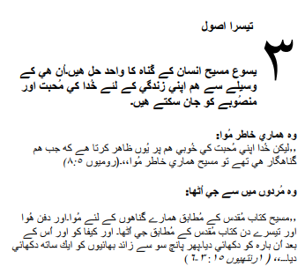

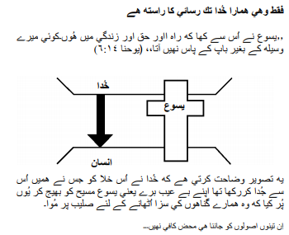

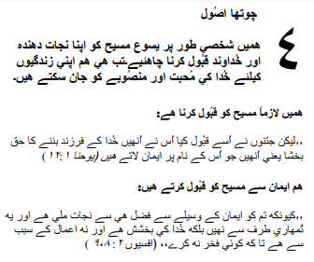

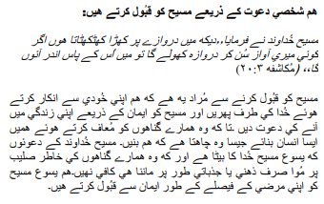

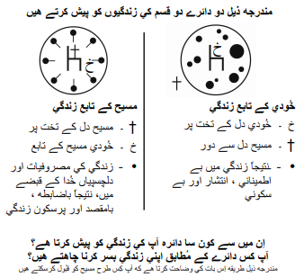

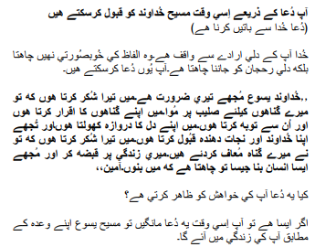

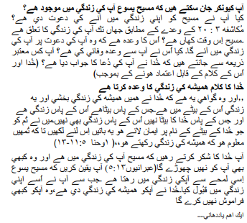

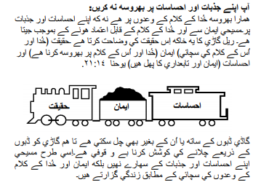

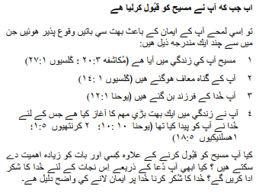

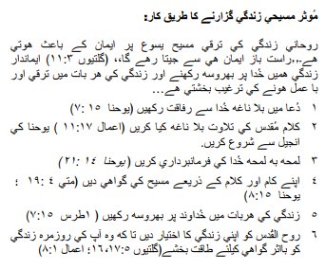

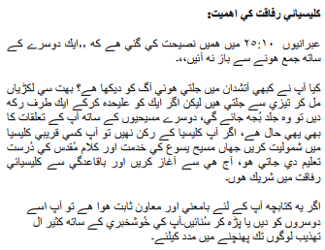

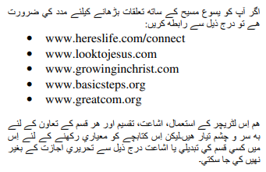

اگر آپ نے مسیح کے اعمال کو قبول کیا تو 2:42 وزارتیں جاننا پسند کریں گی۔ یا اگر آپ کے پاس ان ورک شیٹس کے بارے میں کچھ شیئر کرنا ہے تو براہ کرم ہمیں بتائیں۔

[nathand@242ministries.org](mailto:nathand@242ministries.org)

Türk:

<https://www.youtube.com/watch?v=6YwHd_PwOOQ>





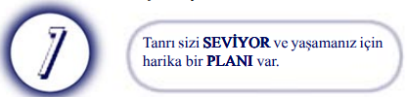

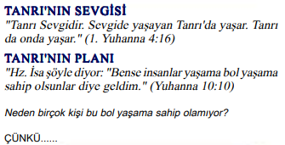

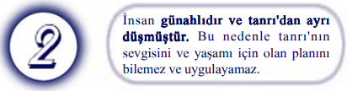

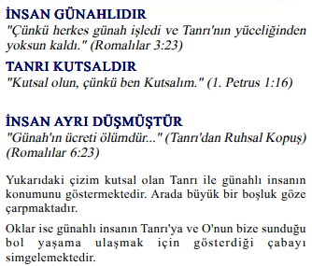

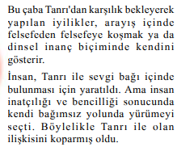

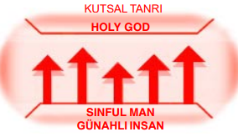



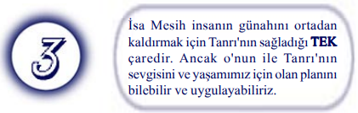

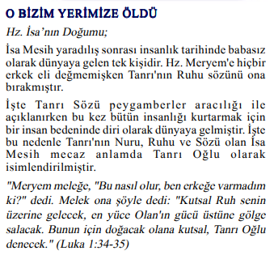



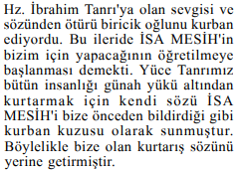

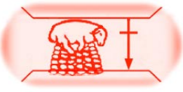

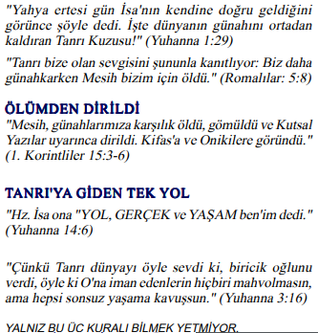

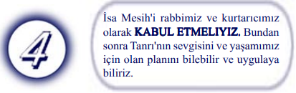

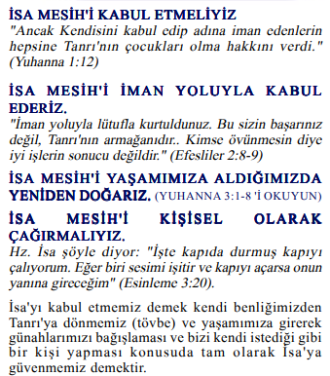

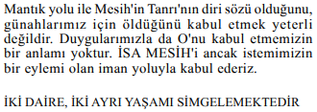

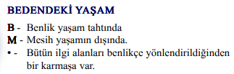

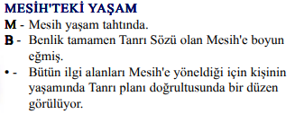

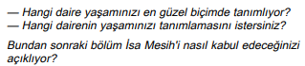

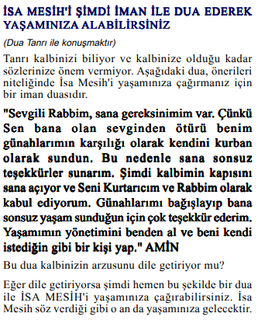

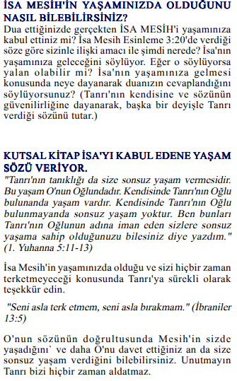

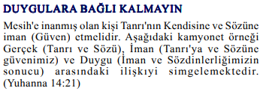



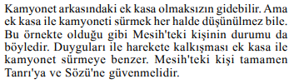

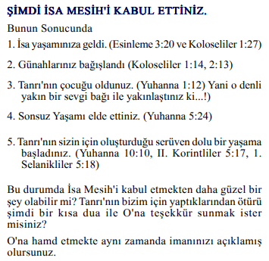

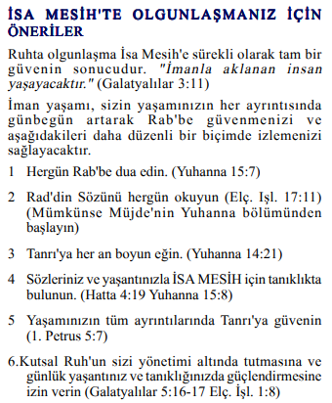

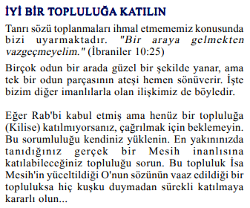

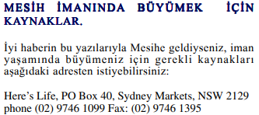

Mesih'in Elçilerinin İşleri 2:42'yi kabul ettiyseniz, Bakanlıklar bilmek ister. Veya bu çalışma sayfaları hakkında paylaşmak istediğiniz bir şey varsa lütfen bize bildirin.

[nathand@242ministries.org](mailto:nathand@242ministries.org)

हिंदी:

<https://www.youtube.com/watch?v=NR7AieVQI2A>

<https://www.youtube.com/watch?v=nmHla8doL5o>

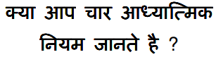

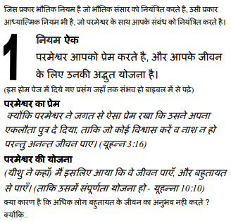

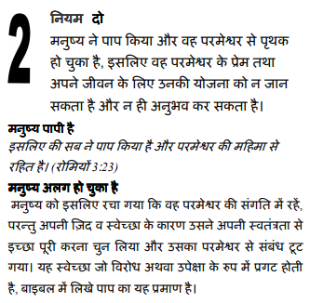

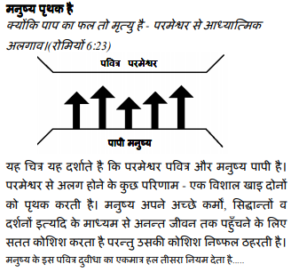

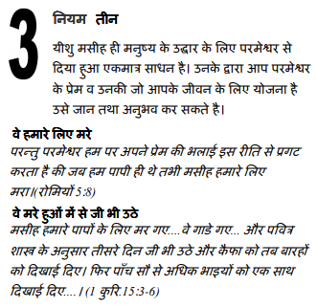

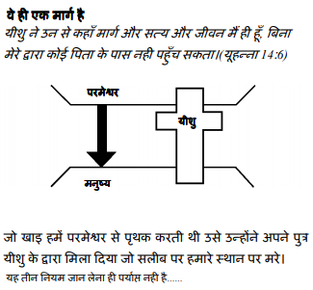

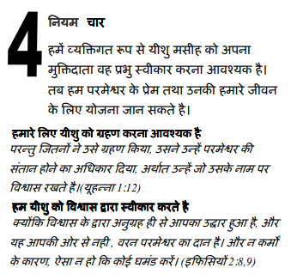

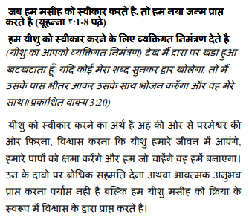

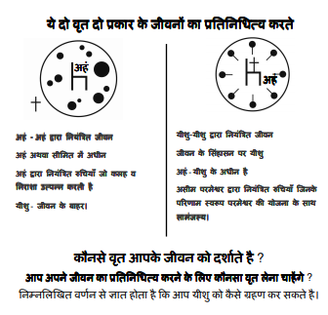

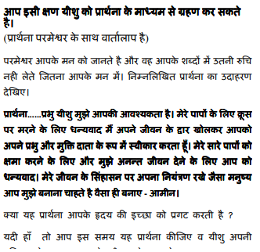

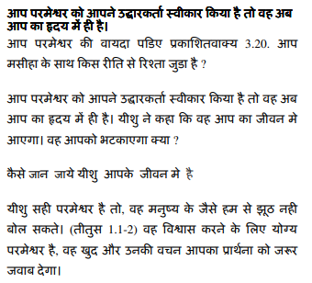

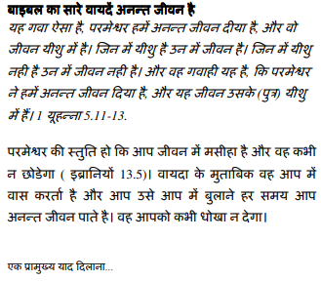

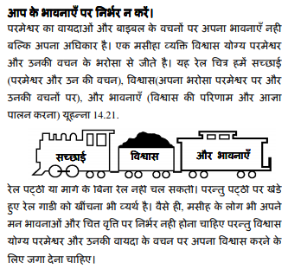

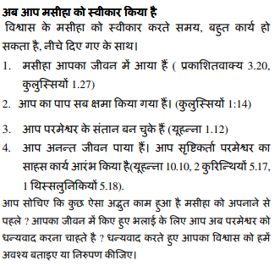

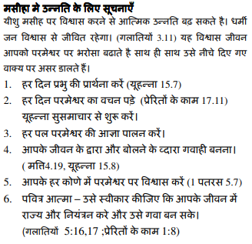

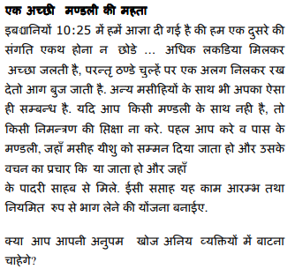

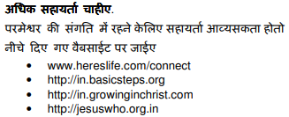

यदि आप मसीह के कामों को स्वीकार करते हैं प्रेरितों 2:42 मंत्रालयों को जानना अच्छा लगेगा। या यदि आपके पास इन कार्यपत्रकों के बारे में साझा करने के लिए कुछ है तो कृपया हमें बताएं।

[nathand@242ministries.org](mailto:nathand@242ministries.org)

中国人:

<https://www.youtube.com/watch?v=ebaT4PvcUEc>









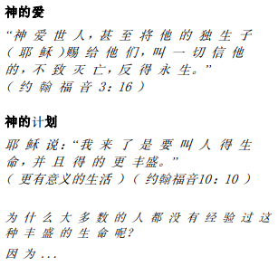



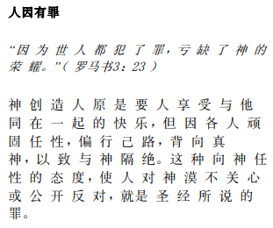

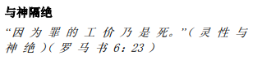

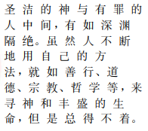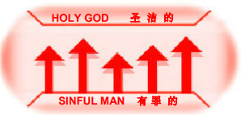





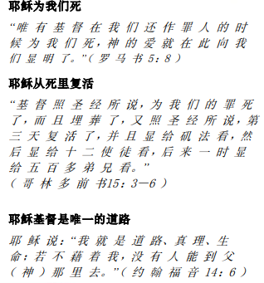

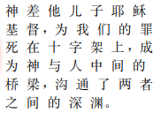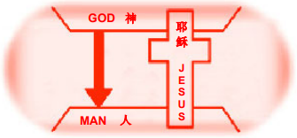





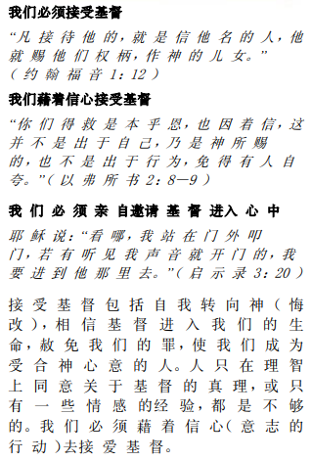

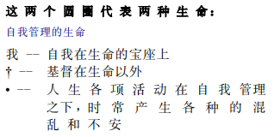

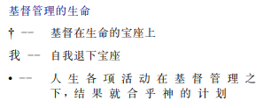

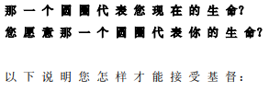

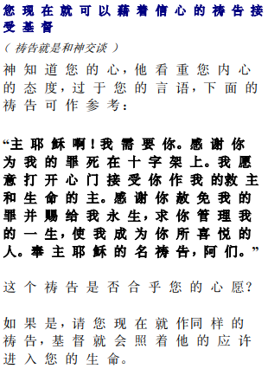

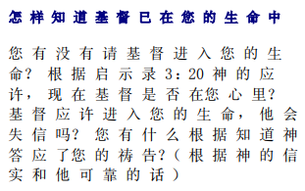

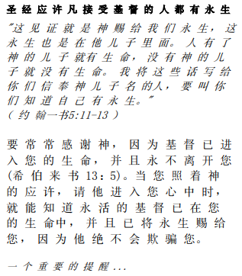

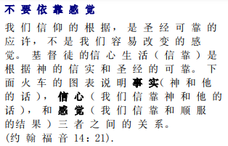

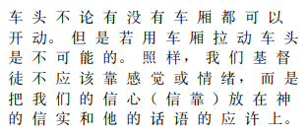

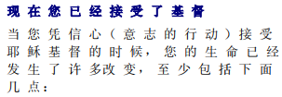

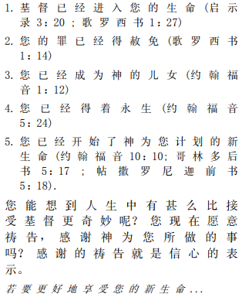

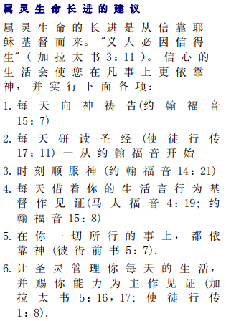

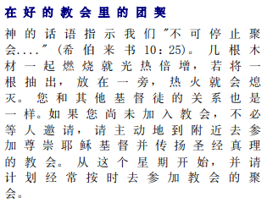



如果你接受基督使徒行传 2:42 事工很想知道。或者，如果您对这些工作表有任何要分享的内容，请告诉我们。

[nathand@242ministries.org](mailto:nathand@242ministries.org)