Lesson 3 – To be (am, is, are) part 1

(Lección 3 – Ser/Estar – parte 1)

|  |  |  |
| --- | --- | --- |
| **English** | **español** | **Foto** |
| I am | Yo soy  Yo estoy | Boy Young Stand - Free vector graphic on Pixabay |
| You (Singular) are | Tú eres  Tú estás | Royalty-Free photo: Man wearing polo shirt while woman wearing ... |
| He is  She is  It is | Él es OR Él está Ella es OR Ella está  Usted es/está  Es OR está | Royalty-free self-portrait photos free download | Pxfuel |
| We are | Nosotros somos  Nosotros estamos | We pronoun | Public domain vectors |
| You (plural) are | Vosotros sois  Vosotros estáis | Pronoun you | Public domain vectors |
| They are | Ellos son OR Ellos están  Ellas son OR Ellas están  Ustedes son/están  Son OR Están | C:\Users\natha\Desktop\pronoun-they.jpg |

Write the correct personal pronoun and am, is OR are

(Escriba el pronombre personal correcto y am, is, OR are)

|  |  |  |
| --- | --- | --- |
| **Number**  (número) | **Picture (imagen)** | **Answer (Responder)** |
| 1 | Pronoun-you-singular-no-text | Free SVG |  |
| 2 |  |  |
| 3 | C:\Users\natha\Desktop\download.png |  |
| 4 | Diverse Group Discussion | Free SVG |  |
| 5 | C:\Users\natha\Desktop\download (1).png |  |

Answers on next page (respuestas en la página siguiente)

1. He is
2. They are
3. I am
4. We are
5. You are

Pick the right answer for the underlined part

(Elija la respuesta correcta para la parte subrayada)

|  |  |
| --- | --- |
| 1. Marco is watching TV. 2. Royalty-free watching tv photos free download | PxfuelHe is 3. He are 4. I am | 1. Maria is swimming. 2. swim, waters, swimmer, wet, pool, swimming, one person, water ...She is 3. They are 4. He are |
| 1. The man and woman are eating food. 2. Couple Eating Rice | Free SVGHe are 3. We are 4. They are | 1. My sister and I are dancing. 2. C:\Users\natha\Desktop\download.jpgShe is 3. We is 4. We are |
| 1. Karen is riding her bike. 2. Free photo Woman Riding Bicycle Helmet Cycle Sport Rider - Max PixelShe am 3. She is 4. I am | 1. Girl running vector drawing | Public domain vectorsSophia is running fast. 2. She are 3. She is 4. We is |

Answers on next page (respuestas en la página siguiente)

1. He is
2. She is
3. They are
4. We are
5. She is
6. She is

Fill in the blanks with the am, is, or are and personal pronoun. – More Difficult

(Complete los espacios en blanco con am, is o are y pronombre personal. -   
Más difícil)

1. How old ___________ ____________ Emily?
2. Bob and Bart are friends. ____________ _________ 5.
3. My name is John. ________ _________ a boy.
4. Kim ______ a girl. ___________________ likes cats.
5. Tyler and I _______ friends. __________________ like dogs.
6. Jim ______ a boy. _______________ likes food.

Answers on next page (respuestas en la página siguiente)

1. are you
2. They are
3. I am
4. is, She
5. are, We
6. is, He

To try at home (Para probar en casa)

1. Easier - Practice naming different people in your family with personal pronouns and adding am, is, or are. (Más fácil - Practique nombrar a diferentes personas de su familia con pronombres personales y agregue am, is o are.)
2. More difficult - Think of a situation for each of the personal pronouns and use am, is, or are to make a sentence. For instance, use I in the sentence “I am cleaning.” Use a translator for the English word if you don’t know it.

(Más difícil - Piense en una situación para cada uno de los pronombres personales y use am, is o are para hacer una oración. Por ejemplo, use I en la oración "Estoy limpiando". Utilice un traductor para la palabra en inglés si no la conoce.)

**Please consider donating to Acts 2:42 Ministries (**<https://www.paypal.com/fundraiser/charity/213230>**) to support the free English lessons. Thank you!**

Considere hacer una donación a Acts 2:42 Ministries (<https://www.paypal.com/fundraiser/charity/213230>) para apoyar las lecciones de inglés gratuitas. ¡Gracias!

How do I get to heaven?

¿Cómo llego al cielo?

كيف أصل إلى الجنة؟

[چگونه به بهشت ​​برسم؟](#فارسی" \o "فارسی)

میں جنت میں کیسے جاؤں؟

[Cennete nasıl gidebilirim?](#Türk" \o "Türk)

[मैं स्वर्ग कैसे पहुँचूँ?](#हिंदी" \o "हिंदी)

我怎样才能上天堂？

English:

<https://peacewithgod.net/>

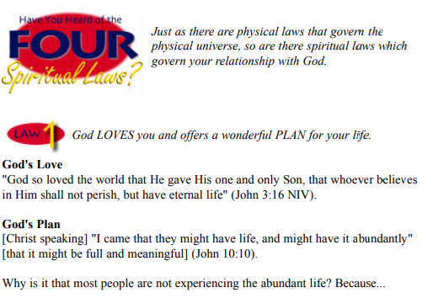

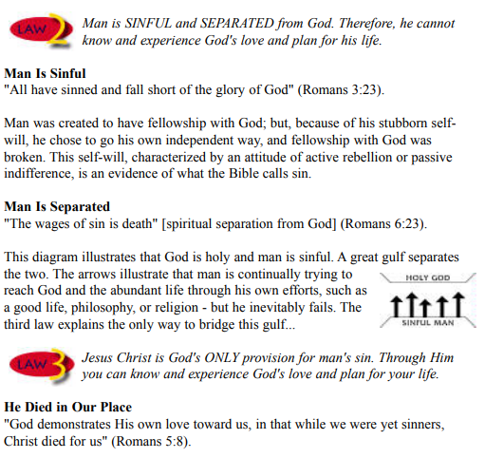

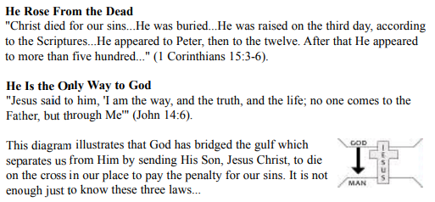

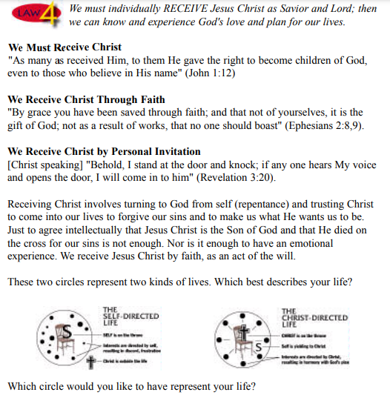

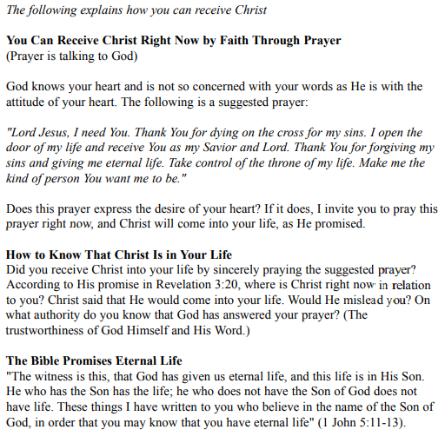

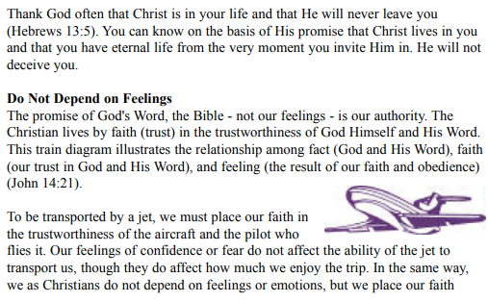

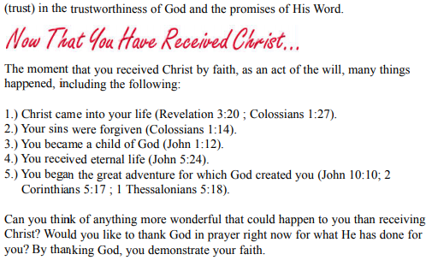

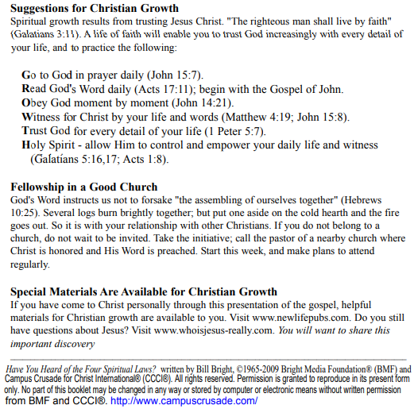

If you accepted Christ Acts 2:42 Ministries would love to know. Or if you have anything to share about these worksheets please let us know. [nathand@242ministries.org](mailto:nathand@242ministries.org)

español:

<https://www.youtube.com/watch?v=NRUqXwqTA8w>



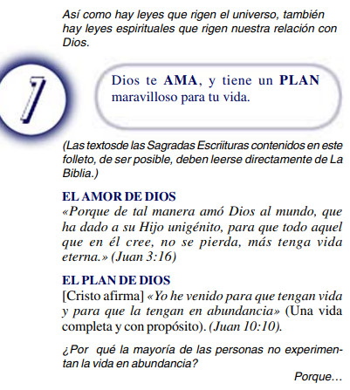

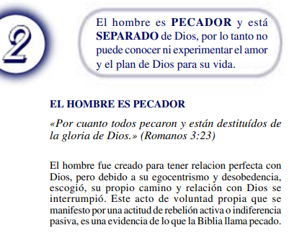

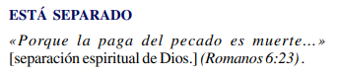

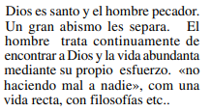

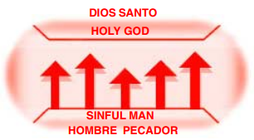



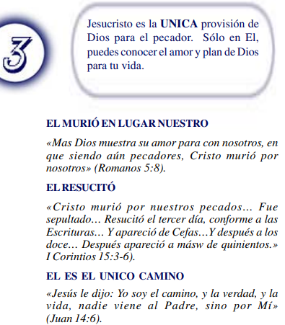

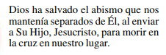

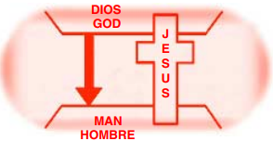



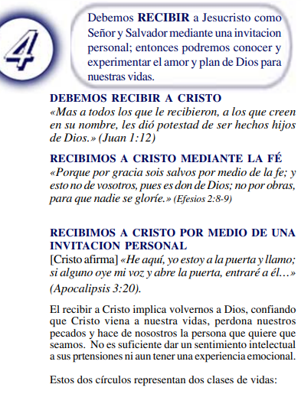

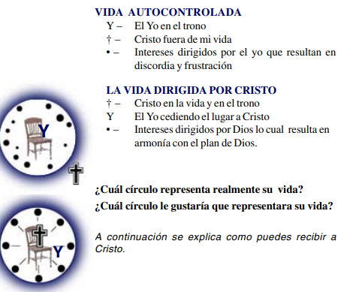

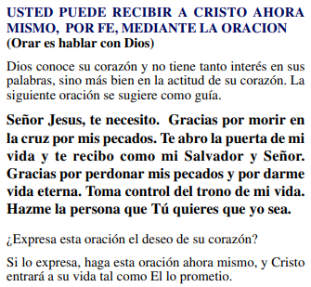

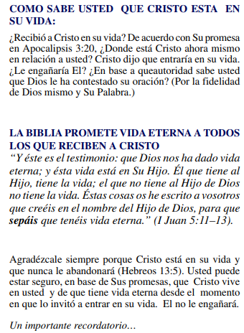

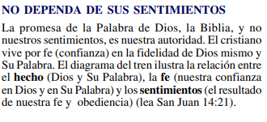

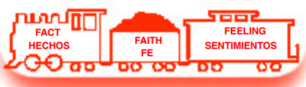

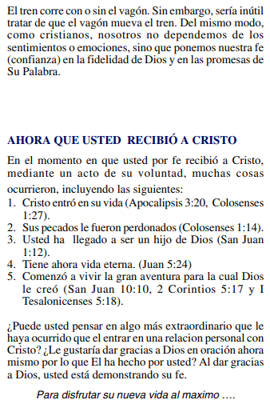

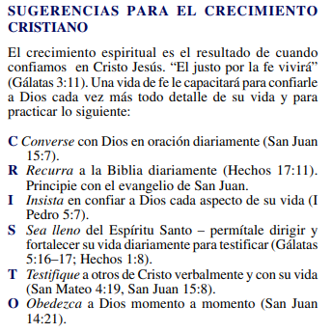

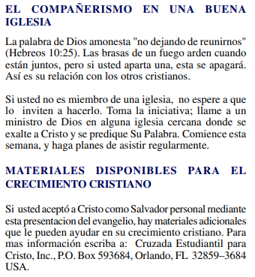

(Si aceptaste a Cristo Hechos 2:42 a Ministerios le encantaría saberlo. O si tiene algo que compartir sobre estas hojas de trabajo, háganoslo saber.)

[nathand@242ministries.org](mailto:nathand@242ministries.org)

عربى:

<https://www.youtube.com/watch?v=ePa_MElCi68>

<https://www.youtube.com/watch?v=o0GFYMPArW0>





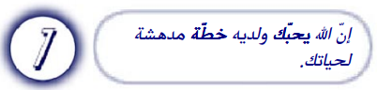

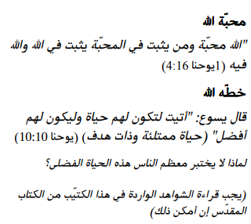

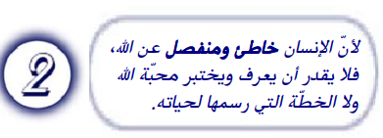

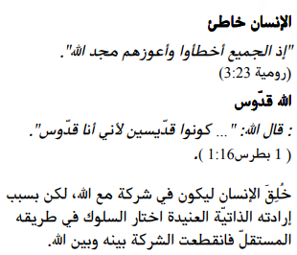

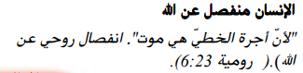

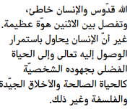

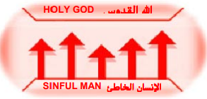



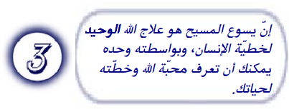

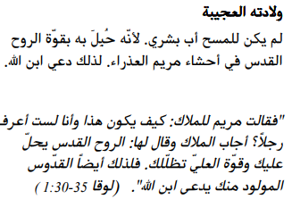

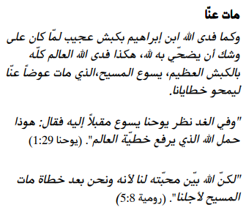

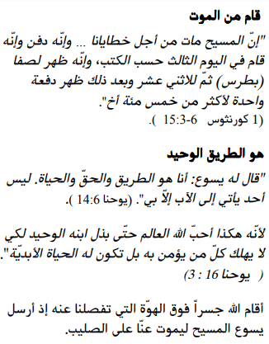

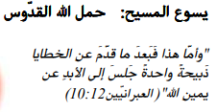

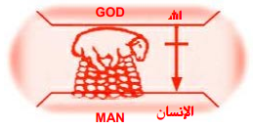





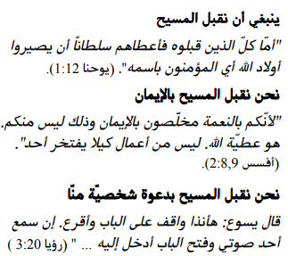

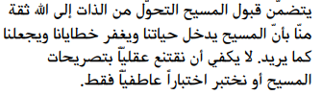



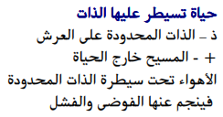

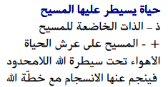

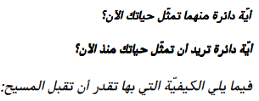

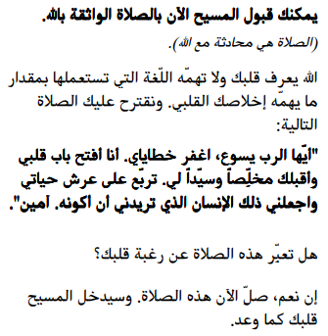

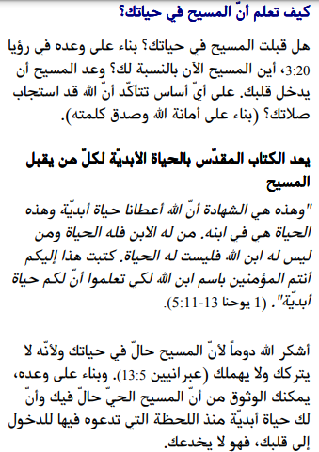

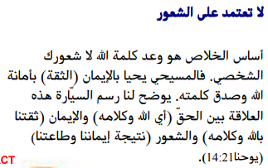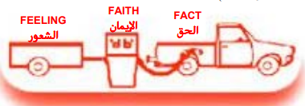

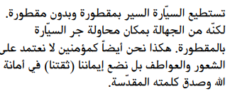

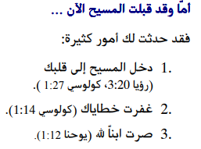

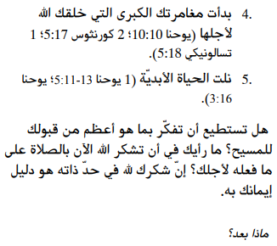

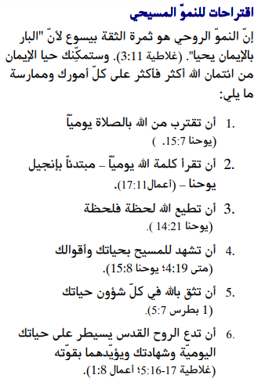

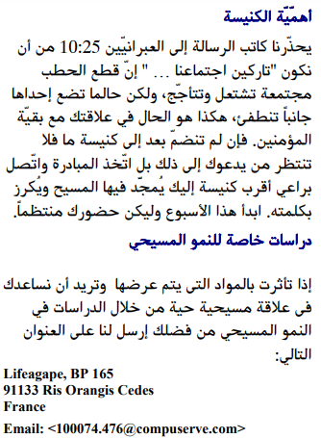

إذا قبلت المسيح فإن الخدمات تحب أن تعرف. أو إذا كان لديك أي شيء تريد مشاركته حول أوراق العمل هذه ، فيرجى إخبارنا بذلك.

[nathand@242ministries.org](mailto:nathand@242ministries.org)

فارسی:<https://www.youtube.com/watch?v=eWLsQ0DTsq0&t=12s>



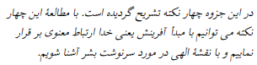

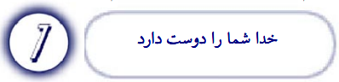

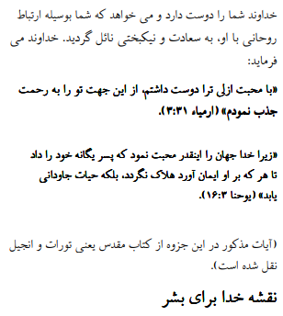

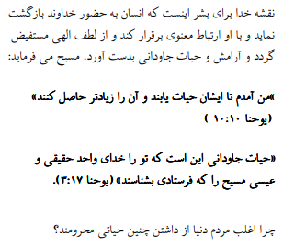



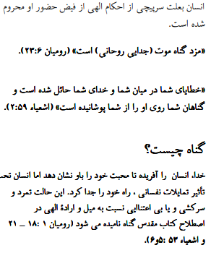

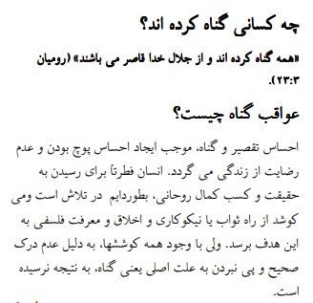

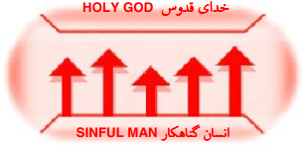



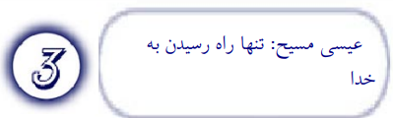

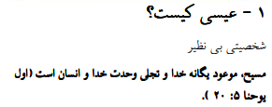

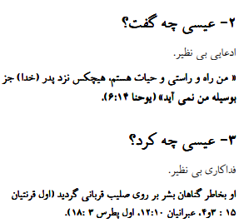

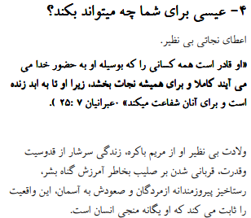

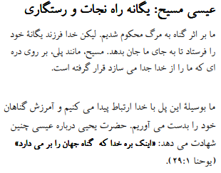

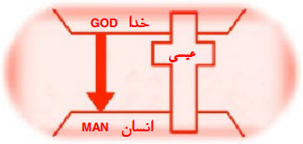



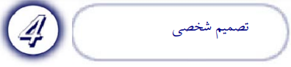

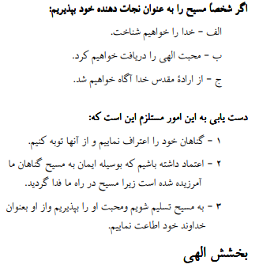

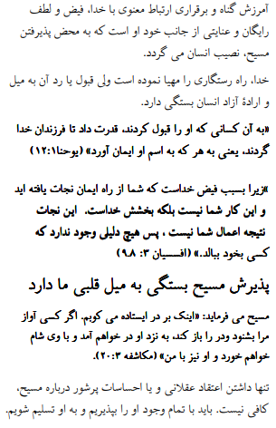

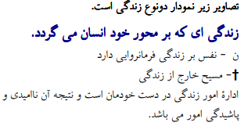



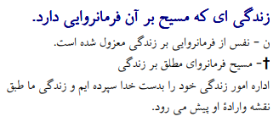



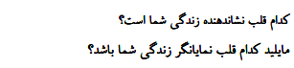

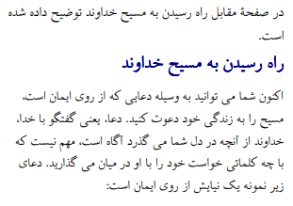

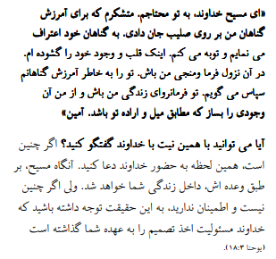

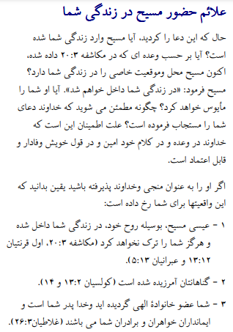

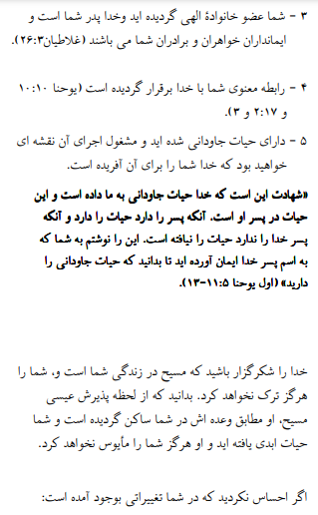

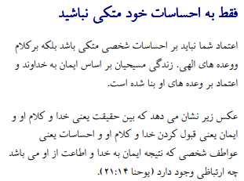

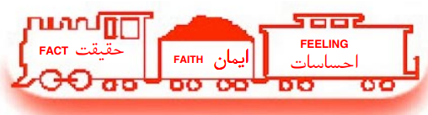

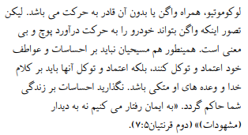

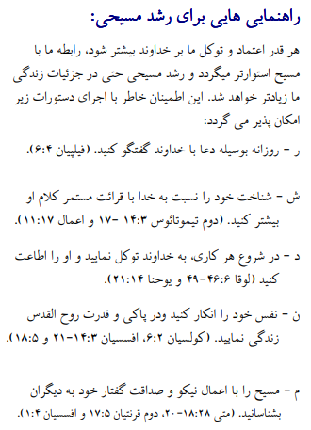

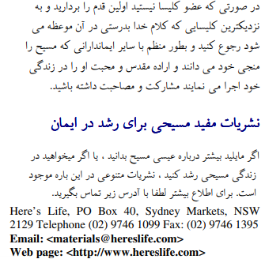

اگر مسیح را پذیرفتید اعمال رسولان 2:42 وزارتخانه ها دوست دارند بدانند. یا اگر چیزی برای به اشتراک گذاشتن در مورد این کاربرگ ها دارید ، لطفاً به ما اطلاع دهید

[nathand@242ministries.org](mailto:nathand@242ministries.org)

اردو:

<https://www.youtube.com/watch?v=6-GclzuUbxY>

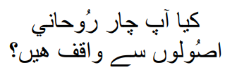

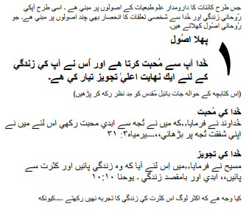

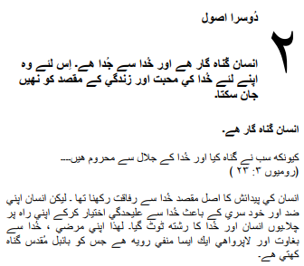

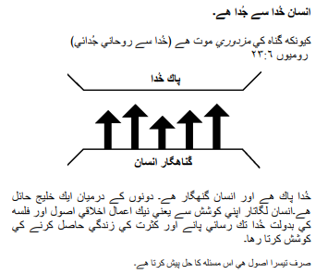

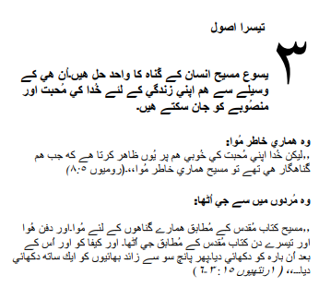

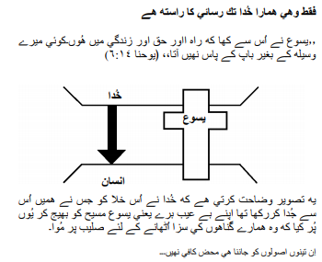

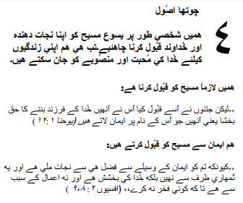

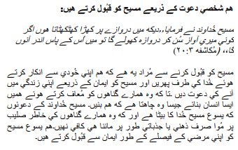

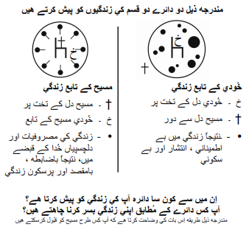

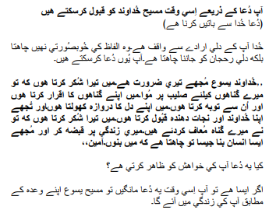

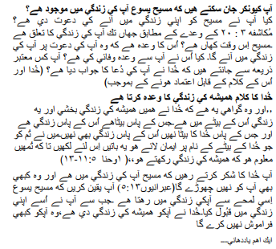

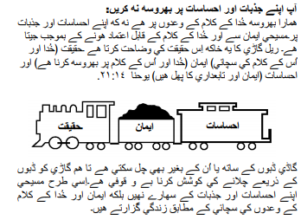

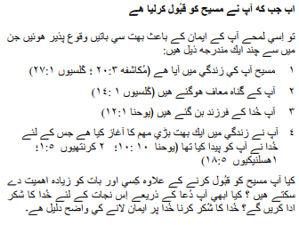

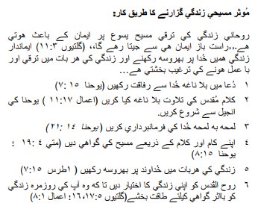

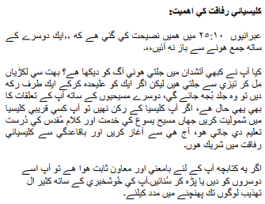

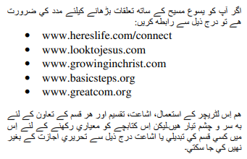

اگر آپ نے مسیح کے اعمال کو قبول کیا تو 2:42 وزارتیں جاننا پسند کریں گی۔ یا اگر آپ کے پاس ان ورک شیٹس کے بارے میں کچھ شیئر کرنا ہے تو براہ کرم ہمیں بتائیں۔

[nathand@242ministries.org](mailto:nathand@242ministries.org)

Türk:

<https://www.youtube.com/watch?v=6YwHd_PwOOQ>





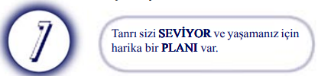

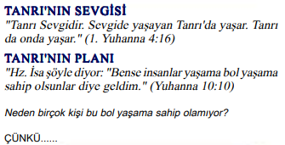

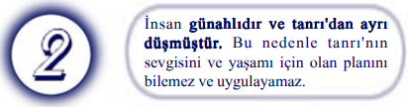

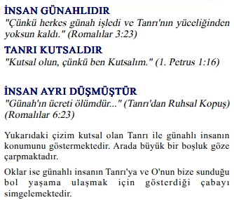

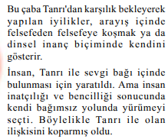

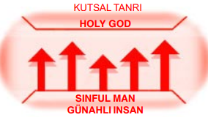



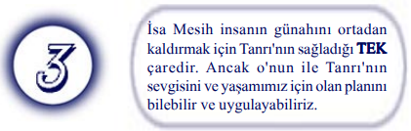

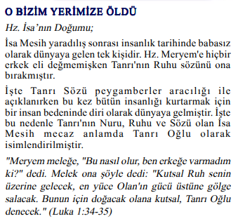



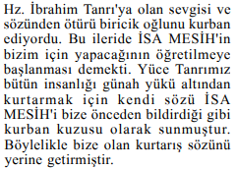

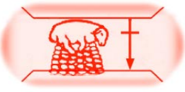

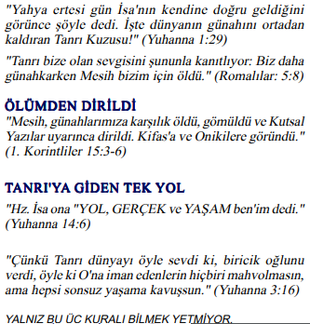

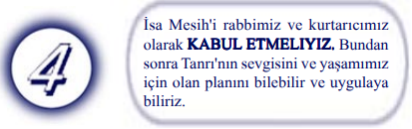

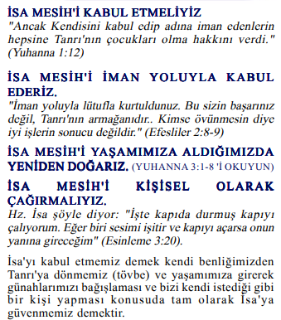

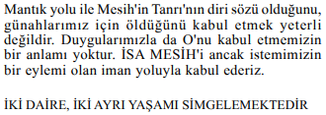

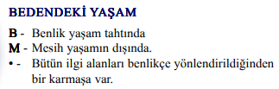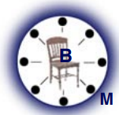

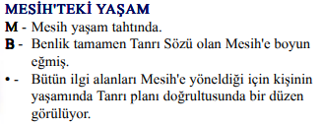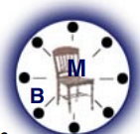

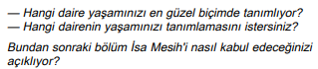

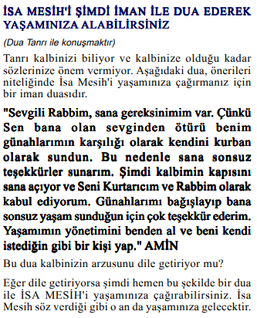

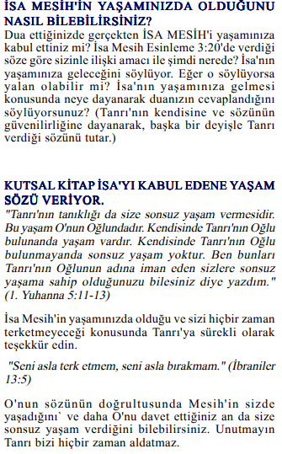

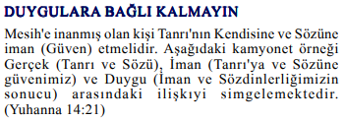

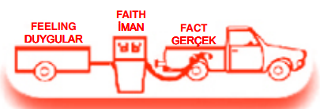

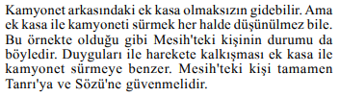

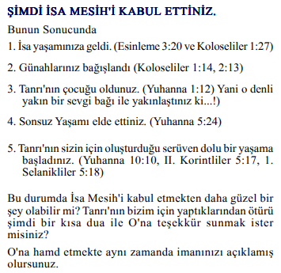

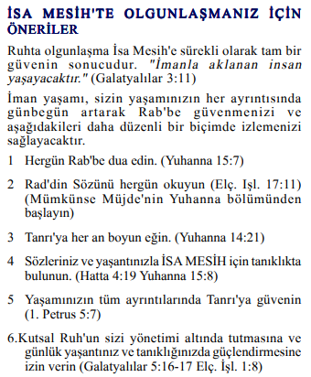

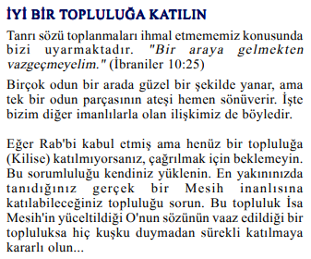

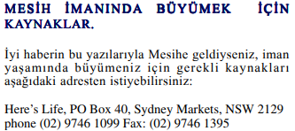

Mesih'in Elçilerinin İşleri 2:42'yi kabul ettiyseniz, Bakanlıklar bilmek ister. Veya bu çalışma sayfaları hakkında paylaşmak istediğiniz bir şey varsa lütfen bize bildirin.

[nathand@242ministries.org](mailto:nathand@242ministries.org)

हिंदी:

<https://www.youtube.com/watch?v=NR7AieVQI2A>

<https://www.youtube.com/watch?v=nmHla8doL5o>

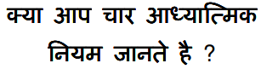

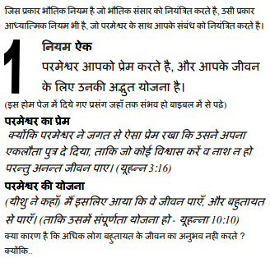

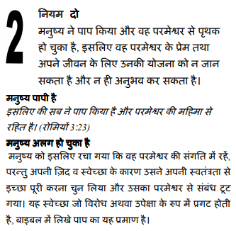

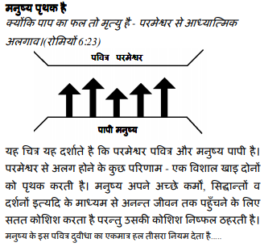

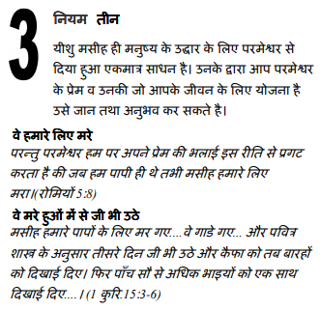

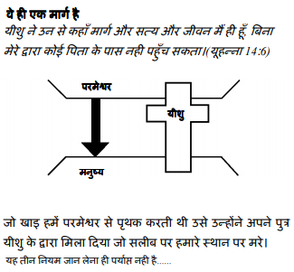

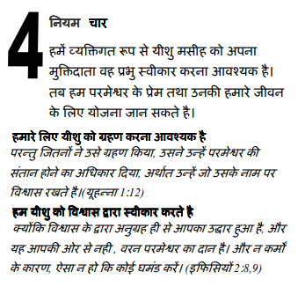

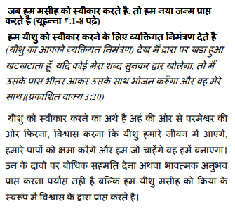

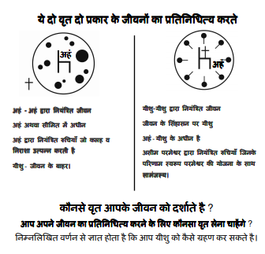

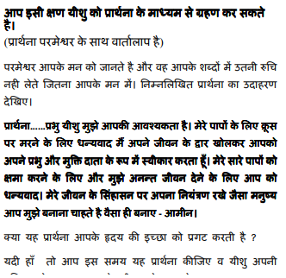

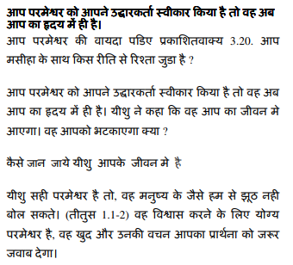

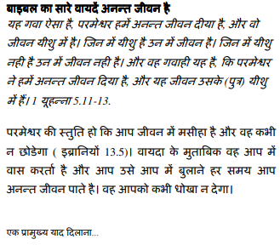

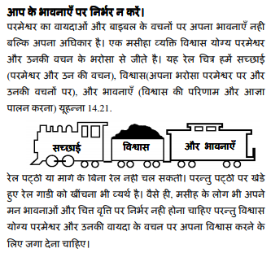

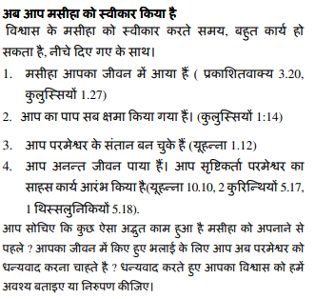

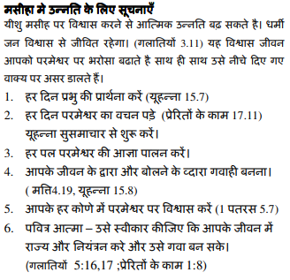

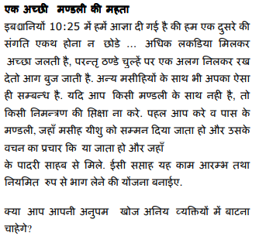

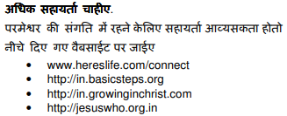

यदि आप मसीह के कामों को स्वीकार करते हैं प्रेरितों 2:42 मंत्रालयों को जानना अच्छा लगेगा। या यदि आपके पास इन कार्यपत्रकों के बारे में साझा करने के लिए कुछ है तो कृपया हमें बताएं।

[nathand@242ministries.org](mailto:nathand@242ministries.org)

中国人:

<https://www.youtube.com/watch?v=ebaT4PvcUEc>









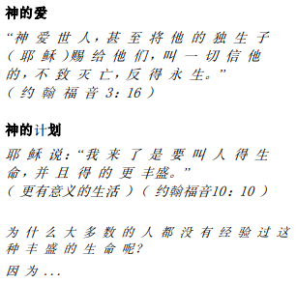

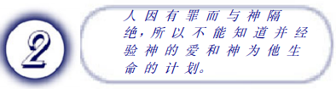

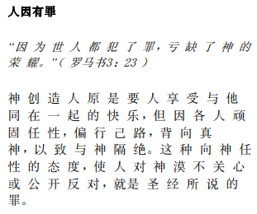

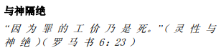

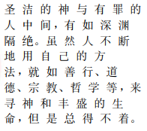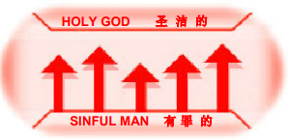





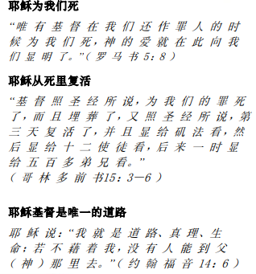

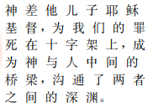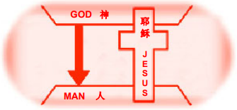



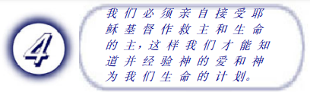

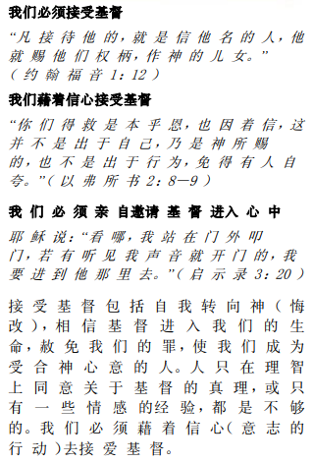

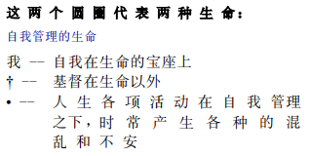

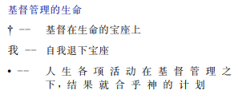

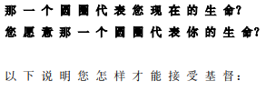

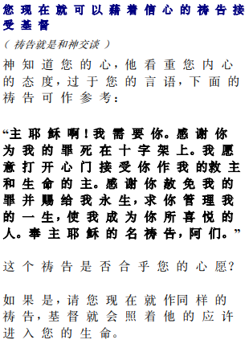

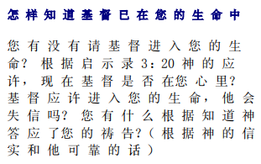

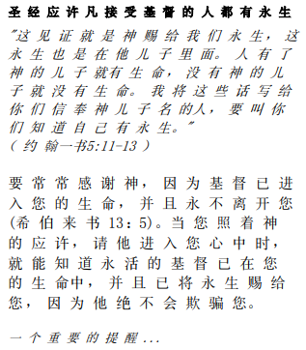

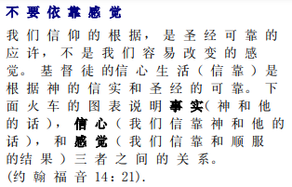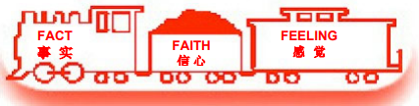

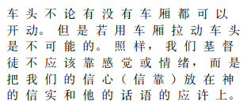

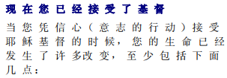

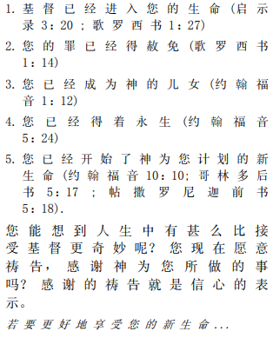

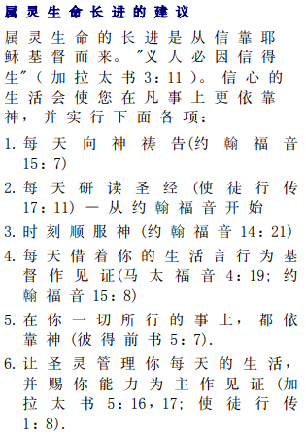

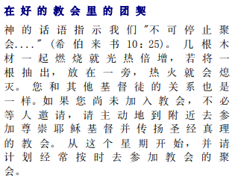



如果你接受基督使徒行传 2:42 事工很想知道。或者，如果您对这些工作表有任何要分享的内容，请告诉我们。

[nathand@242ministries.org](mailto:nathand@242ministries.org)