Lesson 12 – Possessive Adjectives Part 1

(Lección 12 – adjetivos posesivos parte 1)

|  |  |  |
| --- | --- | --- |
| **English** | **español** | **Foto** |
| my | mi | Person Reading Book - Free vector graphic on Pixabay |
| your | tu | 100+ Free Hand Giving & Give Illustrations - Pixabay |
| his/her/  your (formal) | su | Cartoon boy holds high stack of books and girl sits at table in room free  imageChildren Friends Books - Free vector graphic on Pixabay |
| our | nuestro | Drawn boy and girl are reading a purple book free image |
| their/your (formal) | su | Drawn boy and girl are reading a purple book free imageImage result for kid pointing |

Write the possessive adjective with the picture.

(Escribe el adjetivo posesivo con la imagen.)

|  |  |  |
| --- | --- | --- |
| **Number**  (número) | **Picture (imagen)** | **Answer (Responder)** |
| 1 | C:\Users\natha\Desktop\download.jfif |  |
| 2 | Image result for kids reading |  |
| 3 | Image result for kids reading |  |
| 4 | Image result for kids reading |  |
| 5 | Image result for kids reading |  |
| 6 | Image result for kids reading |  |
| 7 | Image result for kids reading |  |
| 8 | File:Demonstrative-pronoun-it.svg |  |

Answers on next page (respuestas en la página siguiente)

1. Our
2. His
3. My
4. Their
5. Her
6. His
7. My
8. Your

Pick the right possessive adjective

(Elige el posesivo adjetivo correcto)

|  |  |
| --- | --- |
| 1. Image result for adult reading \_\_\_\_ computer. 2. Our 3. My 4. Their | 1. Image result for kids reading\_\_\_\_\_\_\_\_ book. 2. My 3. Her 4. Our |
| 1. Image result for kids reading\_\_\_\_\_\_\_\_ book. 2. Our 3. Your 4. His | 1. \_\_\_\_\_\_\_\_\_\_ keys. 2. C:\Users\natha\Desktop\download.pngTheir 3. Your 4. Her |
| 1. \_\_\_\_\_\_\_\_\_\_\_\_ phone. 2. C:\Users\natha\Desktop\5de947b0fd9db2681e01f406.pngHis 3. My 4. Her | 1. \_\_\_\_\_\_\_\_\_\_\_ balls. 2. C:\Users\natha\Desktop\569409214_83a96478b3_q.jpgTheir 3. Your 4. My |

Answers on next page (respuestas en la página siguiente)

1. My
2. Our
3. His
4. Your
5. Her
6. Their

Draw a picture to show the possessive adjective.  
(Haz un dibujo para mostrar el adjetivo posesivo.)

My Your Her

Our His Their

To try at home (Para probar en casa)

1. See how many things you can list using one possessive adjective. For instance, “My home. My computer.” Can you list 10, 20, or 30?

(Vea cuántas cosas puede enumerar usando un adjetivo posesivo. Por ejemplo, “Mi casa. Mi computadora." ¿Puede enumerar 10, 20 o 30?)

1. More difficult - make a sentence with a posessive adjective about your family or friends. Use adjectives or emotions to finish the sentence. For instance, “Your father is tall.”

(Más difícil: haz una oración con un adjetivo posesivo sobre tu familia o amigos. Usa adjetivos o emociones para terminar la oración. Por ejemplo, "Tu padre es alto".)

**Please consider donating to Acts 2:42 Ministries (**<https://www.paypal.com/fundraiser/charity/213230>**) to support the free English lessons. Thank you!**

Considere hacer una donación a Acts 2:42 Ministries (<https://www.paypal.com/fundraiser/charity/213230>) para apoyar las lecciones de inglés gratuitas. ¡Gracias!

[How do I get to heaven?](#English)

[¿Cómo llego al cielo?](#español)

[كيف أصل إلى الجنة؟](#عربى)

[چگونه به بهشت ​​برسم؟](#فارسی" \o "فارسی)

[میں جنت میں کیسے جاؤں؟](#اردو)

[Cennete nasıl gidebilirim?](#Türk" \o "Türk)

[मैं स्वर्ग कैसे पहुँचूँ?](#हिंदी" \o "हिंदी)

[我怎样才能上天堂？](#中国人)

English:

<https://peacewithgod.net/>

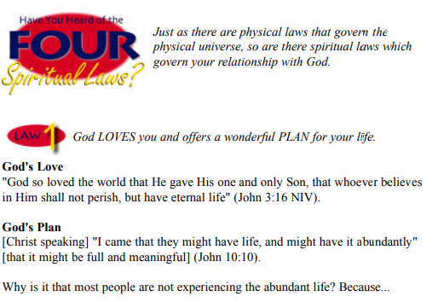

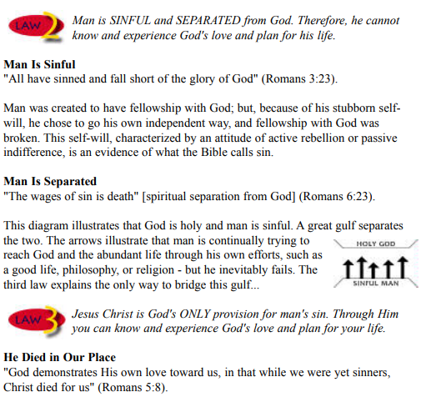

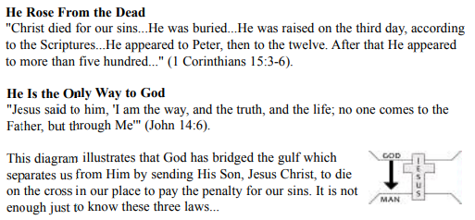

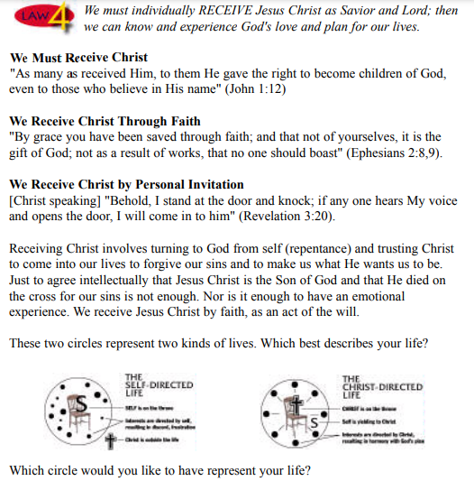

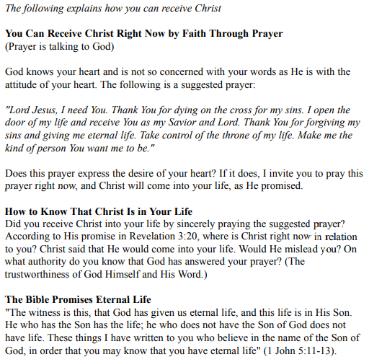

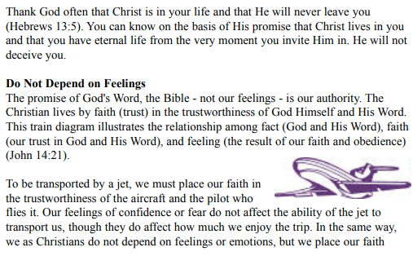

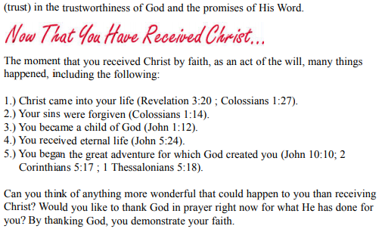

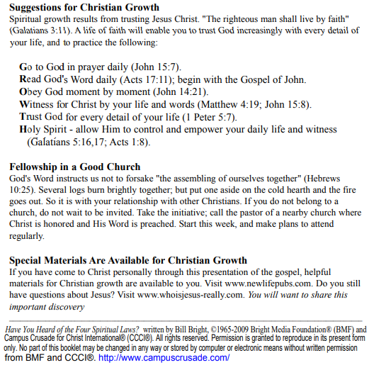

If you accepted Christ Acts 2:42 Ministries would love to know. Or if you have anything to share about these worksheets please let us know. [nathand@242ministries.org](mailto:nathand@242ministries.org)

español:

<https://www.youtube.com/watch?v=NRUqXwqTA8w>



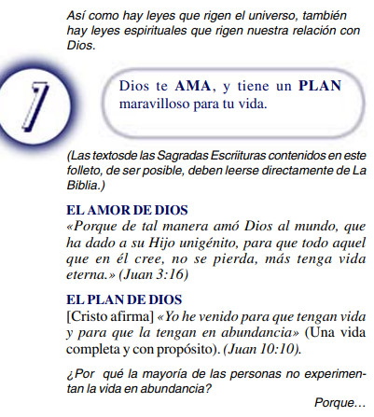

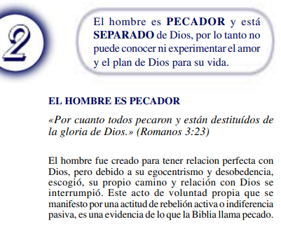

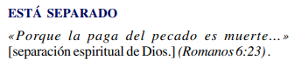

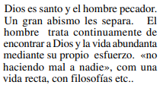

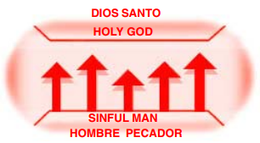



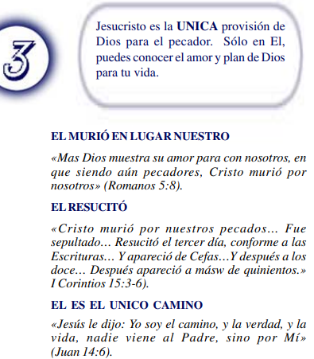

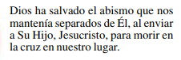

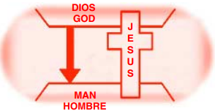



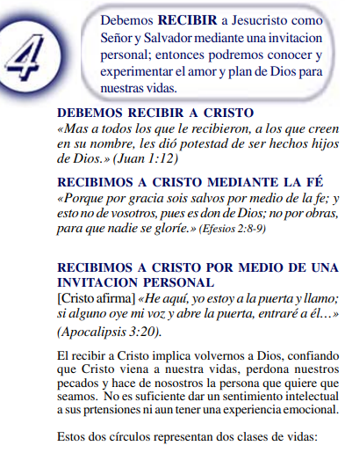

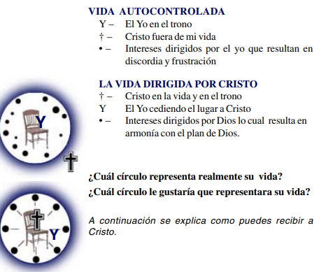

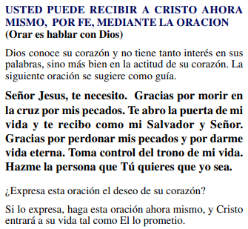

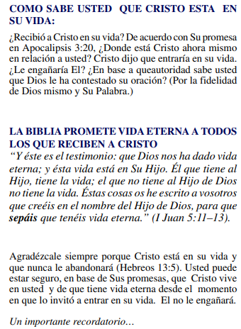

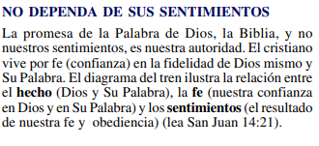

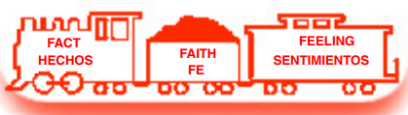

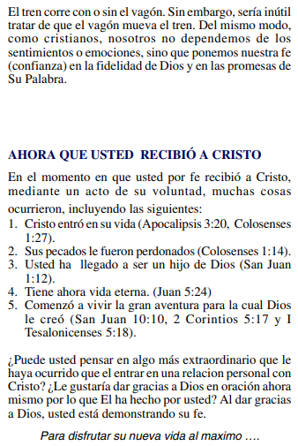

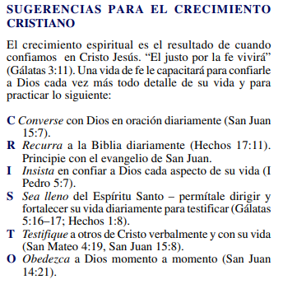

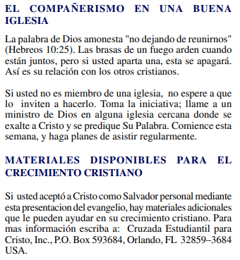

(Si aceptaste a Cristo Hechos 2:42 a Ministerios le encantaría saberlo. O si tiene algo que compartir sobre estas hojas de trabajo, háganoslo saber.)

[nathand@242ministries.org](mailto:nathand@242ministries.org)

عربى:

<https://www.youtube.com/watch?v=ePa_MElCi68>

<https://www.youtube.com/watch?v=o0GFYMPArW0>







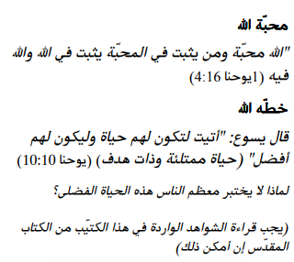

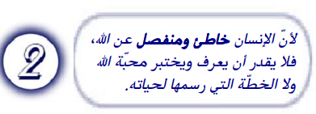

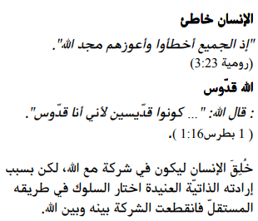

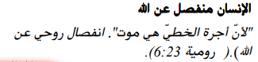

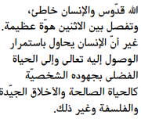

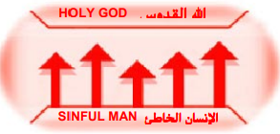



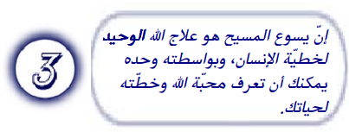

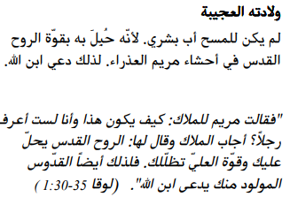

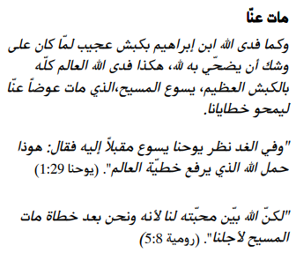

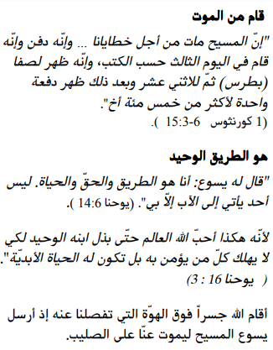

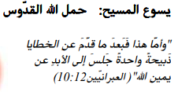

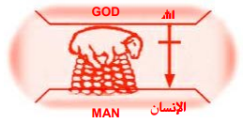





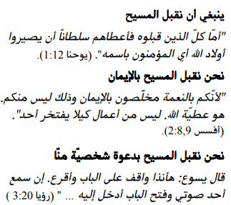

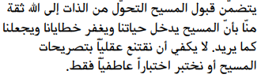



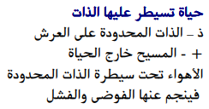

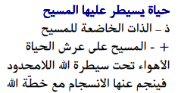

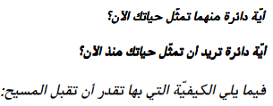

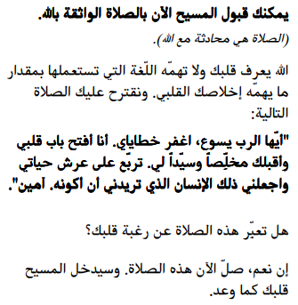

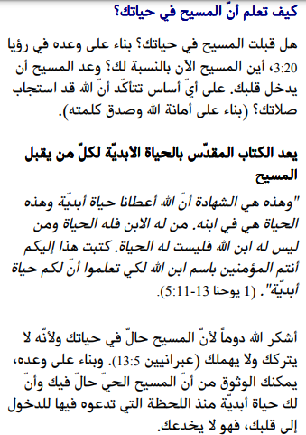

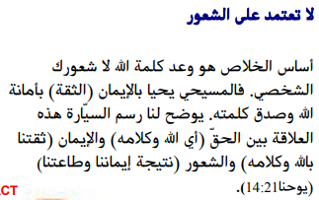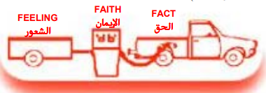

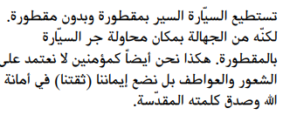

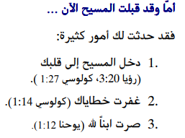

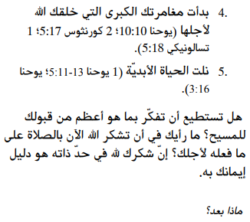

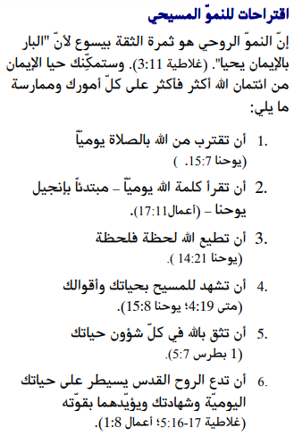

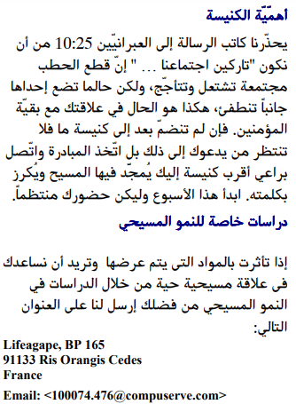

إذا قبلت المسيح فإن الخدمات تحب أن تعرف. أو إذا كان لديك أي شيء تريد مشاركته حول أوراق العمل هذه ، فيرجى إخبارنا بذلك.

[nathand@242ministries.org](mailto:nathand@242ministries.org)

فارسی:<https://www.youtube.com/watch?v=eWLsQ0DTsq0&t=12s>



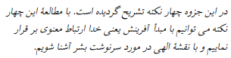



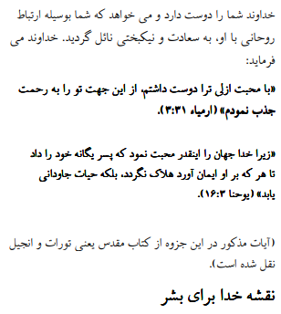

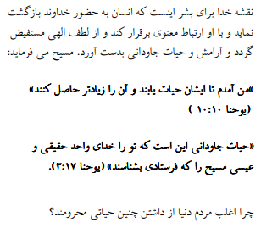



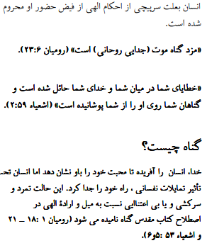

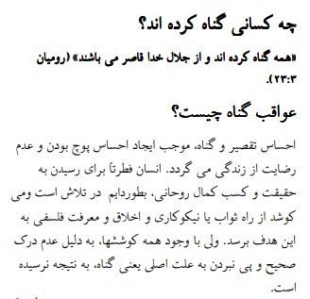

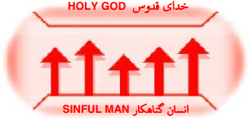





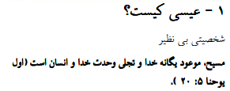

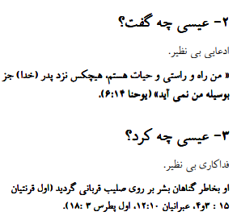

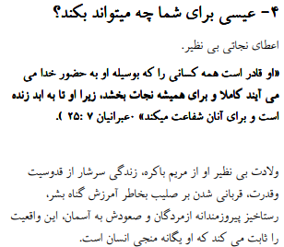

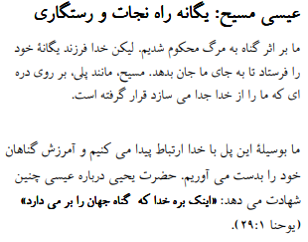

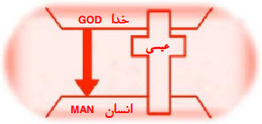





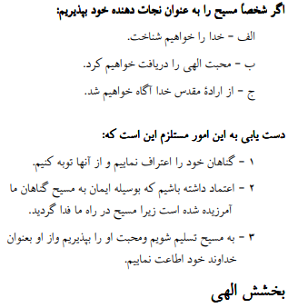

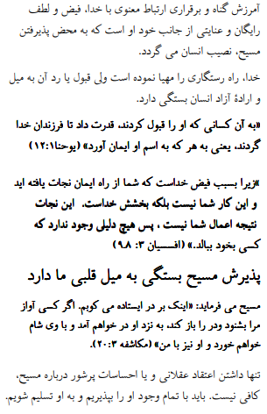

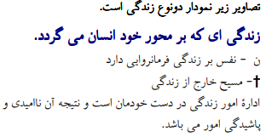



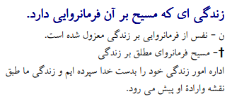





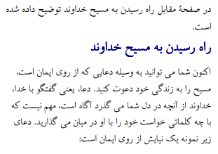

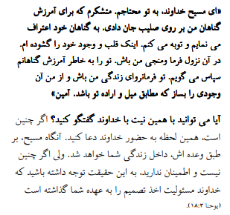

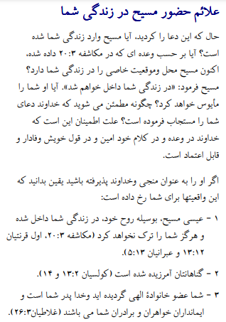

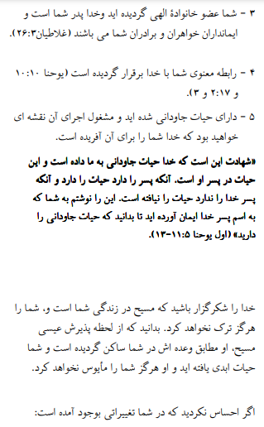

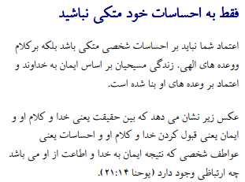

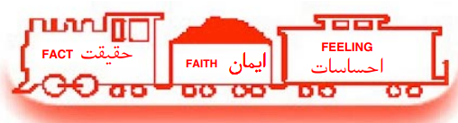

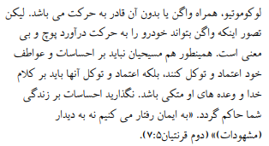

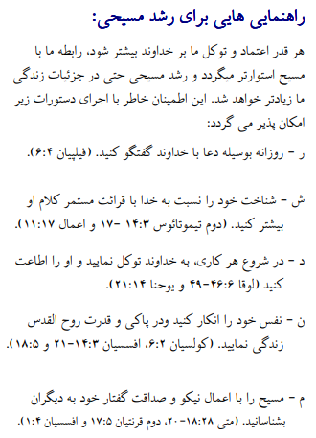

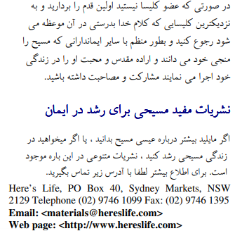

اگر مسیح را پذیرفتید اعمال رسولان 2:42 وزارتخانه ها دوست دارند بدانند. یا اگر چیزی برای به اشتراک گذاشتن در مورد این کاربرگ ها دارید ، لطفاً به ما اطلاع دهید

[nathand@242ministries.org](mailto:nathand@242ministries.org)

اردو:

<https://www.youtube.com/watch?v=6-GclzuUbxY>

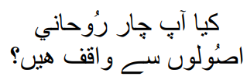

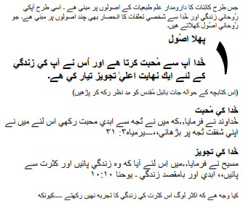

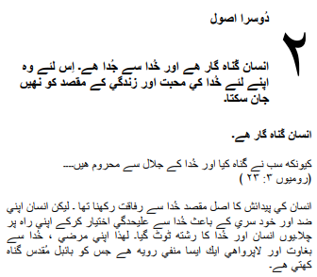

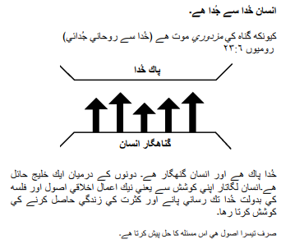

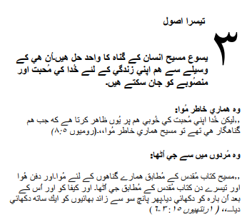

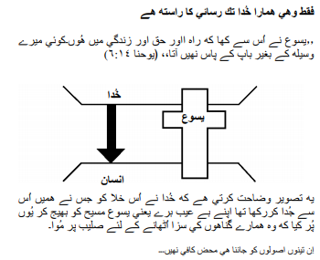

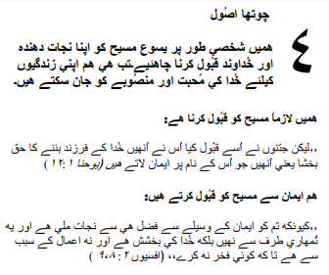

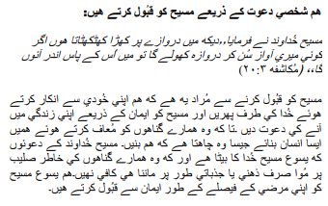

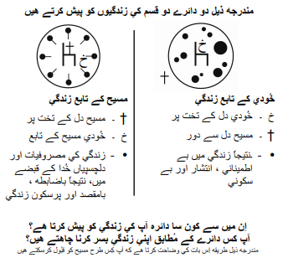

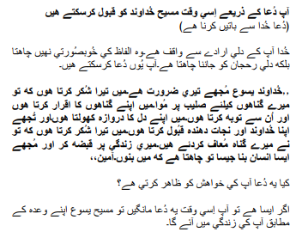

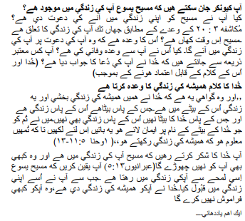

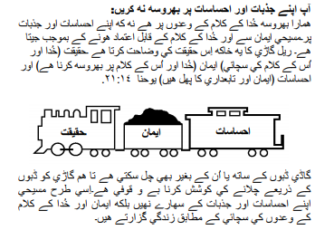

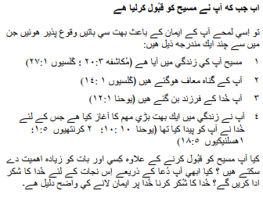

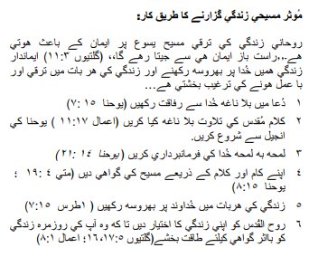

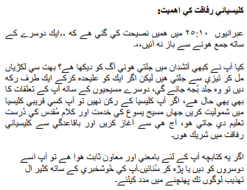

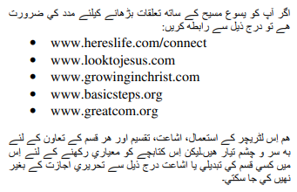

اگر آپ نے مسیح کے اعمال کو قبول کیا تو 2:42 وزارتیں جاننا پسند کریں گی۔ یا اگر آپ کے پاس ان ورک شیٹس کے بارے میں کچھ شیئر کرنا ہے تو براہ کرم ہمیں بتائیں۔

[nathand@242ministries.org](mailto:nathand@242ministries.org)

Türk:

<https://www.youtube.com/watch?v=6YwHd_PwOOQ>





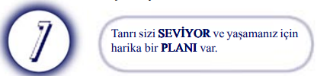

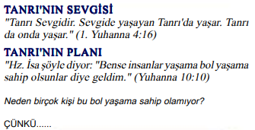

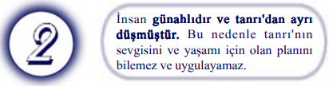

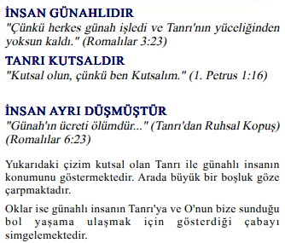

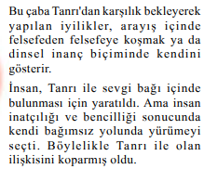

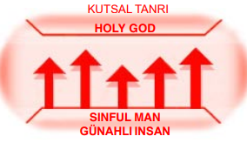



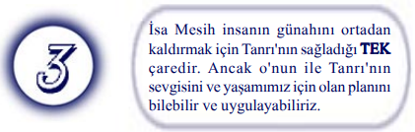

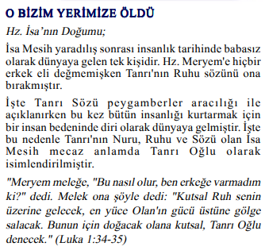



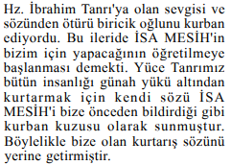

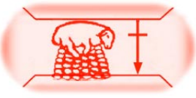

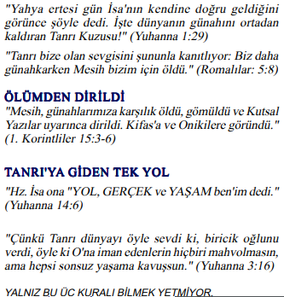

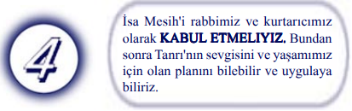

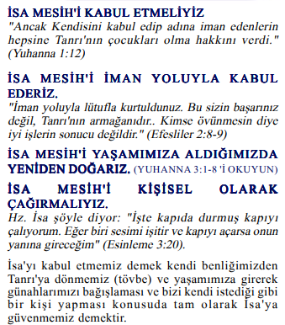

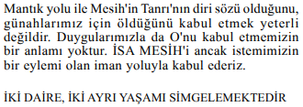

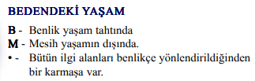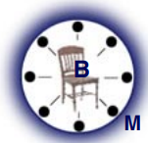

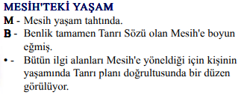

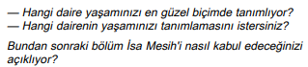

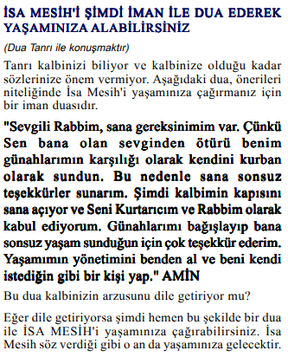

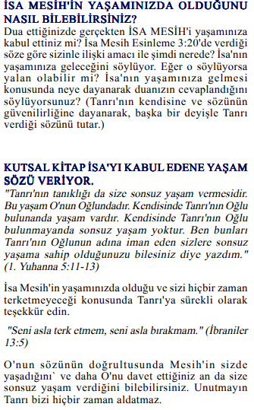

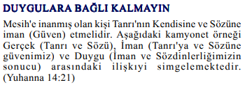



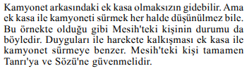

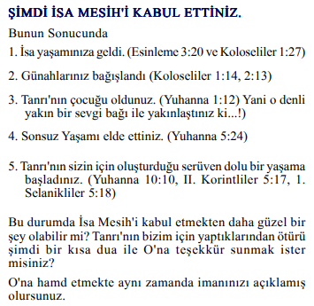

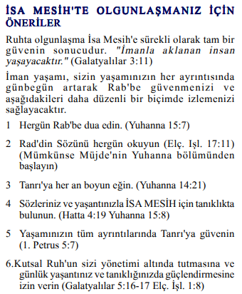

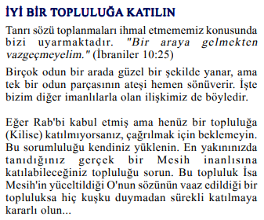

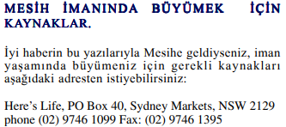

Mesih'in Elçilerinin İşleri 2:42'yi kabul ettiyseniz, Bakanlıklar bilmek ister. Veya bu çalışma sayfaları hakkında paylaşmak istediğiniz bir şey varsa lütfen bize bildirin.

[nathand@242ministries.org](mailto:nathand@242ministries.org)

हिंदी:

<https://www.youtube.com/watch?v=NR7AieVQI2A>

<https://www.youtube.com/watch?v=nmHla8doL5o>

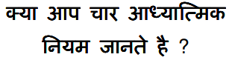

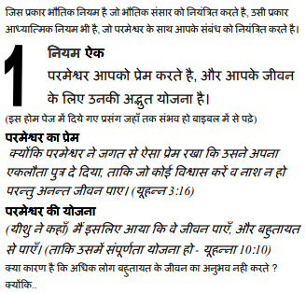

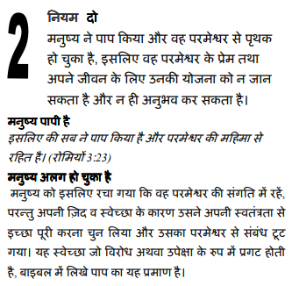

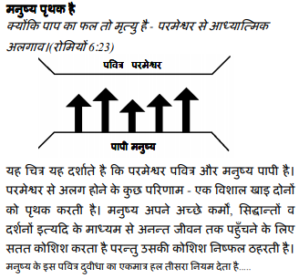

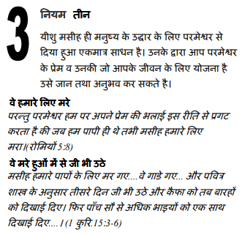

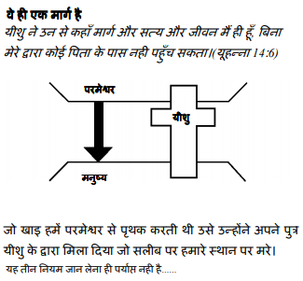

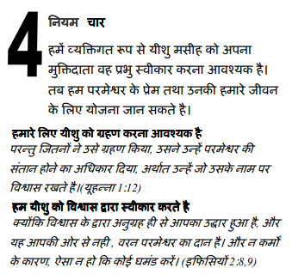

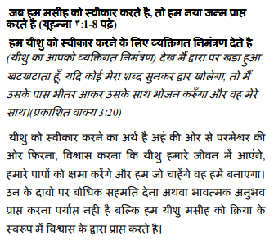

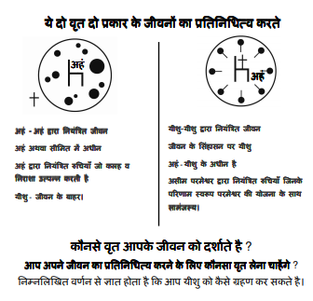

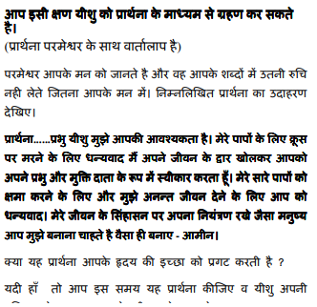

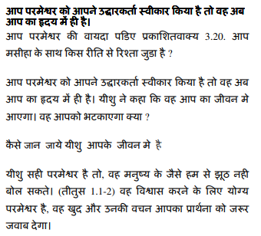

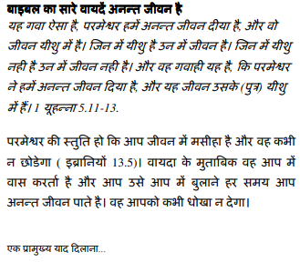

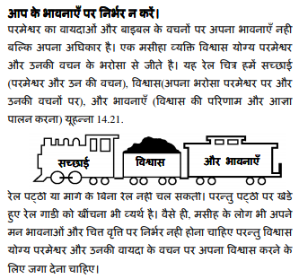

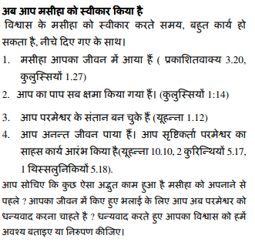

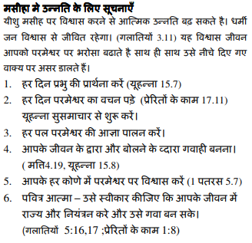

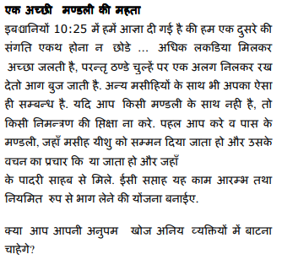

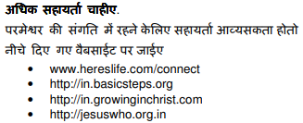

यदि आप मसीह के कामों को स्वीकार करते हैं प्रेरितों 2:42 मंत्रालयों को जानना अच्छा लगेगा। या यदि आपके पास इन कार्यपत्रकों के बारे में साझा करने के लिए कुछ है तो कृपया हमें बताएं।

[nathand@242ministries.org](mailto:nathand@242ministries.org)

中国人:

<https://www.youtube.com/watch?v=ebaT4PvcUEc>









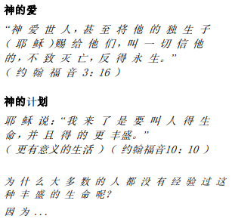



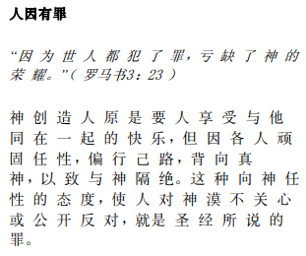

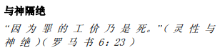

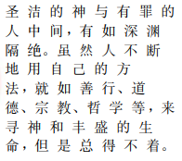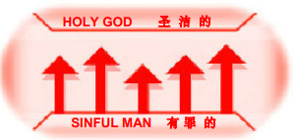





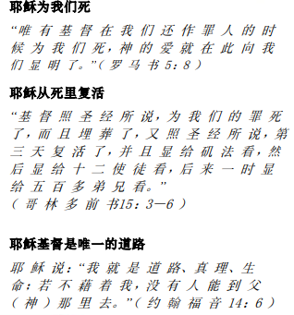

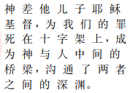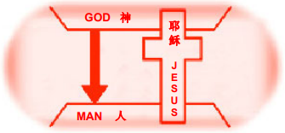





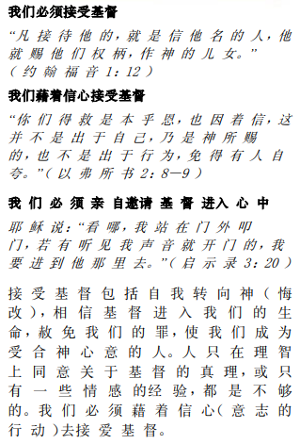

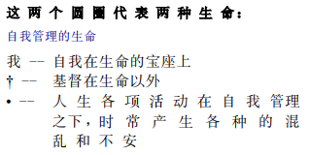

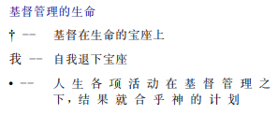

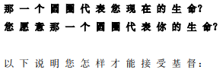

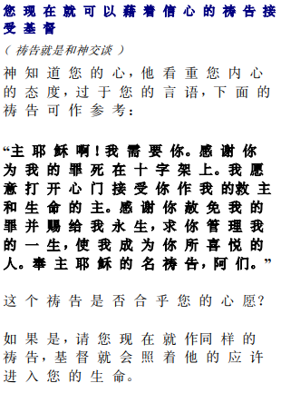

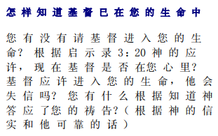

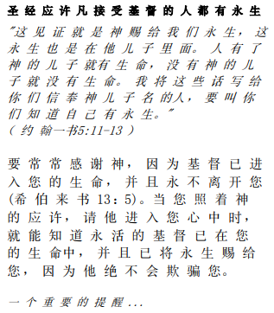

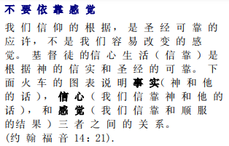

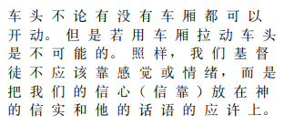

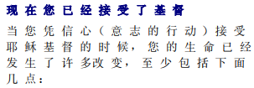

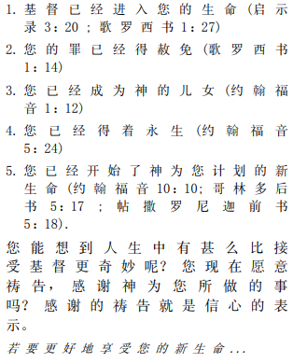

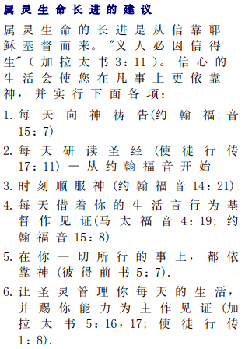

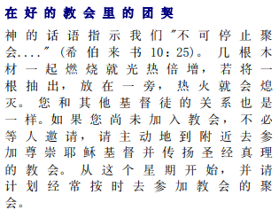



如果你接受基督使徒行传 2:42 事工很想知道。或者，如果您对这些工作表有任何要分享的内容，请告诉我们。

[nathand@242ministries.org](mailto:nathand@242ministries.org)