Lesson 14 – Family Vocabulary

(Lección 14 - Vocabulario familiar)

|  |  |  |
| --- | --- | --- |
| **English** | **español** | **Foto** |
| Husband | marido/esposo | 375x667px Free download | couple, love, beach, happiness, sand, young  adult, two people, couple - relationship, CC0, public domain, royalty free  | Piqsels |
| Wife | mujor/esposa | 375x667px Free download | couple, love, beach, happiness, sand, young  adult, two people, couple - relationship, CC0, public domain, royalty free  | Piqsels |
| Son | hijo | 100+ Free Son & Family Vectors - Pixabay |
| Daughter | hija | SnappyGoat.com - Free Public Domain Images - SnappyGoat.com- daughter -child-dad-family-father-149865.svg |
| Grandson | nieto | Grandfather and grandmother taking care of grandchildren granddaughter free  image |
| Grandaughter | nieta | Grandfather and grandmother taking care of grandchildren granddaughter free  image |

Write the family member’s name with the picture.

(Escriba el nombre del miembro de la familia con la imagen)

|  |  |  |
| --- | --- | --- |
| **Number**  (número) | **Picture (imagen)** | **Answer (Responder)** |
| 1 | Grandfather with grandson in profile free image |  |
| 2 | 300+ Free Wife & Couple Illustrations - Pixabay |  |
| 3 | 40+ Free Grandparents & Grandma Illustrations - Pixabay |  |
| 4 | Wedding Cartoon N8 free image |  |
| 5 | C:\Users\natha\Desktop\download.png |  |
| 6 | Picture of grandmother with granddaughter on a white background free image |  |

Answers on next page (respuestas en la página siguiente)

1. Grandson
2. Wife
3. Daughter
4. Husband
5. Son
6. Granddaughter

Pick the right family member

(Elija al familiar adecuado)

|  |  |
| --- | --- |
| 1. tv, kids, cartoons, movie, toys, entertainment, cartoon, boys ...Marco is watching TV. 2. The sister 3. The brother 4. The father | 1. Grandparent,family,child,grandfather,grandchild - free image from ...Pablo likes to sit. 2. The grandfather 3. The mother 4. The brother |
| 1. Karen likes to cook. 2. Cooking with mother | Free SVGThe grandmother 3. The brother 4. The mother | 1. Sonya likes to dance. 2. Dancing Seniors (#1) | Free SVGThe grandma 3. The grandpa 4. The mother |
| 1. Karen skates on the road. 2. The father 3. The sister 4. HD wallpaper: bikepark, bmx, helmet, sisters, conversation, horse ...The brother | 1. Nick walks on the grass. 2. The grandfather 3. Father and son 1080P, 2K, 4K, 5K HD wallpapers free download ...The brother 4. The father |

Answers on next page (respuestas en la página siguiente)

1. The brother
2. The grandfather
3. The mother
4. The grandma
5. The sister
6. The father

Fill in the blank with the correct personal pronoun from the underlined family member – More Difficult

(Complete el espacio en blanco con el pronombre personal correcto del miembro de la familia subrayado - Más difícil)

1. My grandfather likes to walk. _________
2. The sister and brother ride bikes together. _____________
3. Emily is a girl. ___________
4. John and I are friends. ____________

Answers on next page (respuestas en la página siguiente)

1. He
2. They
3. She
4. We

To try at home (Para probar en casa)

1. Name each person in your family. (Nombra a cada persona de tu familia.)
2. Look at family pictures. Say the family name of each person in the picture.

(Mire fotografías familiares. Diga el apellido de cada persona en la imagen.)

1. More difficult - Think of something you like to do with your family members. Make a sentence. Then use the personal pronouns to make a second sentence. For instance, something you do with your mother. The first sentence “My mother and I eat food.” The second sentence “We eat food”. Use a translator to figure out the English word if you don’t know it.

(Más difícil - Piense en algo que le guste hacer con los miembros de su familia. Haz una oración. Luego usa los pronombres personales para hacer una segunda oración. Por ejemplo, algo que haces con tu madre. La primera oración "Mi madre y yo comemos". La segunda frase “Comemos comida”. Utilice un traductor para averiguar la palabra en inglés si no la conoce.)

**Please consider donating to Acts 2:42 Ministries (**<https://www.paypal.com/fundraiser/charity/213230>**) to support the free English lessons. Thank you!**

Considere hacer una donación a Acts 2:42 Ministries (<https://www.paypal.com/fundraiser/charity/213230>) para apoyar las lecciones de inglés gratuitas. ¡Gracias!

[How do I get to heaven?](#English" \o "English)

¿Cómo llego al cielo?

كيف أصل إلى الجنة؟

[چگونه به بهشت ​​برسم؟](#فارسی" \o "فارسی)

میں جنت میں کیسے جاؤں؟

[Cennete nasıl gidebilirim?](#Türk" \o "Türk)

[मैं स्वर्ग कैसे पहुँचूँ?](#हिंदी" \o "हिंदी)

我怎样才能上天堂？

English:

<https://peacewithgod.net/>

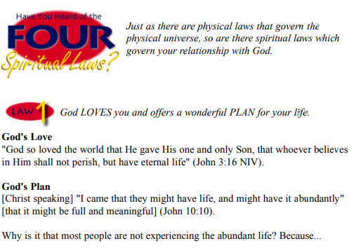

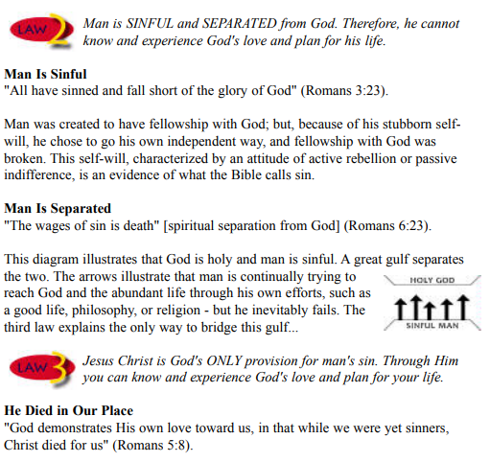

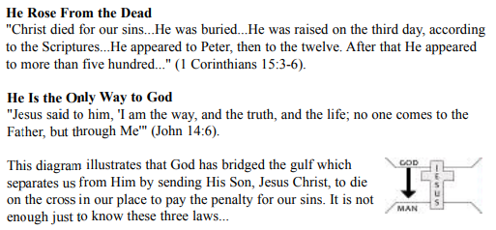

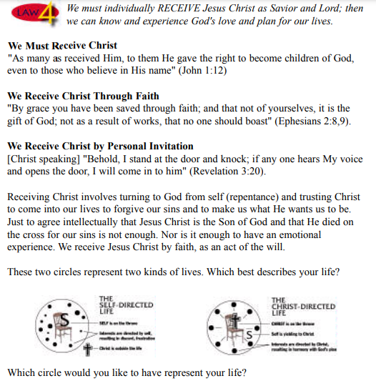

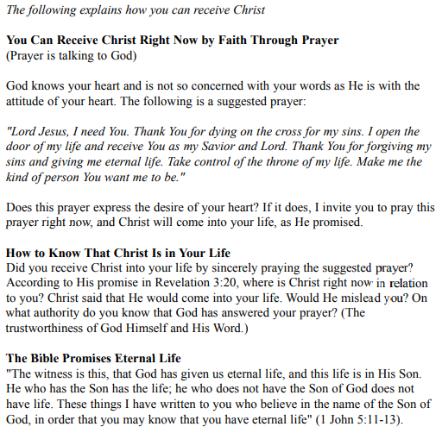

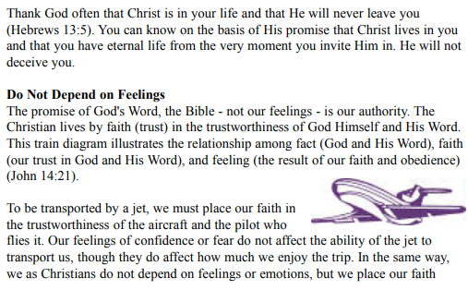

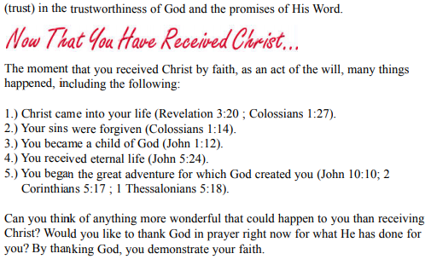

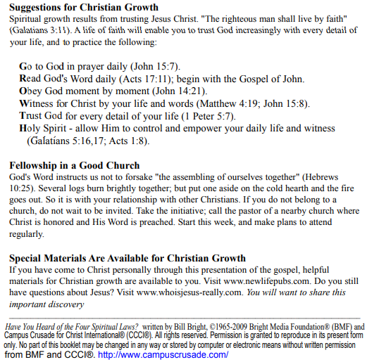

If you accepted Christ Acts 2:42 Ministries would love to know. Or if you have anything to share about these worksheets please let us know. [nathand@242ministries.org](mailto:nathand@242ministries.org)

español:

<https://www.youtube.com/watch?v=NRUqXwqTA8w>



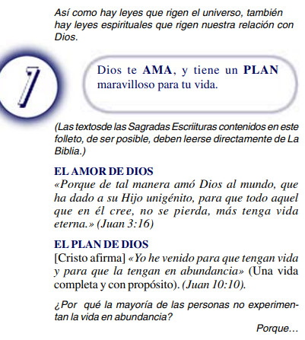

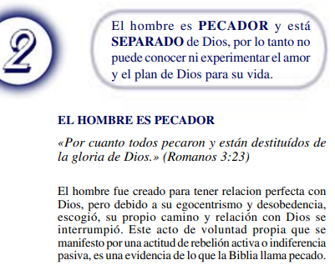

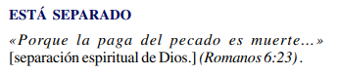

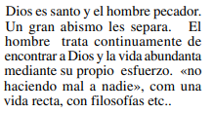

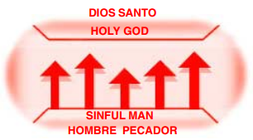



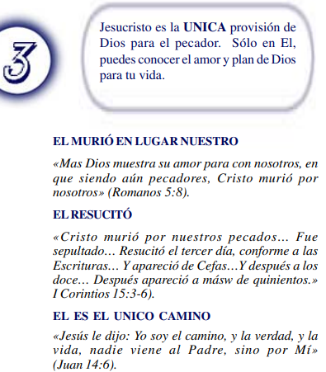

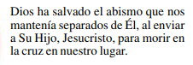

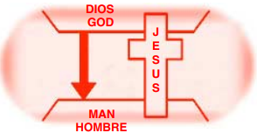



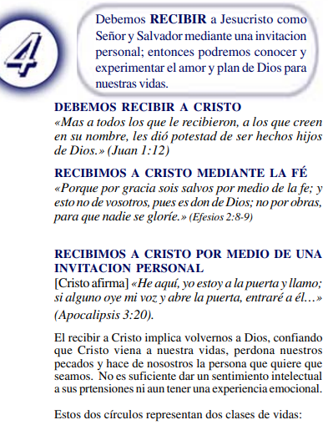

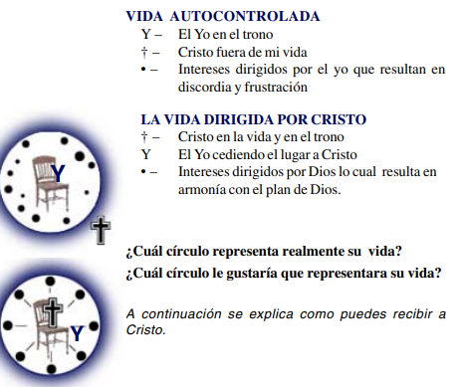

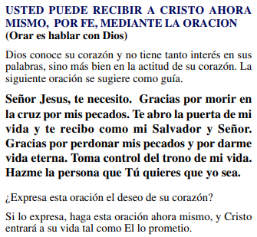

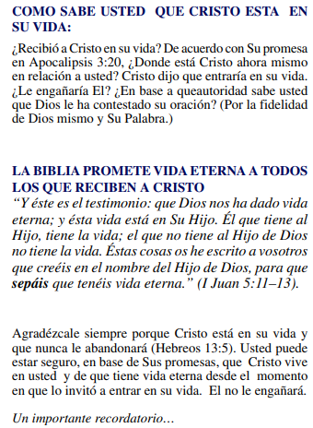

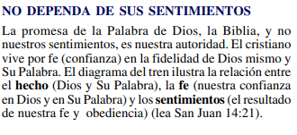

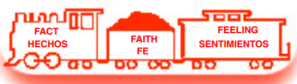

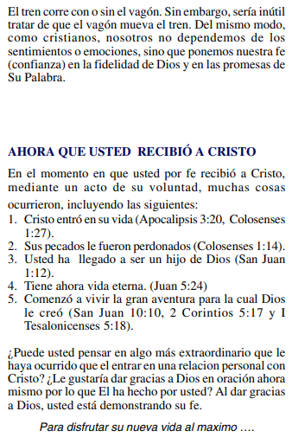

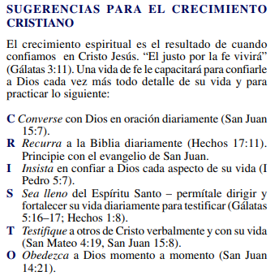

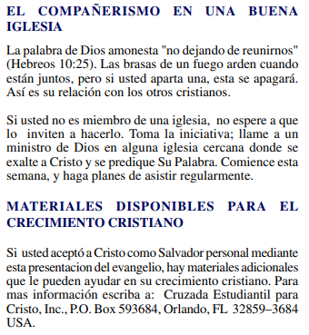

(Si aceptaste a Cristo Hechos 2:42 a Ministerios le encantaría saberlo. O si tiene algo que compartir sobre estas hojas de trabajo, háganoslo saber.)

[nathand@242ministries.org](mailto:nathand@242ministries.org)

عربى:

<https://www.youtube.com/watch?v=ePa_MElCi68>

<https://www.youtube.com/watch?v=o0GFYMPArW0>





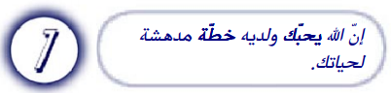

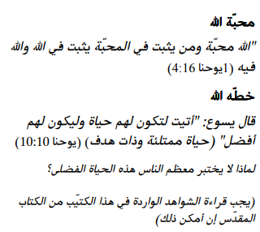

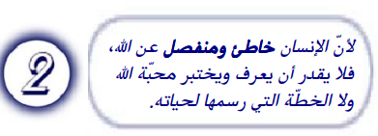

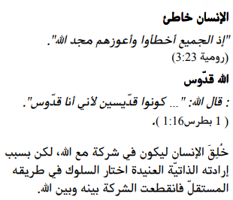

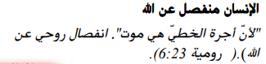

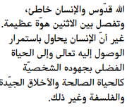

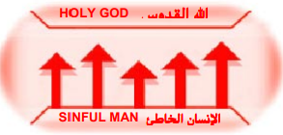



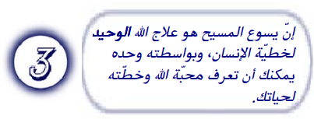

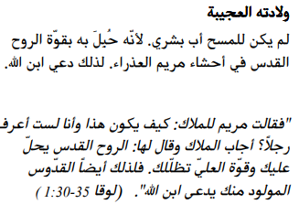

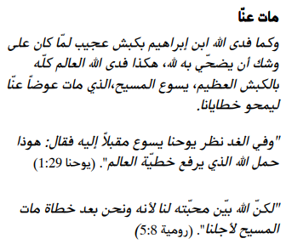

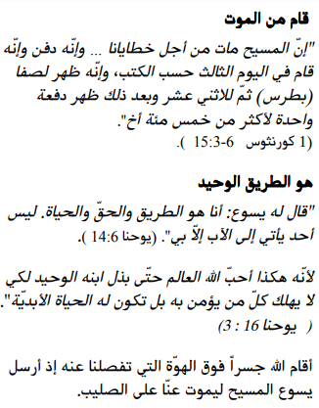

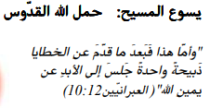

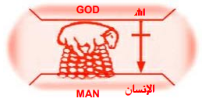





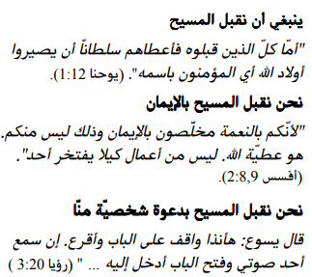

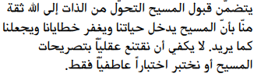



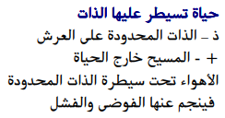

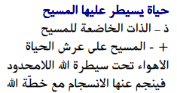

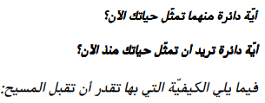

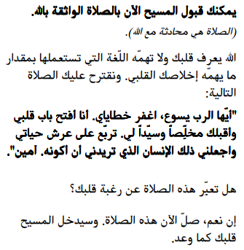

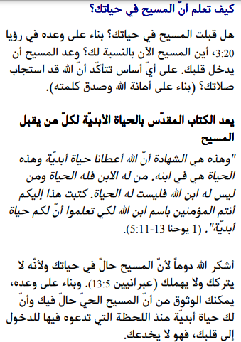

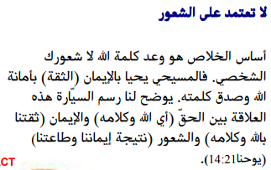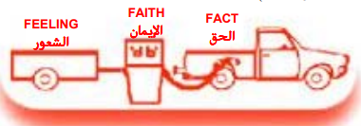

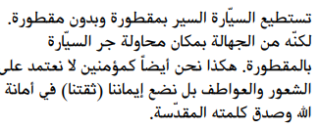

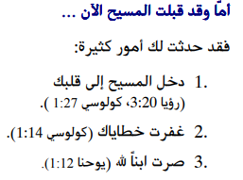

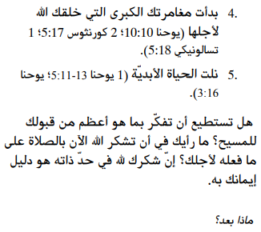

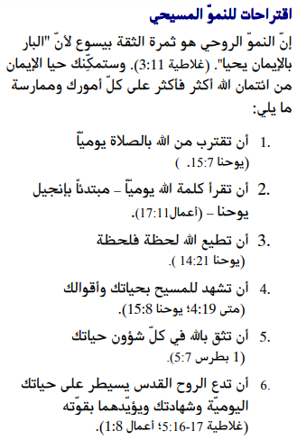

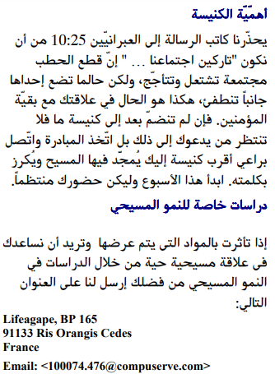

إذا قبلت المسيح فإن الخدمات تحب أن تعرف. أو إذا كان لديك أي شيء تريد مشاركته حول أوراق العمل هذه ، فيرجى إخبارنا بذلك.

[nathand@242ministries.org](mailto:nathand@242ministries.org)

فارسی:<https://www.youtube.com/watch?v=eWLsQ0DTsq0&t=12s>



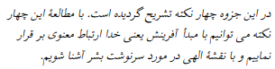

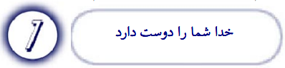

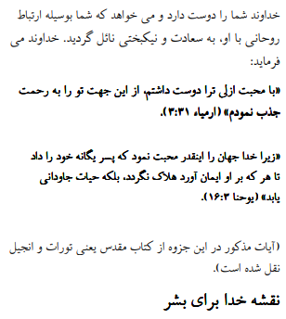

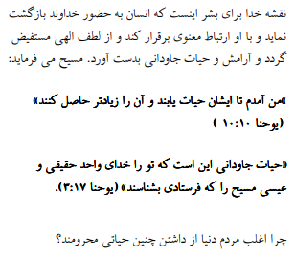

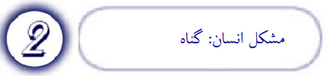

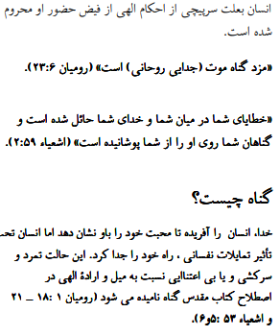

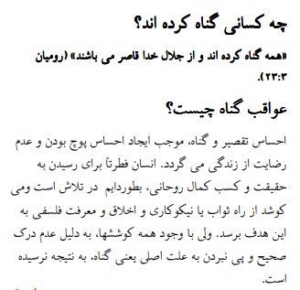

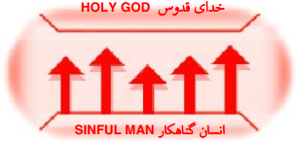



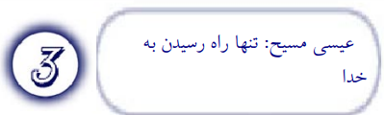

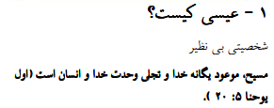

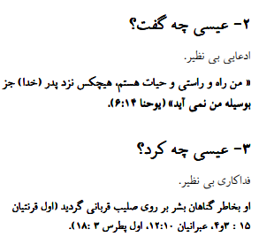

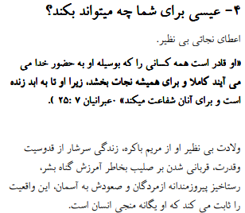

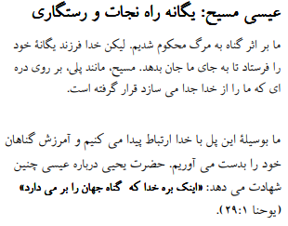

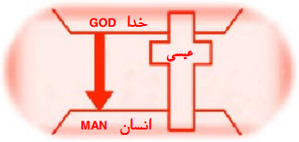



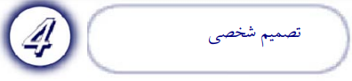

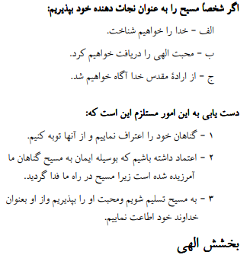

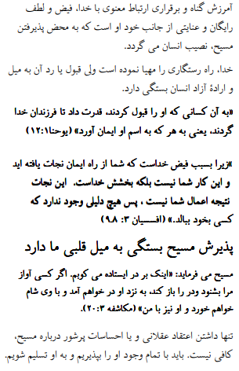

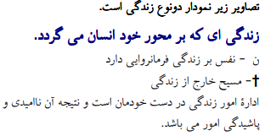



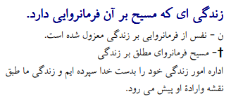



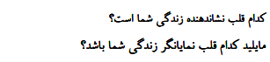

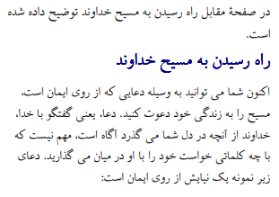

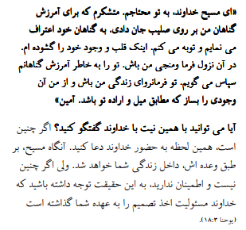

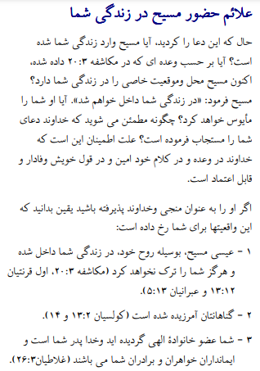

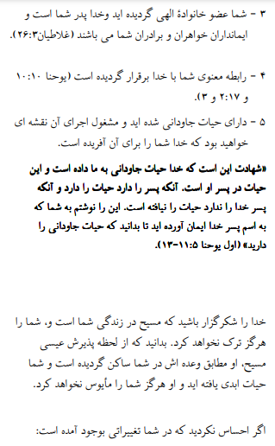

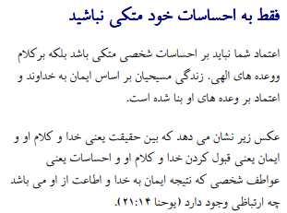

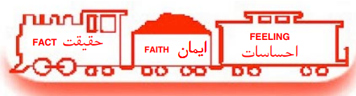

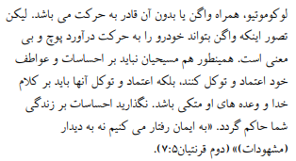

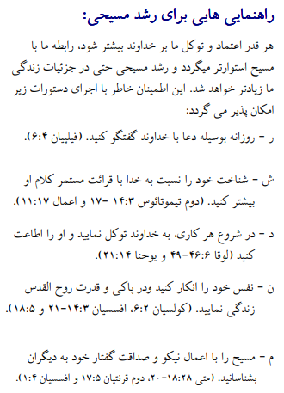

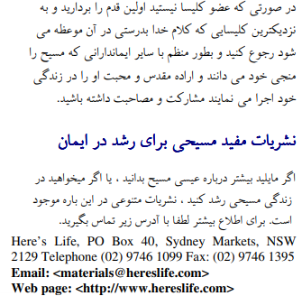

اگر مسیح را پذیرفتید اعمال رسولان 2:42 وزارتخانه ها دوست دارند بدانند. یا اگر چیزی برای به اشتراک گذاشتن در مورد این کاربرگ ها دارید ، لطفاً به ما اطلاع دهید

[nathand@242ministries.org](mailto:nathand@242ministries.org)

اردو:

<https://www.youtube.com/watch?v=6-GclzuUbxY>

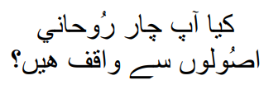

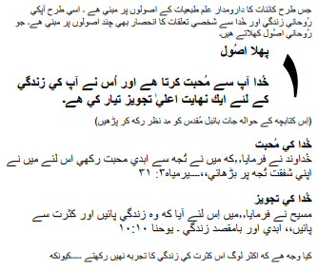

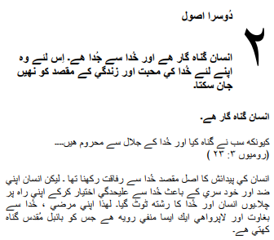

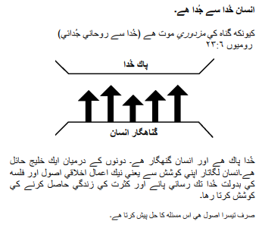

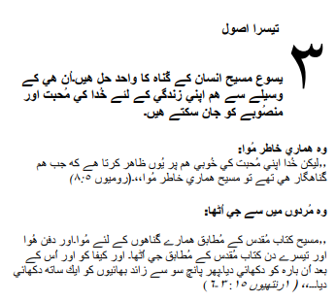

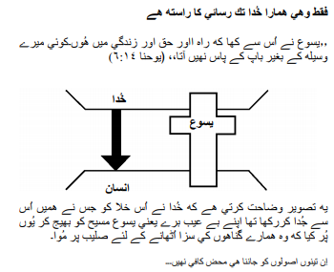

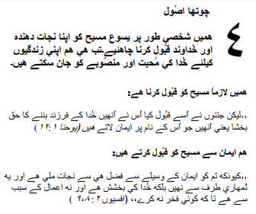

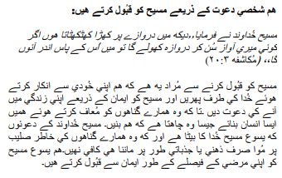

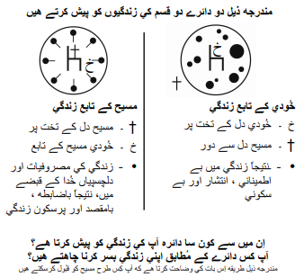

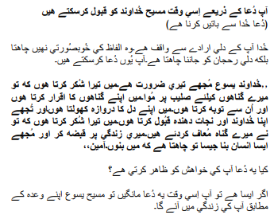

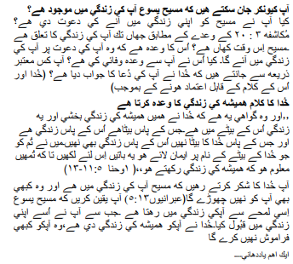

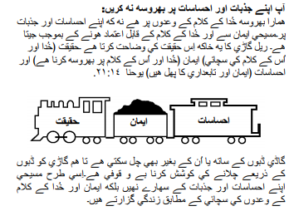

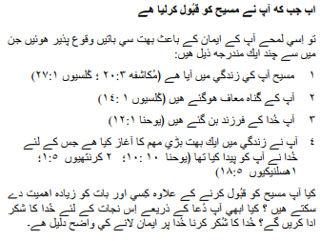

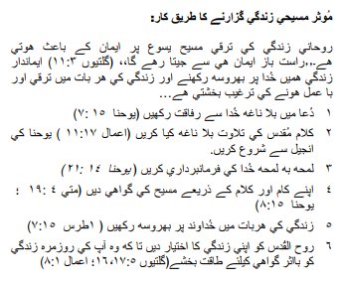

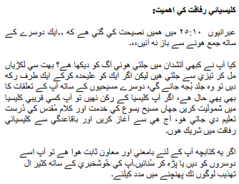

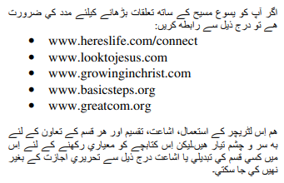

اگر آپ نے مسیح کے اعمال کو قبول کیا تو 2:42 وزارتیں جاننا پسند کریں گی۔ یا اگر آپ کے پاس ان ورک شیٹس کے بارے میں کچھ شیئر کرنا ہے تو براہ کرم ہمیں بتائیں۔

[nathand@242ministries.org](mailto:nathand@242ministries.org)

Türk:

<https://www.youtube.com/watch?v=6YwHd_PwOOQ>





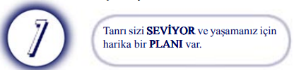

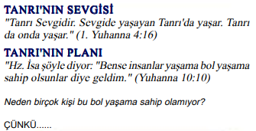

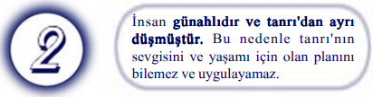

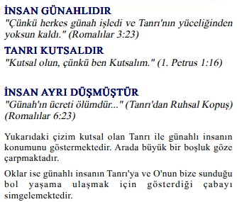

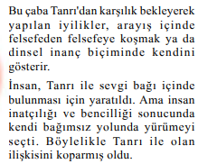

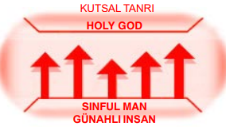



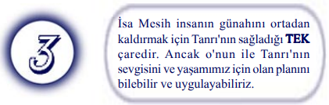

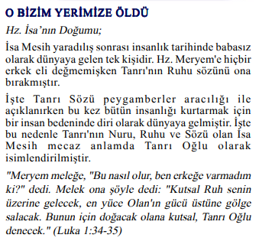



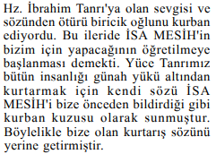

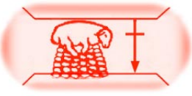

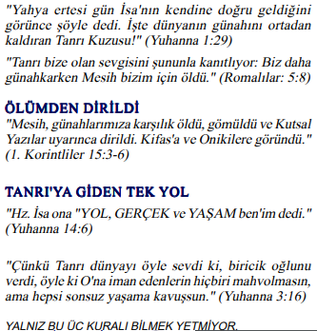

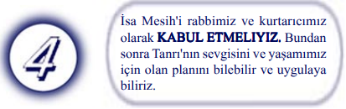

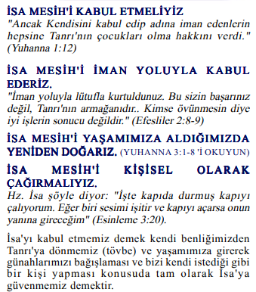

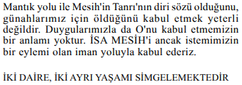

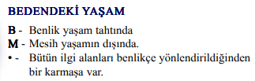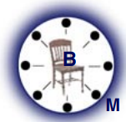

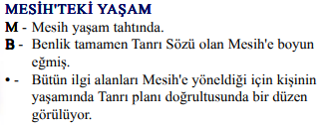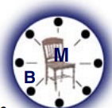

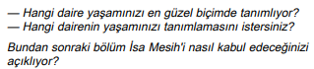

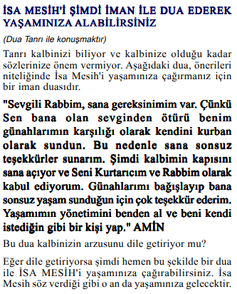

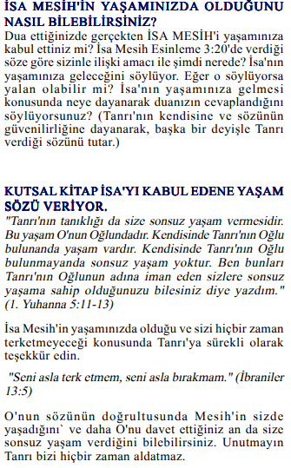

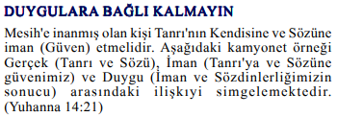

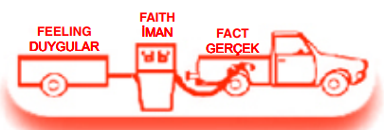

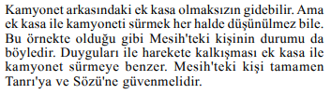

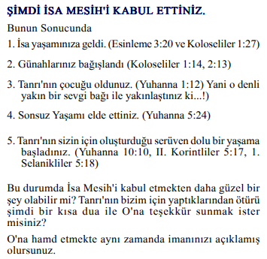

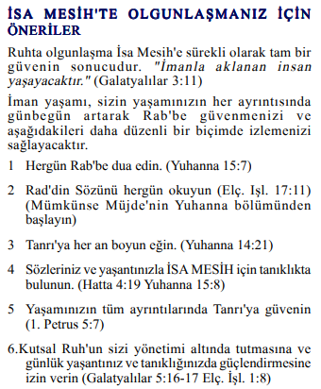

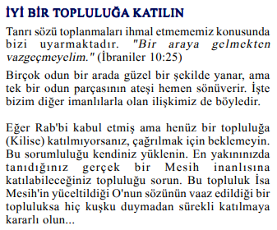

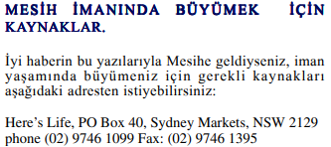

Mesih'in Elçilerinin İşleri 2:42'yi kabul ettiyseniz, Bakanlıklar bilmek ister. Veya bu çalışma sayfaları hakkında paylaşmak istediğiniz bir şey varsa lütfen bize bildirin.

[nathand@242ministries.org](mailto:nathand@242ministries.org)

हिंदी:

<https://www.youtube.com/watch?v=NR7AieVQI2A>

<https://www.youtube.com/watch?v=nmHla8doL5o>

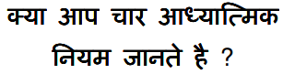

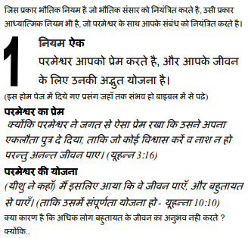

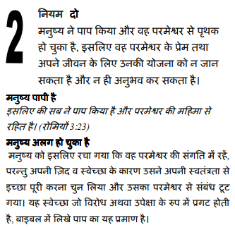

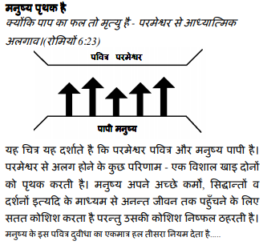

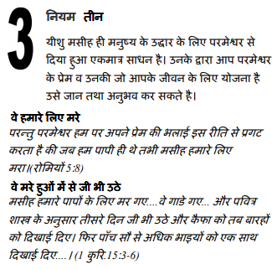

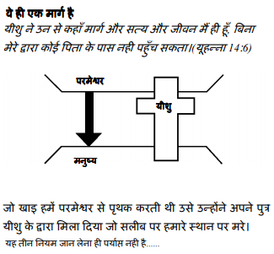

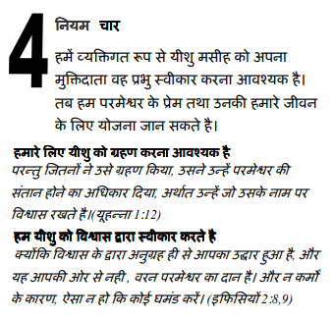

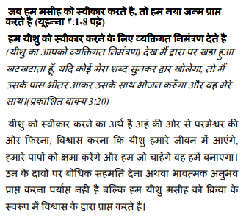

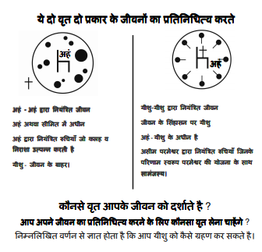

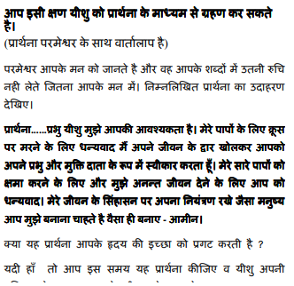

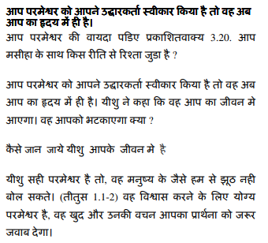

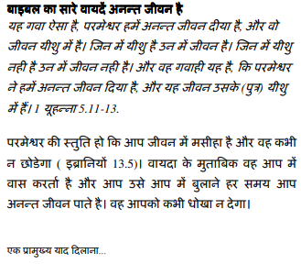

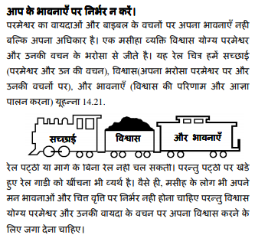

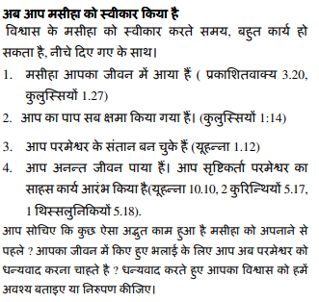

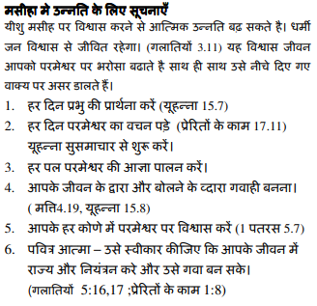

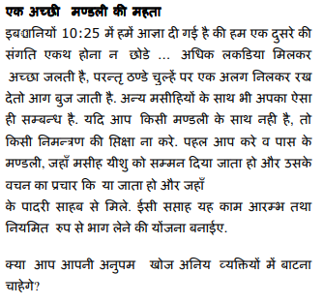

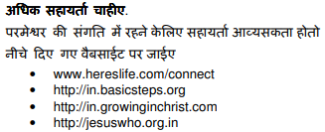

यदि आप मसीह के कामों को स्वीकार करते हैं प्रेरितों 2:42 मंत्रालयों को जानना अच्छा लगेगा। या यदि आपके पास इन कार्यपत्रकों के बारे में साझा करने के लिए कुछ है तो कृपया हमें बताएं।

[nathand@242ministries.org](mailto:nathand@242ministries.org)

中国人:

<https://www.youtube.com/watch?v=ebaT4PvcUEc>





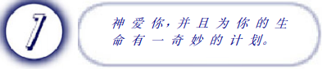



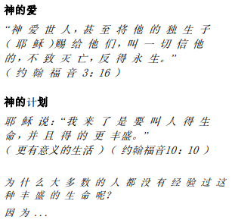

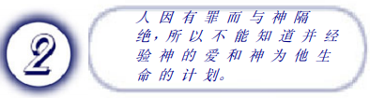

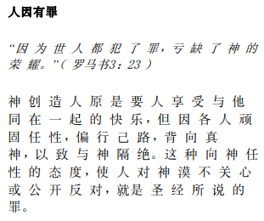

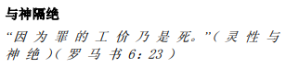

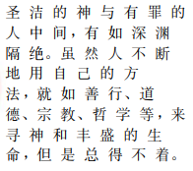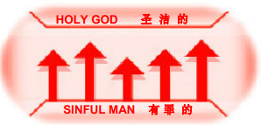



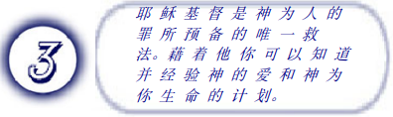

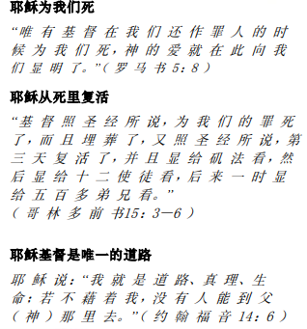

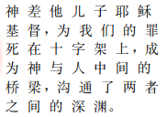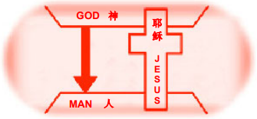



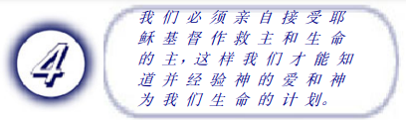

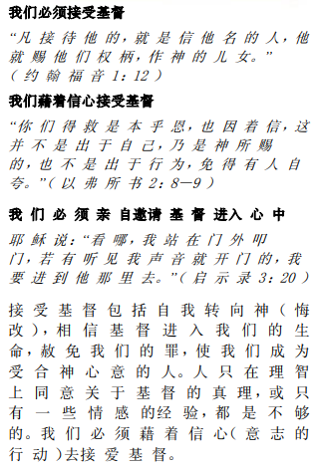

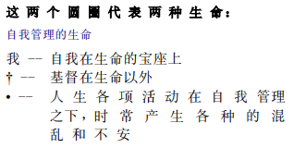

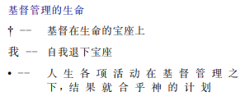

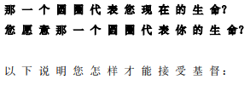

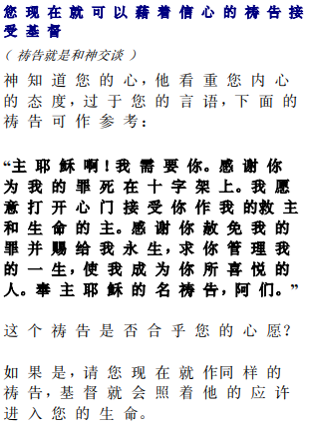

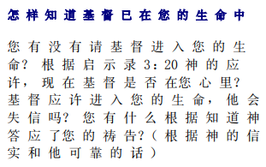

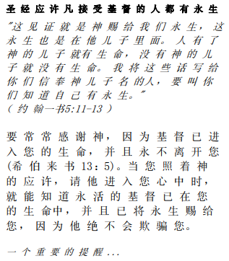

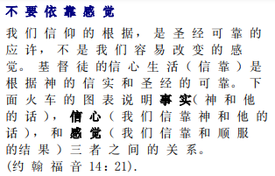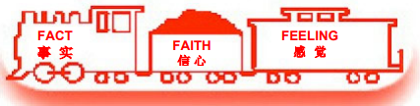

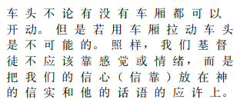

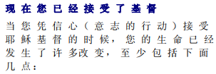

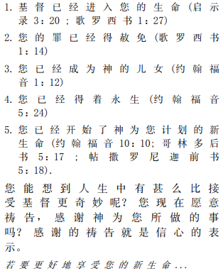

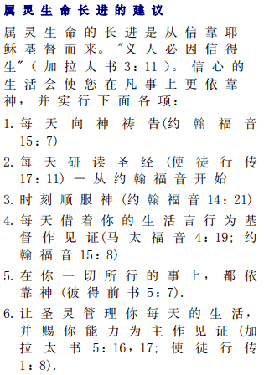

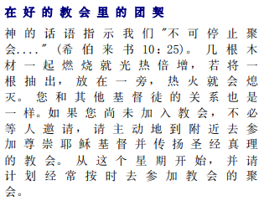



如果你接受基督使徒行传 2:42 事工很想知道。或者，如果您对这些工作表有任何要分享的内容，请告诉我们。

[nathand@242ministries.org](mailto:nathand@242ministries.org)