Lesson 5 – Emotions part 1

(Lección 5 – Emociones parte 1)

|  |  |  |
| --- | --- | --- |
| **English** | **español** | **Foto** |
| Happy | Feliz / Contento(a) | Smile Smiling Face - Free image on Pixabay |
| Sad | Triste | C:\Users\natha\Desktop\download.png |
| Mad or Angry | Enojado(a) | Angry Icon of Flat style - Available in SVG, PNG, EPS, AI & Icon fonts |
| Fear or Scared | Miedo o Asustado(a) | Cartoon scared man free image |
| Surprised | Sorprendido(a) | Surprised bee clipart. Free download transparent .PNG | Creazilla |
| Excited | Emocionado(a) | Happy cartoon Goofy free image |
| Tired or Sleepy | Cansado(a) o soñoliento(a) | Sleepy Cartoon Face Sco free image |
| Hungry | hambriento(a) | 90+ Free Hungry & Food Illustrations - Pixabay |
| Sick | Enfermo(a) | Sick Boy Cartoon N5 free image |

Write the emotion with the picture.

(Escribe la emoción con la imagen.)

|  |  |  |
| --- | --- | --- |
| **Number**  (número) | **Picture (imagen)** | **Answer (Responder)** |
| 1 | 60+ Free Excited & Happy Vectors - Pixabay |  |
| 2 | Cartoon sick car free image |  |
| 3 | File:Angry anime girl.png - Wikimedia Commons |  |
| 4 | Sleepy emoji clipart. Free download transparent .PNG | Creazilla |  |
| 5 | Sad Cartoon Face Vector Illustration N2 free image |  |
| 6 | Hunger Eat Hungry - Free image on Pixabay |  |
| 7 | Happy Family Cartoon - Free image on Pixabay |  |
| 8 | 70+ Free Shock & Shocked Vectors - Pixabay |  |
| 9 | Cartoon Person Running Away Scared free image |  |

Answers on next page (respuestas en la página siguiente)

1. Excited
2. Sick
3. Mad or Angry
4. Tired or Sleepy
5. Sad
6. Hungry
7. Happy
8. Surprised
9. Fear or Scared

Pick the right emotion

(Elige la emoción correcta)

|  |  |
| --- | --- |
| 1. C:\Users\natha\Desktop\blue-1293194_1280.pngMarco feels \_\_\_\_\_\_\_. 2. Mad or Angry 3. Sad 4. Surprised | 1. Excited employee clipart. Free download transparent .PNG | CreazillaJohn is \_\_\_\_\_\_\_\_\_\_. 2. Excited 3. Hungry 4. Tired or Sleepy |
| 1. Doctor And Sick Patient Cartoon free imageRalph feels \_\_\_\_\_\_\_\_\_. 2. Happy 3. Fear or Scared 4. Sick | 1. Surprised Face Big Eyes Icons - Download Free Vector Icons | Noun ProjectCharley is \_\_\_\_\_\_. 2. Sad 3. Surprised 4. Sick |
| 1. Cartoon hungry fish free imageFred feels \_\_\_\_\_\_. 2. Hungry 3. Happy 4. Fear or Scared | 1. Angry Person Cartoon drawing free imageBob is \_\_\_\_\_\_\_\_\_\_. 2. Tired or Sleepy 3. Excited 4. Mad or Angry |

Answers on next page (respuestas en la página siguiente)

1. Surprised
2. Excited
3. Sick
4. Surprised
5. Hungry
6. Mad or Angry

Draw the emotion on the face.  
(Dibuja la emoción en la cara.)



Happy Sad Fear or Scared

  

Mad or Angry Excited Surprised

To try at home (Para probar en casa)

1. Tell how you are feeling each day. (Dígale cómo se siente cada día.)
2. Tell how each of your family members feels. Use personal pronouns.

(Diga cómo se siente cada uno de los miembros de su familia. Usa pronombres personales.)

1. More difficult - Think of how you feel when something happens. Then make a sentence. For instance, “I feel happy when I get money.” Use a translator to figure out the English word if you don’t know it.

(Más difícil - Piense en cómo se siente cuando sucede algo. Luego haz una oración. Por ejemplo, "Me siento feliz cuando recibo dinero". Utilice un traductor para averiguar la palabra en inglés si no la conoce.)

**Please consider donating to Acts 2:42 Ministries (**<https://www.paypal.com/fundraiser/charity/213230>**) to support the free English lessons. Thank you!**

Considere hacer una donación a Acts 2:42 Ministries (<https://www.paypal.com/fundraiser/charity/213230>) para apoyar las lecciones de inglés gratuitas. ¡Gracias!

[How do I get to heaven?](#English)

[¿Cómo llego al cielo?](#español)

[كيف أصل إلى الجنة؟](#عربى)

[چگونه به بهشت ​​برسم؟](#فارسی" \o "فارسی)

[میں جنت میں کیسے جاؤں؟](#اردو)

[Cennete nasıl gidebilirim?](#Türk" \o "Türk)

[मैं स्वर्ग कैसे पहुँचूँ?](#हिंदी" \o "हिंदी)

[我怎样才能上天堂？](#中国人)

English:

<https://peacewithgod.net/>

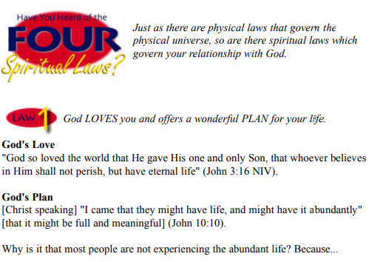

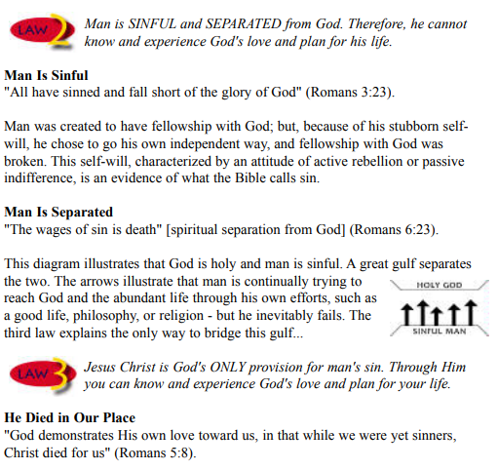

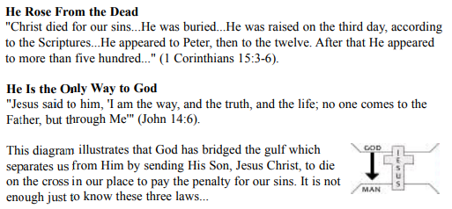

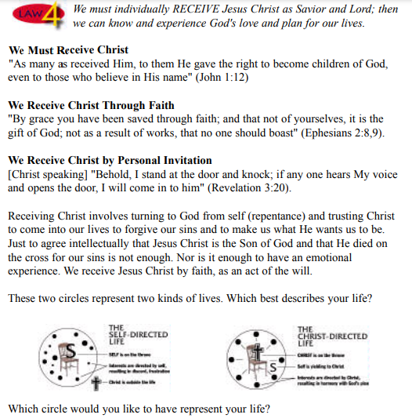

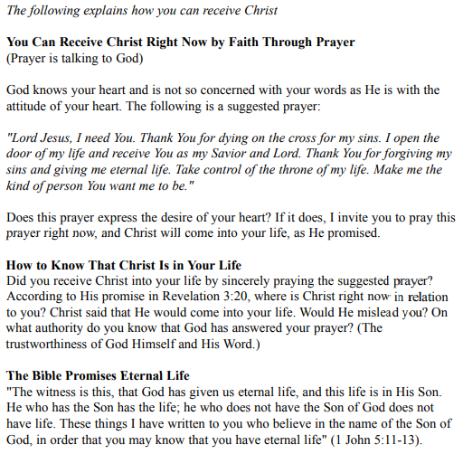

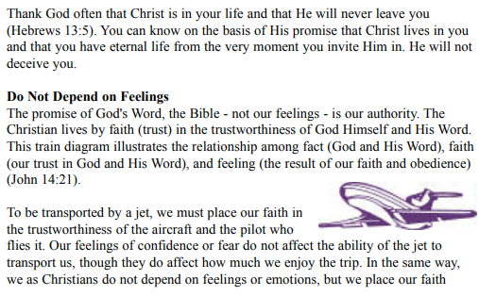

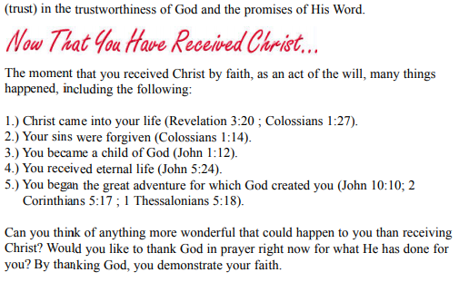

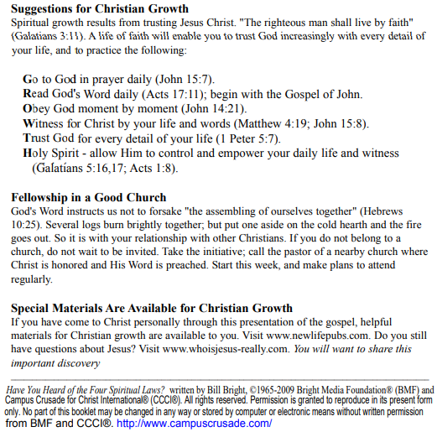

If you accepted Christ Acts 2:42 Ministries would love to know. Or if you have anything to share about these worksheets please let us know. [nathand@242ministries.org](mailto:nathand@242ministries.org)

español:

<https://www.youtube.com/watch?v=NRUqXwqTA8w>



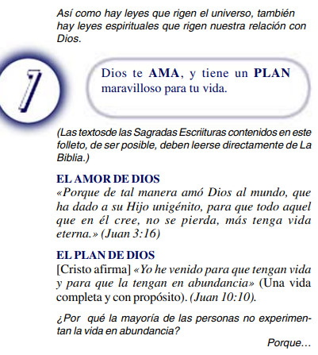

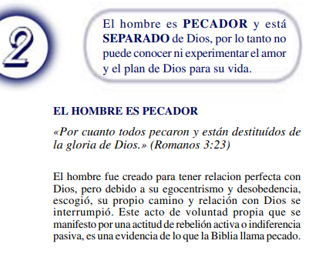

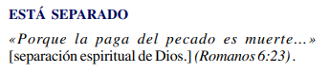

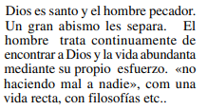

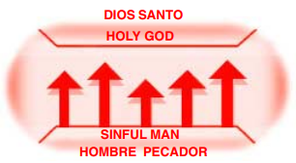



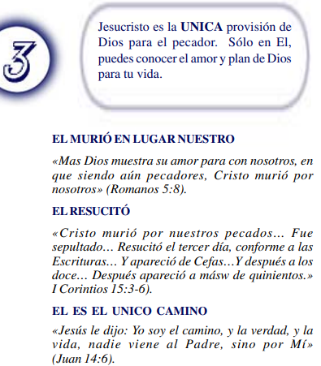

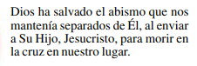

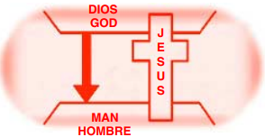



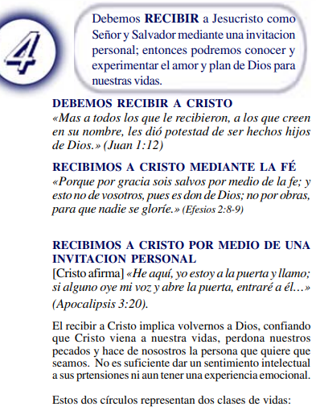

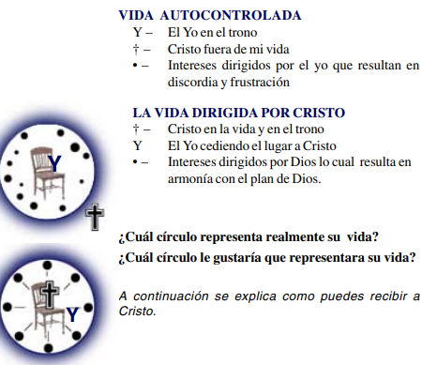

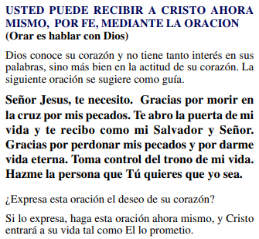

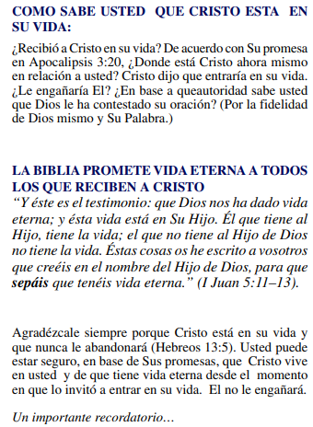

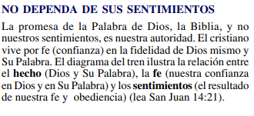

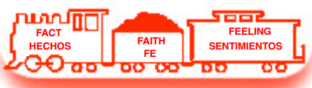

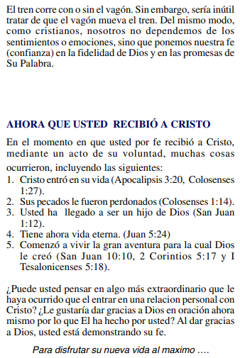

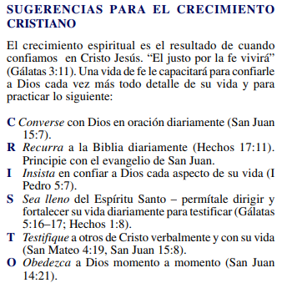

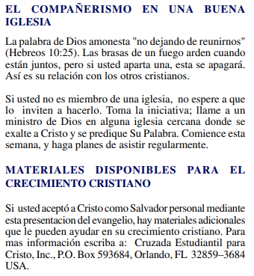

(Si aceptaste a Cristo Hechos 2:42 a Ministerios le encantaría saberlo. O si tiene algo que compartir sobre estas hojas de trabajo, háganoslo saber.)

[nathand@242ministries.org](mailto:nathand@242ministries.org)

عربى:

<https://www.youtube.com/watch?v=ePa_MElCi68>

<https://www.youtube.com/watch?v=o0GFYMPArW0>







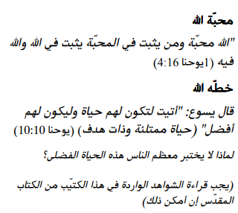

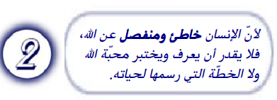

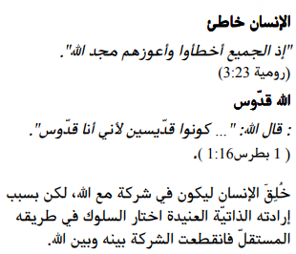

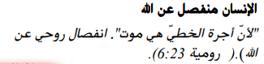

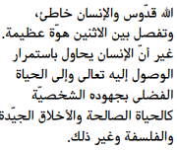

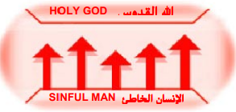



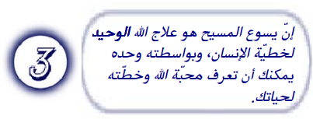

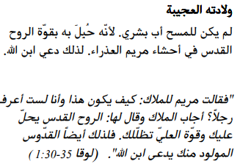

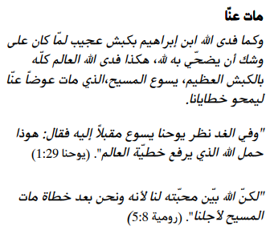

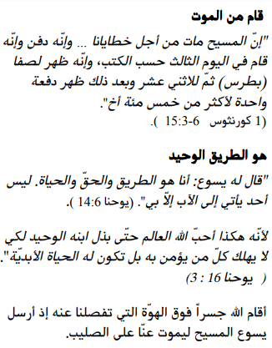

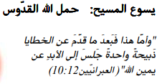







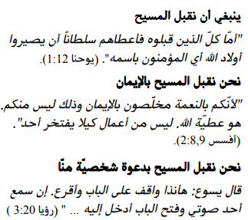

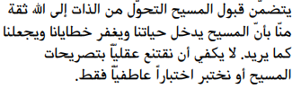



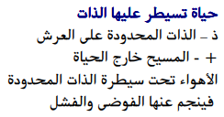

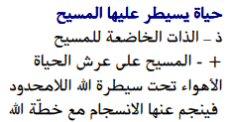

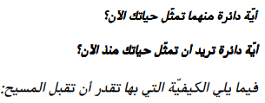

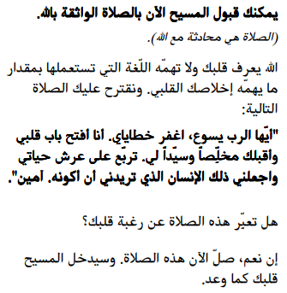

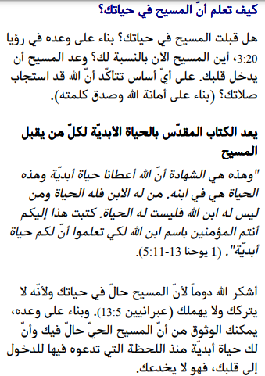

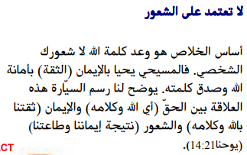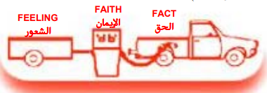

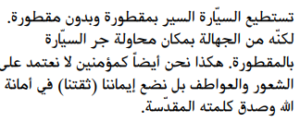

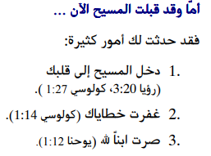

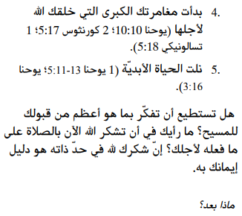

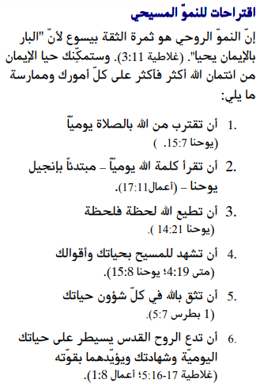

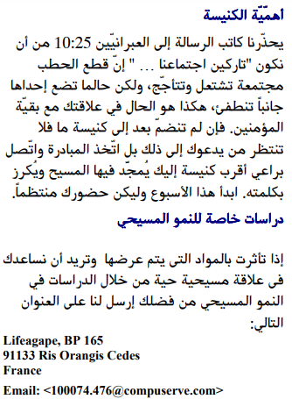

إذا قبلت المسيح فإن الخدمات تحب أن تعرف. أو إذا كان لديك أي شيء تريد مشاركته حول أوراق العمل هذه ، فيرجى إخبارنا بذلك.

[nathand@242ministries.org](mailto:nathand@242ministries.org)

فارسی:<https://www.youtube.com/watch?v=eWLsQ0DTsq0&t=12s>



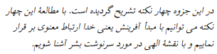



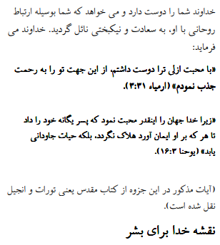

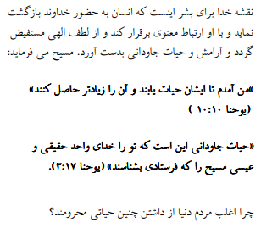



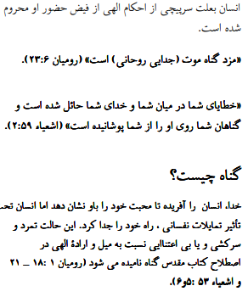

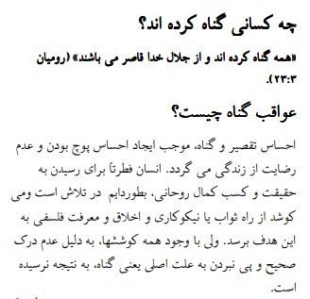

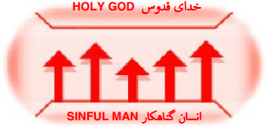





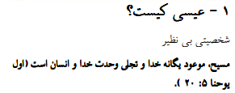

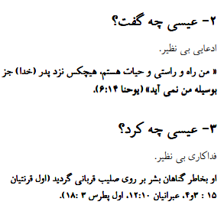

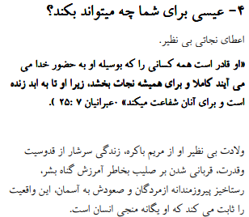

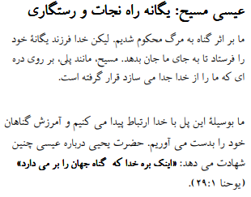

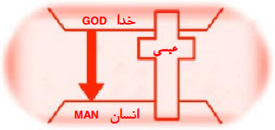





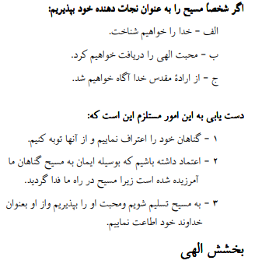

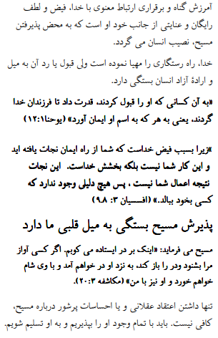

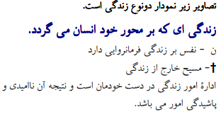



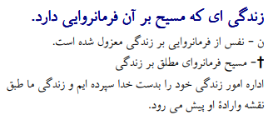





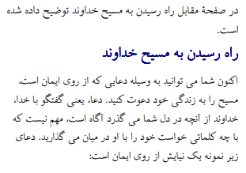

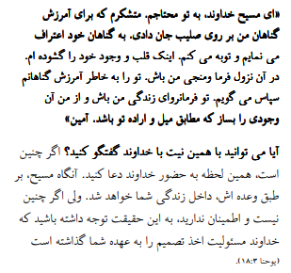

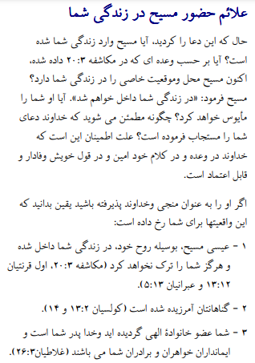

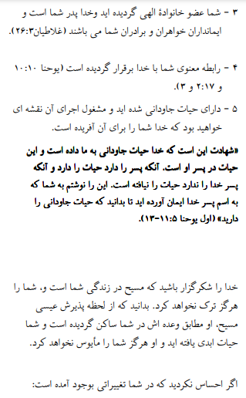

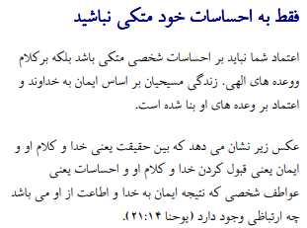

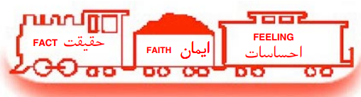

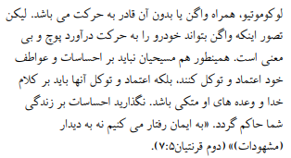

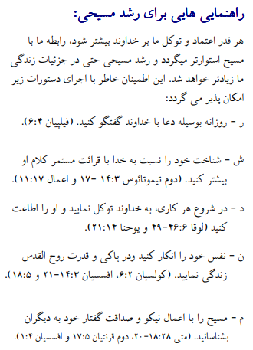



اگر مسیح را پذیرفتید اعمال رسولان 2:42 وزارتخانه ها دوست دارند بدانند. یا اگر چیزی برای به اشتراک گذاشتن در مورد این کاربرگ ها دارید ، لطفاً به ما اطلاع دهید

[nathand@242ministries.org](mailto:nathand@242ministries.org)

اردو:

<https://www.youtube.com/watch?v=6-GclzuUbxY>

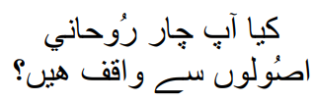

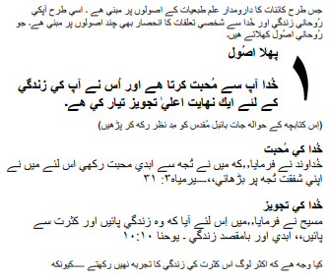

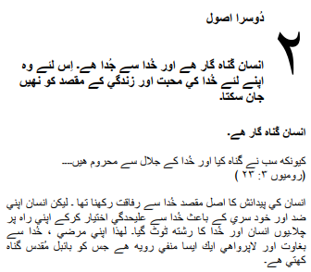

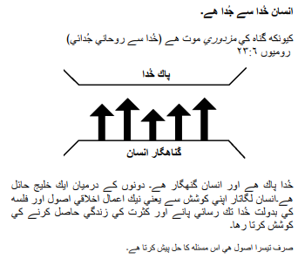

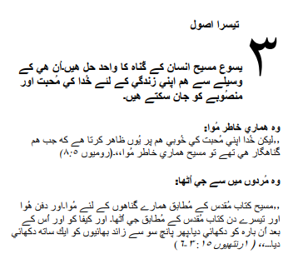

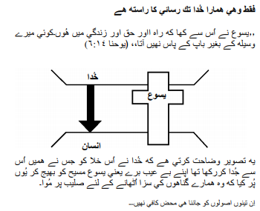

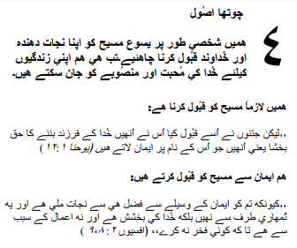

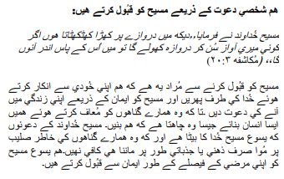

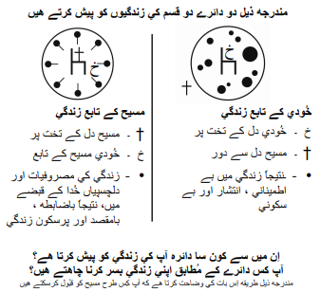

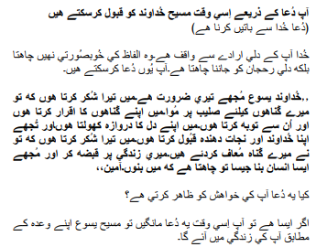

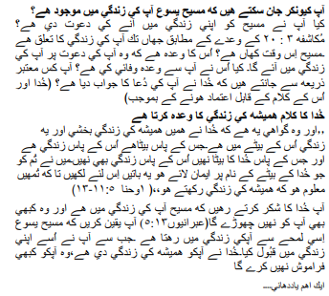

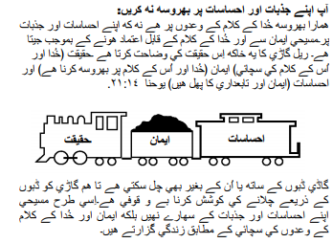

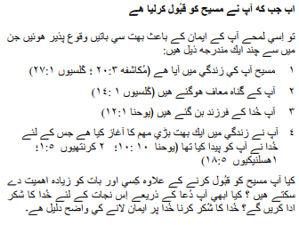

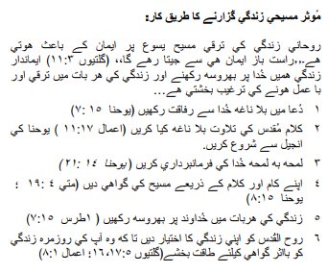

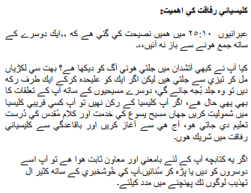

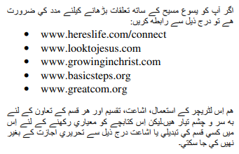

اگر آپ نے مسیح کے اعمال کو قبول کیا تو 2:42 وزارتیں جاننا پسند کریں گی۔ یا اگر آپ کے پاس ان ورک شیٹس کے بارے میں کچھ شیئر کرنا ہے تو براہ کرم ہمیں بتائیں۔

[nathand@242ministries.org](mailto:nathand@242ministries.org)

Türk:

<https://www.youtube.com/watch?v=6YwHd_PwOOQ>







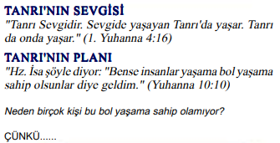



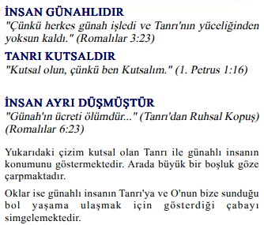

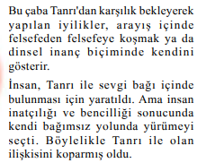

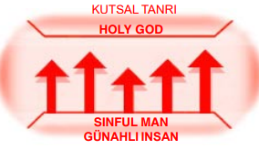





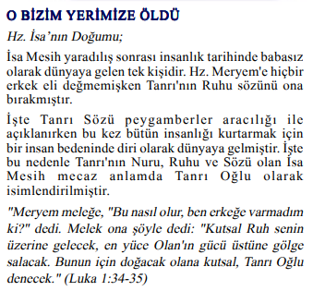



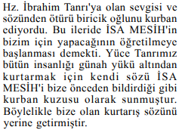

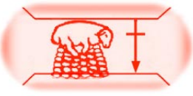

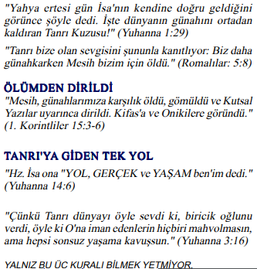



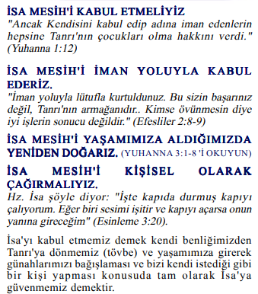

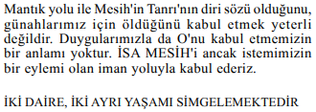

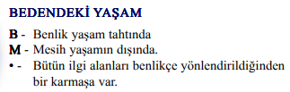

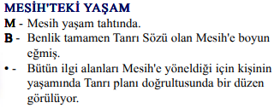

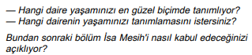

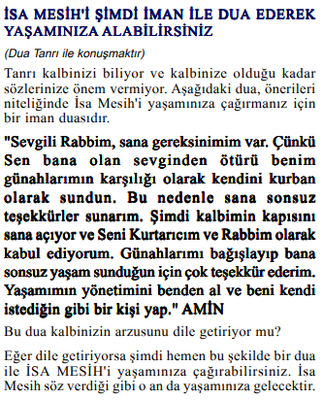

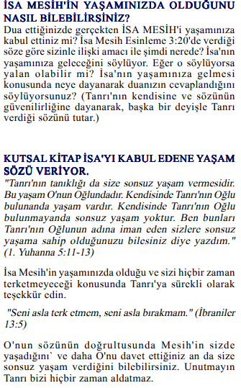

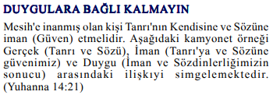



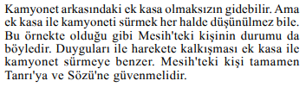

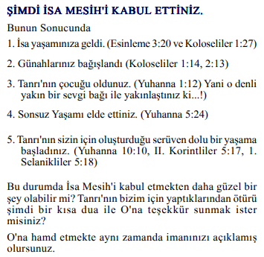

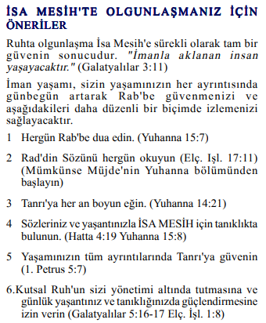

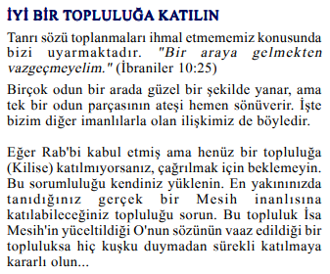

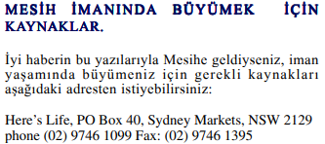

Mesih'in Elçilerinin İşleri 2:42'yi kabul ettiyseniz, Bakanlıklar bilmek ister. Veya bu çalışma sayfaları hakkında paylaşmak istediğiniz bir şey varsa lütfen bize bildirin.

[nathand@242ministries.org](mailto:nathand@242ministries.org)

हिंदी:

<https://www.youtube.com/watch?v=NR7AieVQI2A>

<https://www.youtube.com/watch?v=nmHla8doL5o>

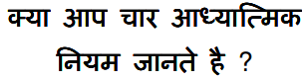

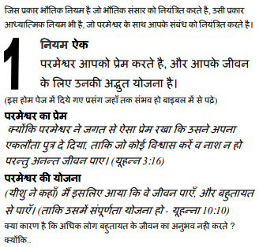

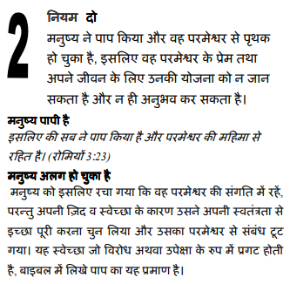

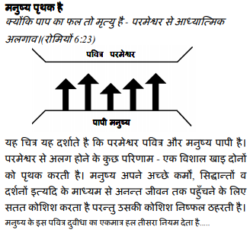

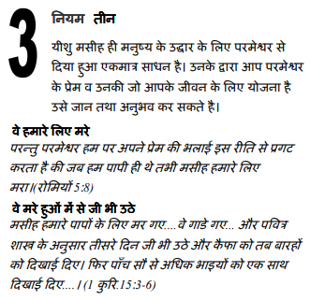

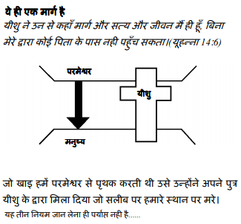

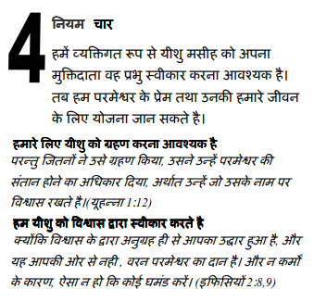

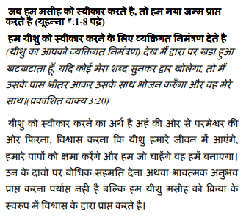

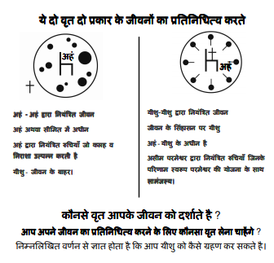

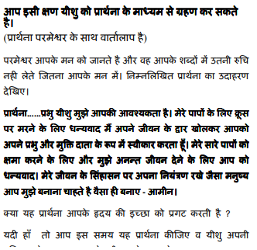

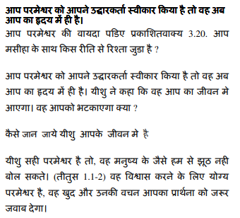

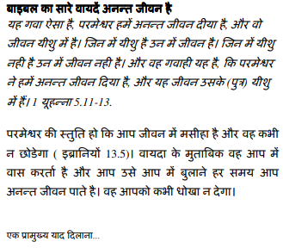

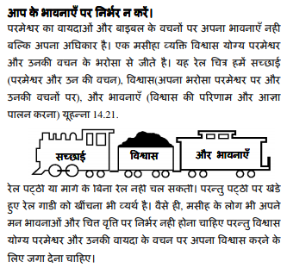

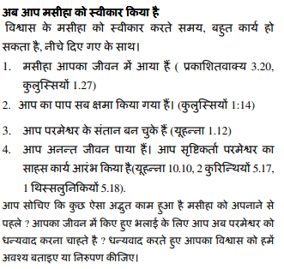

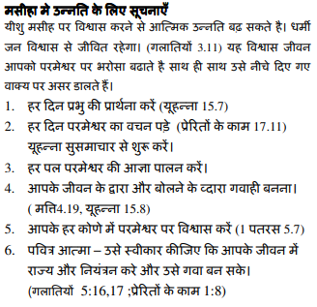

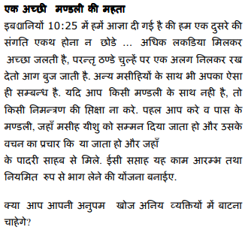

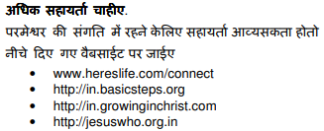

यदि आप मसीह के कामों को स्वीकार करते हैं प्रेरितों 2:42 मंत्रालयों को जानना अच्छा लगेगा। या यदि आपके पास इन कार्यपत्रकों के बारे में साझा करने के लिए कुछ है तो कृपया हमें बताएं।

[nathand@242ministries.org](mailto:nathand@242ministries.org)

中国人:

<https://www.youtube.com/watch?v=ebaT4PvcUEc>









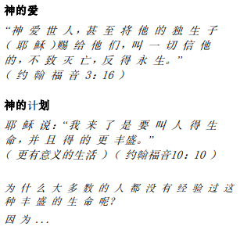



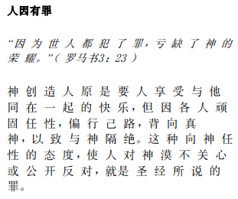

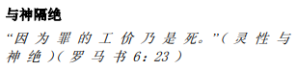

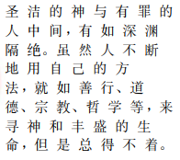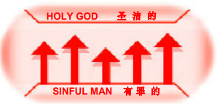





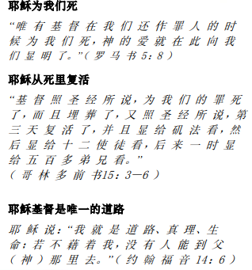

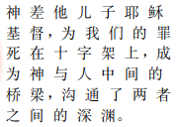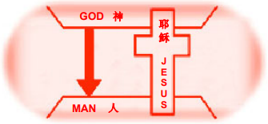





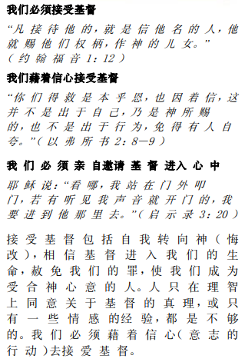

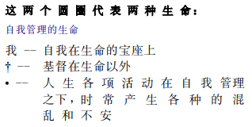

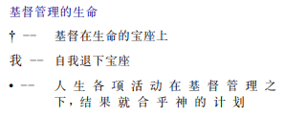

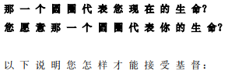

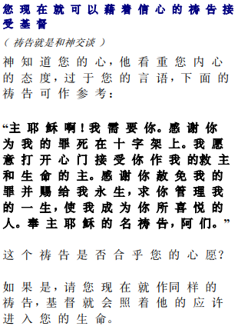

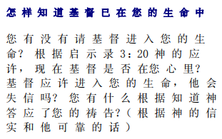

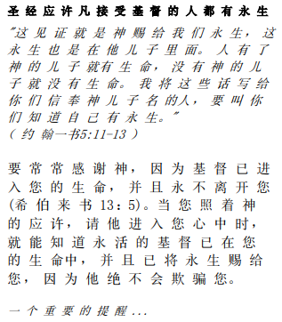

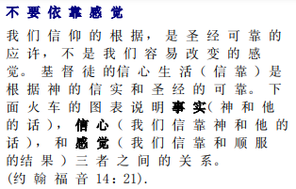

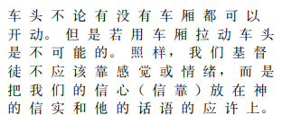

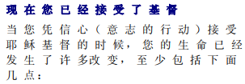

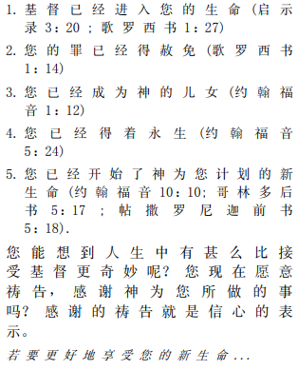

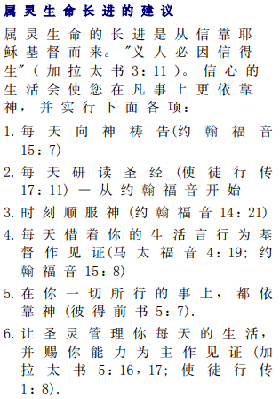

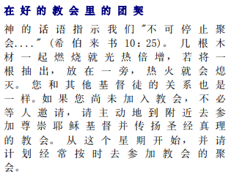



如果你接受基督使徒行传 2:42 事工很想知道。或者，如果您对这些工作表有任何要分享的内容，请告诉我们。

[nathand@242ministries.org](mailto:nathand@242ministries.org)